DS LAB 2
SOLVED EXERCISES

Name: Drishaan Prasad
Registration No.: 210905282

1. Example 1: Introduction to PANDAS
import pandas as pd
import numpy as np
#PANDAS : Series data structure
s=pd.Series([3,9,-2,10,5])
print(s.sum())
print(s.min())
print(s.max())

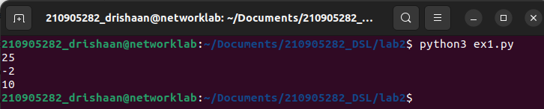
2. Creating a Data Frame
import pandas as pd
data = [['Dinesh',10],['Nithya',12],['Raji',13]]
df = pd.DataFrame(data,columns=['Name','Age'])
print(df)

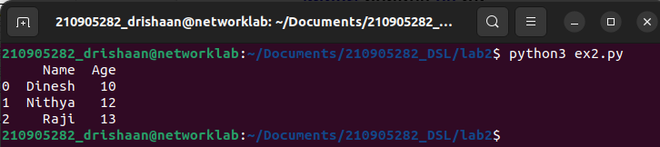
3. Indexed Data Frame
import pandas as pd
data = {'Name':['Kavitha', 'Sudha', 'Raju','Vignesh'],'Age':[28,34,29,42]}
df = pd.DataFrame(data, index=['rank1','rank2','rank3','rank4'])
print(df)

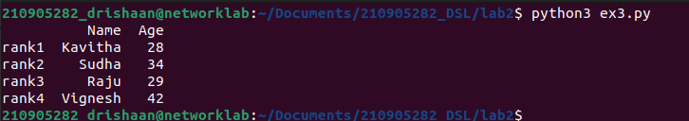
4. Creating a Data Frame using Dictionary
import pandas as pd
import numpy as np
df1=pd.DataFrame({'A':pd.Timestamp('20130102'),'B':np.array([3]*4,dtype='int32'),
'C':pd.Categorical(['Male','Female','Male','Female'])})
print(df1)
print(df1.shape)
print(df1.dtypes)
print(df1.head())
print(df1.tail())
#print(df1.summary())
print(df1.T)

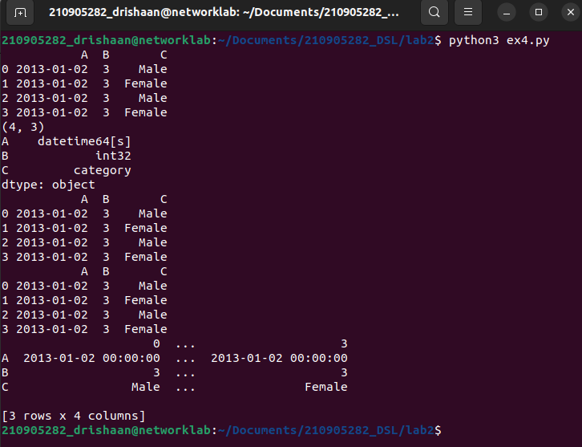

5. import pandas as pd
import numpy as np
df=pd.DataFrame({'A':pd.Timestamp('20130102'),'B':np.array([3]*4,dtype='int32'),
'C':pd.Categorical(['Male','Female','Male','Female'])})
dates=pd.date_range('20130101', periods=100)
df = pd.DataFrame(np.random.randn(100,4), index=dates, columns=list('ABCD'))
#To view first 5 records
print(df.head())import pandas as pd
import numpy as np
df=pd.DataFrame({'A':pd.Timestamp('20130102'),'B':np.array([3]*4,dtype='int32'),
'C':pd.Categorical(['Male','Female','Male','Female'])})
dates=pd.date_range('20130101', periods=100)
df = pd.DataFrame(np.random.randn(100,4), index=dates, columns=list('ABCD'))
#To view first 5 records
print(df.head())
#To view last 5 records
print(df.tail())
#To view the index
print(df.index)
#To view the column names
print(df.columns)
#To transpose the df
print(df.T)
#Sorting by Axis
print(df.sort_index(axis=1, ascending=False))
#Sorting by Values
print(df.sort_values(by='B'))
#Slicing the rows
print(df[0:3]) #which slice first 3 records (rows)
#Slicing with index name
print(df['20130105':'20130110'])
#Slicing with row and column index (like 2D Matrix)
print(df.iloc[0]) #will fetch entire 1st row
print(df.iloc[0,:2]) #will fetch 1st row, first 2 columns
print(df.iloc[0,0]) #will fetch 1st row, 1st column element (single element)
#Selecting a single column
print(df['A']) #which yields a Series
#Selecting more than one column
print(df[['A','B']]) #entire 2 columns
#Selecting more than one column, with selected number of records
print(df[['A','B']][:5]) #first 5 records
#OR
print(df.loc['20130101':'20130105',['A','B']][:5]) #first 5 records
#To view last 5 records
print(df.tail())
#To view the index
print(df.index)
#To view the column names
print(df.columns)
#To transpose the df
print(df.T)
#Sorting by Axis
print(df.sort_index(axis=1, ascending=False))
#Sorting by Values
print(df.sort_values(by='B'))
#Slicing the rows
print(df[0:3]) #which slice first 3 records (rows)
#Slicing with index name
print(df['20130105':'20130110'])
#Slicing with row and column index (like 2D Matrix)
print(df.iloc[0]) #will fetch entire 1st row
print(df.iloc[0,:2]) #will fetch 1st row, first 2 columns
print(df.iloc[0,0]) #will fetch 1st row, 1st column element (single element)
#Selecting a single column
print(df['A']) #which yields a Series
#Selecting more than one column
print(df[['A','B']]) #entire 2 columns
#Selecting more than one column, with selected number of records
print(df[['A','B']][:5]) #first 5 records
#OR
print(df.loc['20130101':'20130105',['A','B']][:5]) #first 5 records

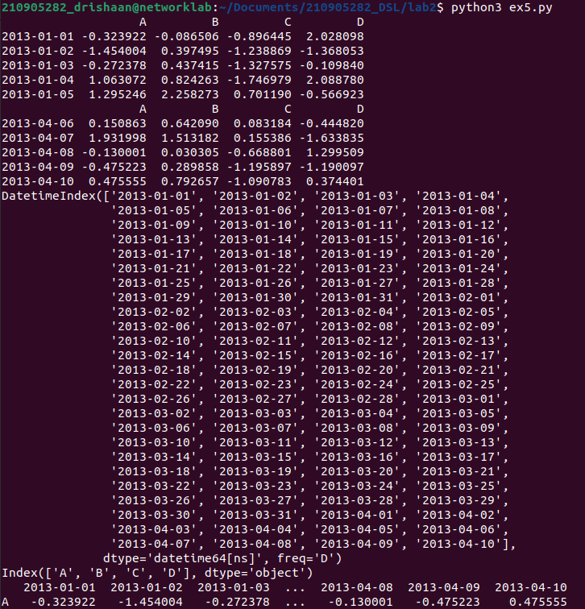

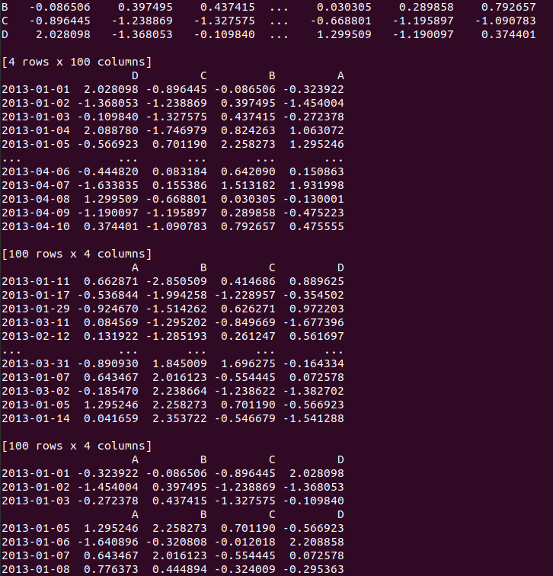

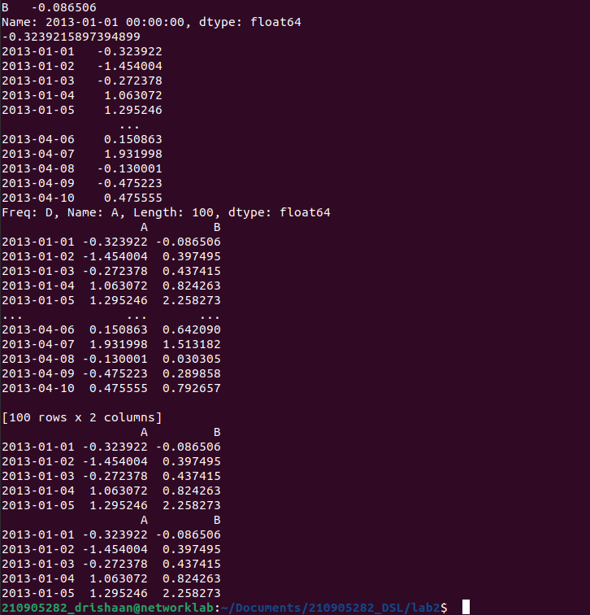

6. import pandas as pd
import numpy as np
df=pd.DataFrame({'A':pd.Timestamp('20130102'),'B':np.array([3]*4,dtype='int32'),'C':pd.Categorical(['Male','Female','Male','Female'])})
print(df[df.A>0]) #will fetch all positive values of A column
#Include a 6th column (a categorical) character data
print(df['F']==['Male','Female','Female','Male','Female','Female'])
#Setting by assigning with a numpy array
print(df.loc[:,'D']==np.array([5]*len(df))) #Which will replace the ‘D’, column with all 5
print(df.drop ('col_name', axis =1, inplace=True))
#will drop the column name specified in col_name
print(df.drop ('row_index', axis =0, inplace=True))
#will drop the row specified in row_index
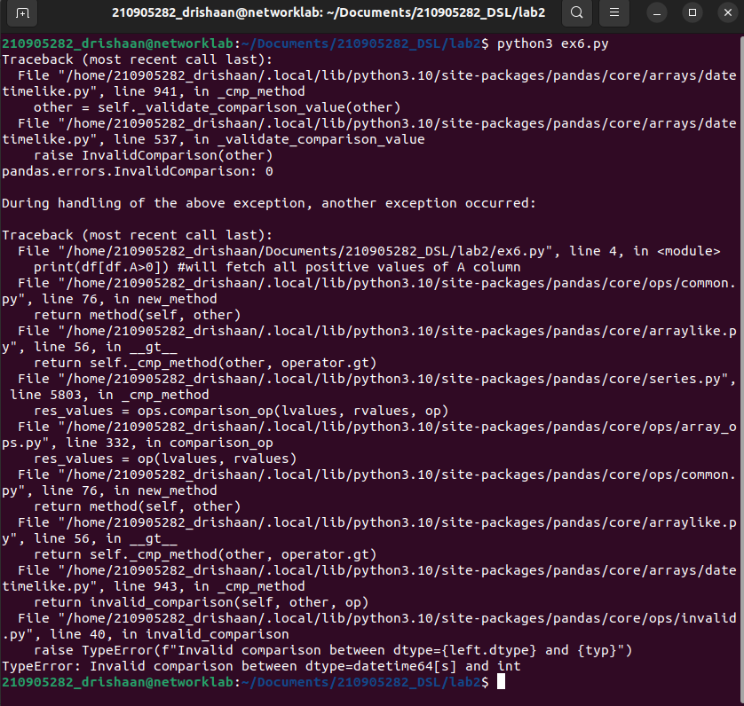
7. I/O operations with external files
import pandas as pd
import numpy as np
import matplotlib.pyplot as plt
# Reading a CSV file & XLS file format
df = pd.read_csv('/home/210905282_drishaan/Documents/210905282_DSL/lab2/xyz.csv',header=None)
df.head() #This will display 1 st 5 records
df.tail() #This will display last 5 records
#The above dataset doesn’t have header, we shall attach our own header.
df.columns=['preg','glu','bp','sft','ins','bmi','dpf','age','class']
#Let us visualize the scatter plot of two continuous variable.
plt.scatter(df['bmi'],df['glu'])
plt.xlabel('bmi')
plt.ylabel('Glucose')
plt.show()
plt.hist(df['age'])
plt.show()
plt.boxplot(df['age'])
plt.show()

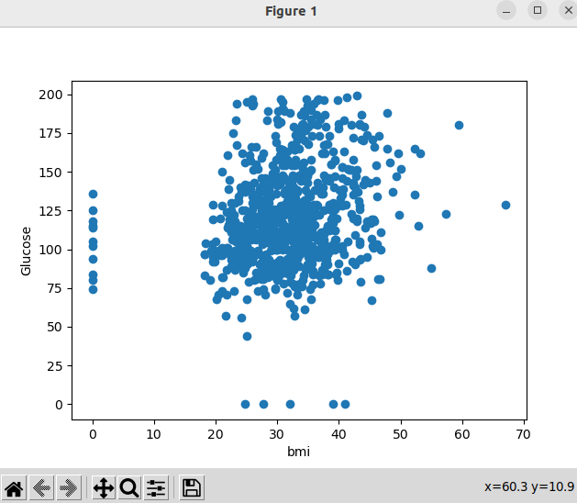

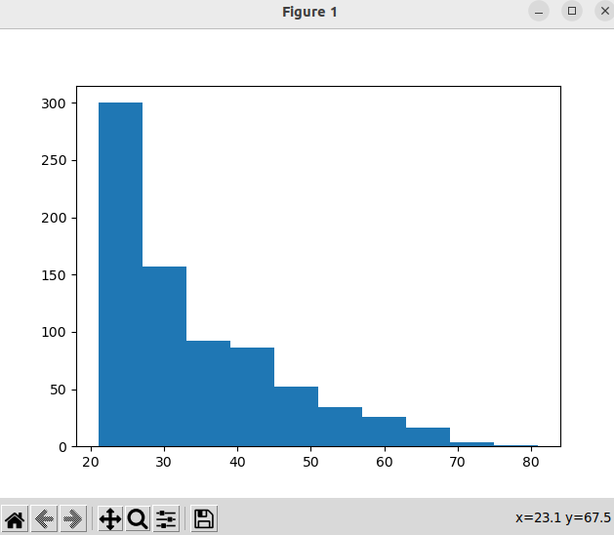

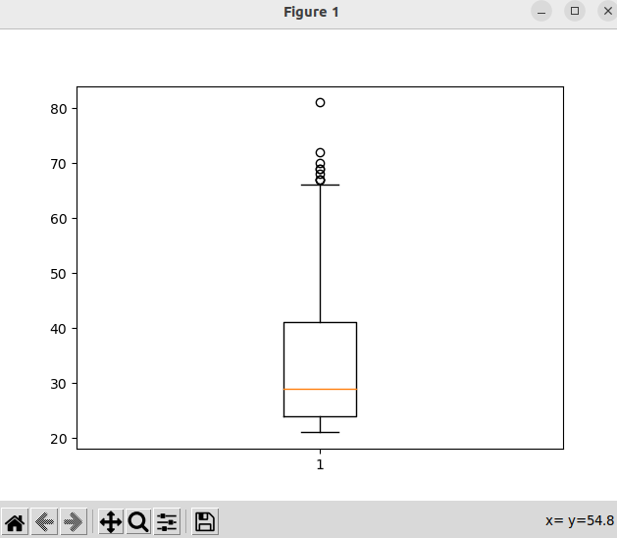

8. import numpy as np
import pandas as pd
import matplotlib.pyplot as plt
df = pd.read_table("HR_for_Week2.txt")
print(df.head())
f = df["Department"].value_counts()
print(f)
f.plot(kind='bar')
plt.show()
f.plot(kind='pie')
plt.show()
fa = pd.crosstab(df['Gender'], df['Attrition'])
fa.plot(kind='bar')
plt.show()

