DS LAB 1
SOLVED EXERCISES

Name: Drishaan Prasad
Registration No.: 210905282
CSE – A
Roll No.: 47

1. Assigning values to variables
counter = 100 # An integer assignment
miles = 1000.0 # A floating point
name = "John" # A string
print (counter)
print (miles)
print (name)

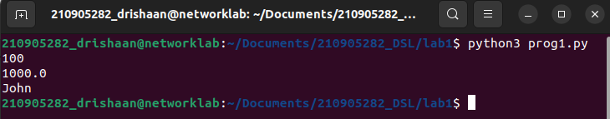
2. Python Numbers
a = 5 # integer assignment
b= 4.56 #floating point assignment
#mathematical operations with scalar variables
print (5*a) #would give the result 25
print (a/2) #would give the result 2.5print(a**2), is the power (squaring operation) would give the result 25

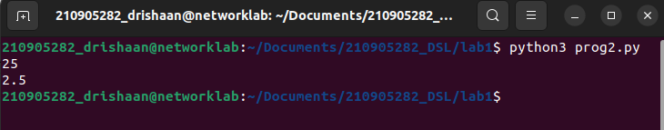
3. Python Strings
str = 'Hello World!'
print (str) # Prints complete string
print (str[0]) # Prints first character of the string
print (str[2:5]) # Prints characters starting from 3rd to 5th
print (str[2:]) # Prints string starting from 3rd character
print (str * 2) # Prints string two times
print (str + "TEST") # Prints concatenated string

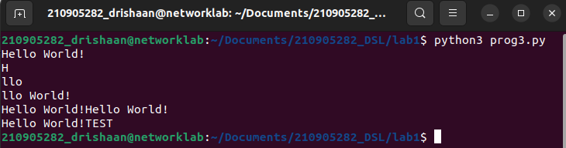
4. Updating a string
var1 = 'Hello World!'
print ("Updated String :", var1[:6] + 'Python')

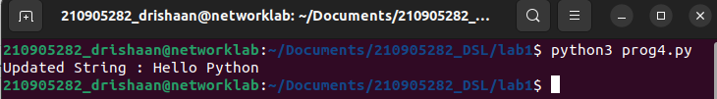
5. String formatting operator
print( "My name is %s and weight is %d kg!" % ('Abay', 55))

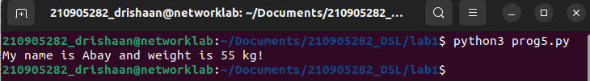
6. Built-in String methods
#capitalize() , the first character of the string is converted to upper case.
str = "this is string example wow!!!";
print (str.capitalize())

#count(), counts the number of times a specific ‘substring’, occurrence in the main string
str = "this is string example ... wow!!!";
print(str.count('s'))

#find() , will locate the position of searching ‘substring’, (index)
print(str.find('example'))

#lower(),returns a copy of the string in which all case−based characters have been lowercased.
str = "THIS IS STRING EXAMPLE ... WOW!!!";
print (str.lower())

#replace(), this method returns a copy of the string with all occurrences of substring old replaced by new.
str = "this is string example ... wow!!! this is really string";
print (str.replace("is", "was"))

#swapcase(), this method returns a copy of the string in which al l the case−based characters have had their case swapped.
str = "this is string example ... wow!!!";
print (str.swapcase())

#title(),returns a copy of the string in which first characters of all the words are capitalized.
str = "this is string example ... wow!!!";
print (str.title())

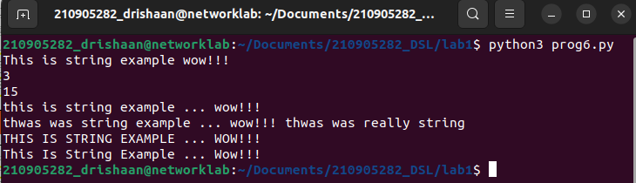
7. Python Lists
list = [ 'abcd', 786 , 2.23, 'john', 70.2 ]
tinylist = [123, 'john']
print (list) # Prints complete list
print (list[0]) # Prints first element of the list
print (list[1:3]) # Prints elements starting from 2nd till 3rd
print (list[2:]) # Prints elements starting from 3rd element
print (tinylist * 2) # Prints list two times
print (list + tinylist) # Prints concatenated lists

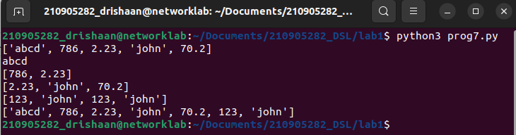
8. Functions and Methods in Lists
list = ['physics', 'chemistry', 1997, 2000];
list.append('maths')
print(list)

#To delete an element in a list
del list[2] #will remove 1997 record from the list.
print(list)
#To check a data in a list,
print('physics' in list) #will return ‘True’
print('english' in list) #will return ‘False’
print(len(list)) #will return total items in list
print(list.count('physics'))

#list.pop (), will remove and return the last item from the list.
list = ['physics', 'chemistry', 1997, 2000];
list.pop()
print(list)

#list.insert() , will insert an item in the specified index
list = ['physics', 'chemistry', 1997, 2000];
list.insert (2, 'maths')
print(list)

list = ['physics', 'chemistry', 1997, 2000];
list.remove('chemistry') #will remove the item specified.
print(list)

list = ['physics', 'chemistry', 1997, 2000];
list.reverse() #will reverse the objects of the list in place.
print(list)

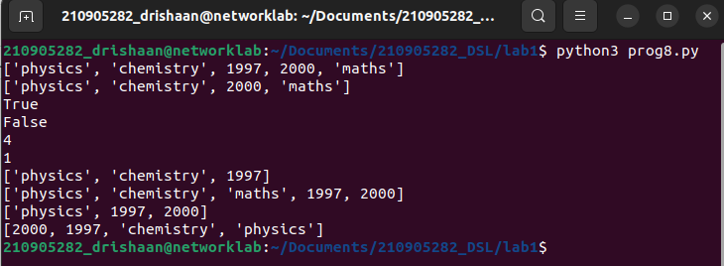
9. Python Tuple
tuple = ( 'abcd', 786 , 2.23, 'john', 70.2 )
list = [ 'abcd', 786 , 2.23, 'john', 70.2 ]
# tuple[2] = 1000 # Invalid syntax with tuple
list[2] = 1000 # Valid syntax with list
print(list)

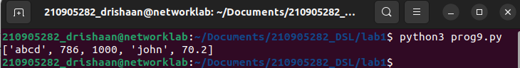
Looping and Conditional Branches in Python

Ex1:
num=float(input('Enter a number:'))
if num>0:
print('pos number')
elif num==0:
print('zero')
else:
print('Neg number')

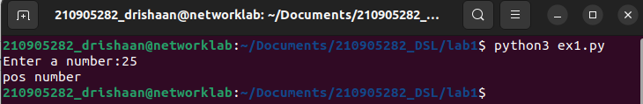
Ex2:
x=float(input('Enter a number:'))
if x<10:
print('smaller')
if x>20:
print('bigger')
print('Finished')

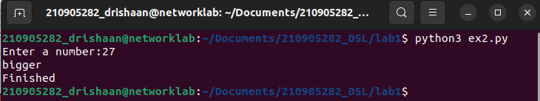
Ex3:
x=5
print('Before 5')
if x==5:
print ('this is 5')
print('still 5')
print('After 5')
print('Before 6')
if x==6:
print('this is 6')
print ('After 6')

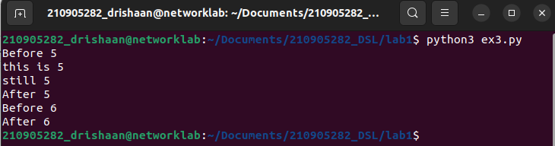
Ex4:
x=float(input('Enter a number:'))
if x<20:
print('Below 20')
elif x<10:
print('Below 10')
else:
print('something else')

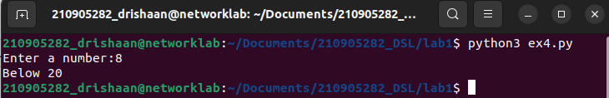
Ex5:
x=42
if x>1:
print('above one')
if x<100:
print('less than 100')
print('All done')

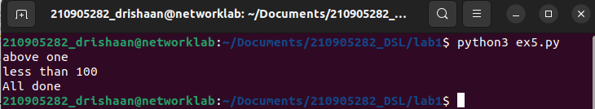
Ex6:
age=15
b=('kid' if age<18 else 'adult')
print(b) #this will print 'kid'
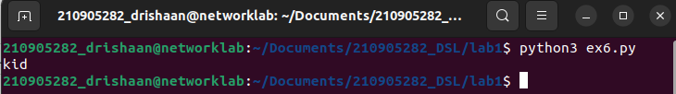
Usage of For-loop

Ex1:
for val in [5,4,3,2,1]:
print(val)
print ('Done')

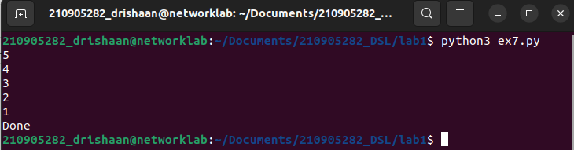
Ex2:
stud=['Ram','Vijay','Nithya','Anu','Ramesh','suja']
for k in stud:
print('Hello:', k)
print('done')

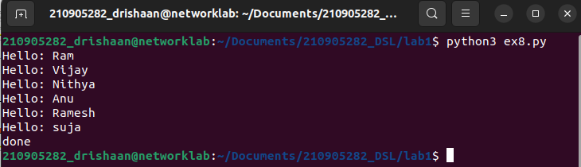
Ex3:
for i in range(5):
print(i)
if i>2:
print('Bigger than 2')
print('Done with i',i)
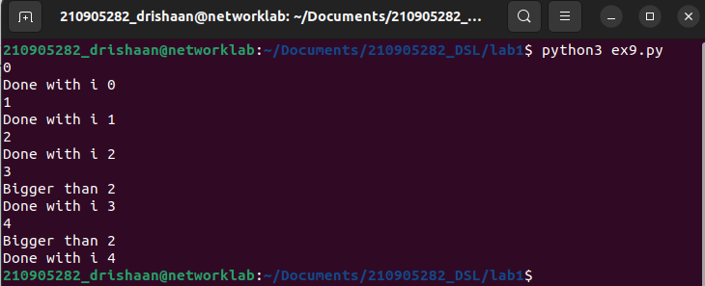
Ex4:
x=int(input('Enter a number:'))
for i in range(1,x+1):
if x%i ==0:
print(i)

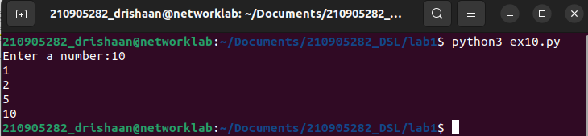
Ex5:
from math import *
x= [9, 41, 12, 3, 74, 15]
Largest=-inf
for i in x:
if i>Largest:
Largest=i
print(Largest)

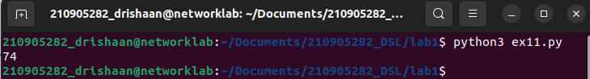
Ex6:
from math import *
x= [9, 41, 12, 3, 74, 15]
smallest=inf
for i in x:
if i<smallest:
smallest=i
print(smallest)

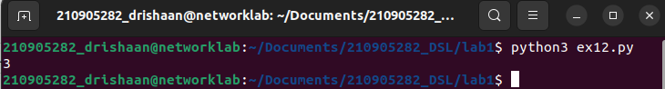
Ex7:
x= [9, 41, 12, 3, 74, 15]
count=sum=avg=0
for i in x:
count=count+1
sum=sum+i
avg=sum/count
print(count)
print(sum)
print(avg)

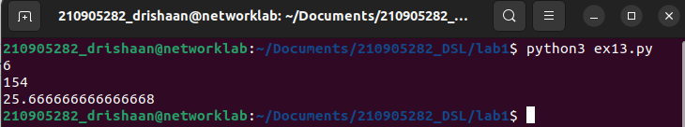
Ex8:
x= [9, 41, 12, 3, 74, 15]
for i in x:
if i>20:
print (i)

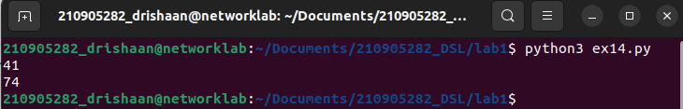
Ex9:
x= [9, 41, 12, 3, 74, 15]
res=[]
for i in x:
if i>20:
res.append(i)
print(res)

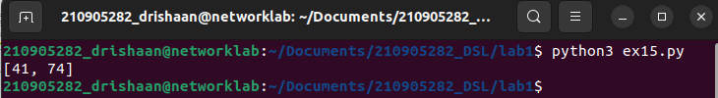
Ex10:
import numpy as np
x= [9, 41, 12, 3, 74, 15]
y=np.zeros(len(x))
for i in range(len(x)):
if x[i]>20:
y[i]=x[i]
print(y)

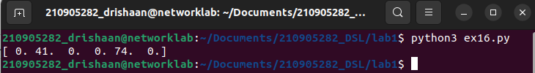
Ex11:
price = 100
if price > 100:
print("price is greater than 100")
elif price == 100:
print("price is 100")
elif price < 100:
print("price is less than 100")

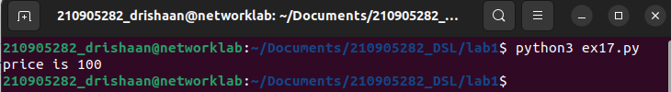
Ex12:
#program to display numbers from 1 to 5
# initialize the variable
i=1
n=5
# while loop from i = 1 to 5
while i <= n:
print(i)
i=i+1

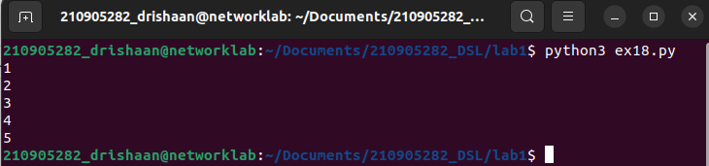
Ex13:
total = 0
number = int(input('Enter a number: '))
# add numbers until number is zero
while number != 0:
total += number # total = total + number
# take integer input again
number = int(input('Enter a number: '))
print('total =', total)

