DS LAB 4
SOLVED EXERCISES

Name: Drishaan Prasad
Registration No.: 210905282

1. Socket programming using connection-oriented approach.

Server code:
import socket
# Import socket module
host = '172.16.59.52' # Get local machine name
port = 1112# Reserve a port for your service.
s = socket.socket()# Create a socket object
s.bind((host, port))# Bind to the port
s.listen(5)
# Now wait for client connection.
conn, addr = s.accept()
# Establish connection with client.
print('Got connection from', addr[0], '(', addr[1], ')')
print('Thank you for connecting')
while True:
data = conn.recv(1024)
if not data:
break
conn.sendall(data)
print('Received message is sent back to client')
conn.close()
# Close the connection

Client code:
import socket
# Import socket module
host = '172.16.59.52' # Get local machine name
port = 1112# Reserve a port for your service.
s = socket.socket()# Create a socket object
s.connect((host, port))
s.sendall(b'Welcome user!')
print('Client is connected to server and it has sent the message to server')
data = s.recv(1024)
print('This is printing the message received back by the server')
print(repr(data))
s.close()
# Close the socket when done

Output:
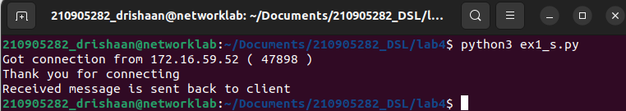
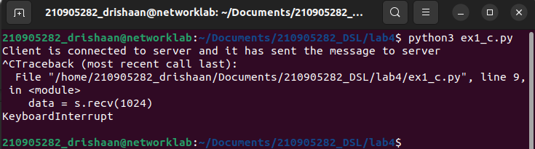
2. Socket programming using connection-less approach.

Server code:
import socket
sock = socket.socket(socket.AF_INET,socket.SOCK_DGRAM)
udp_host = '172.16.59.52'
udp_port = 12345
# For UDP
# Host IP
# specified port to connect
sock.bind((udp_host, udp_port))
while True:
print('Waiting for client...')
data,addr = sock.recvfrom(1024)
#receive data from client
print('Received Messages:',data.decode(),'from',addr)
sock.close()

Client code:
import socket
# Import socket module
sock = socket.socket(socket.AF_INET,socket.SOCK_DGRAM)
udp_host = '172.16.59.52' # Host IP
udp_port = 12345
# specified port to connect
msg = "UDP Program third time!"
print('UDP target IP:', udp_host)
print('UDP target Port:', udp_port)
sock.sendto(msg.encode(),(udp_host,udp_port))
sock.sendto(msg.encode(),(udp_host,udp_port))
sock.close()
Output:
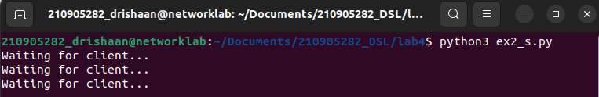
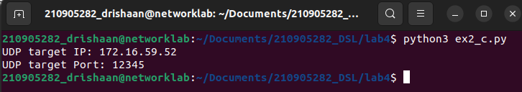
3. Write a TCP chat server in python using socket programming.

Server code:
import socket
HOST = '127.0.0.1' # Standard loopback interface address (localhost)
PORT = 31622 # Port to listen on (non-privileged ports are > 1023)
s = socket.socket()
s.bind((HOST, PORT))
s.listen()
print("\nWaiting for incoming connections...\n")
conn, addr = s.accept()
print("Received connection from ", addr[0], "(", addr[1], ")\n")
s_name = conn.recv(1024)
s_name = s_name.decode()
print(s_name, "has connected to the chat room\n")
print("Enter [e] to exit chat room\n")
name = input(str("Enter your name: "))
conn.send(name.encode())
while True:
message = input(str("Me : "))
if message == "[e]":
message = "Left chat room!"
conn.send(message.encode())
print("\n")
break
conn.send(message.encode())
message = conn.recv(1024)
message = message.decode()
print(s_name, ":", message)

Client code:
import socket
HOST = '127.0.0.1' # Standard loopback interface address (localhost)
PORT = 31622 # Port to listen on (non-privileged ports are > 1023)
s = socket.socket()
name = input(str("\nEnter your name: "))
print("\nTrying to connect to ", HOST, "(", PORT, ")\n")
s.connect((HOST, PORT))Forking/ Threading (Concurrent Server)
print("Connected...\n")
s.send(name.encode())Forking/ Threading (Concurrent Server)
s_name = s.recv(1024)
s_name = s_name.decode()
print(s_name, "has joined the chat room\n")
print("Enter [e] to exit chat room\n")
while True:
message = s.recv(1024)
message = message.decode()
print(s_name, ":", message)
message = input(str("Me : "))
if message == "[e]":
message = "Left chat room!"
s.send(message.encode())
print("\n")
break
s.send(message.encode())

Output:
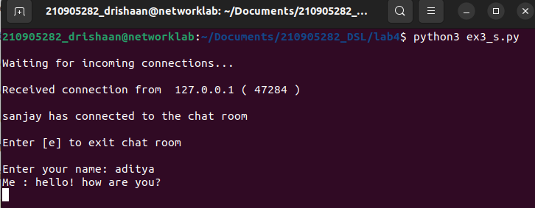
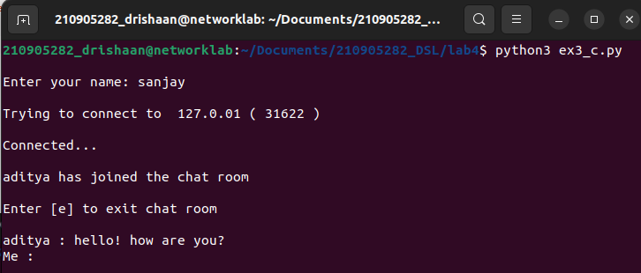

4. Forking/ Threading (Concurrent Server)

Server code:
import socket
from _thread import *
ServerSocket = socket.socket()
host = '172.16.59.52'
port = 11596
ThreadCount = 0
try:
ServerSocket.bind((host, port))
except socket.error as e:
print(str(e))
print('Waiting for a Connection..')
ServerSocket.listen(5)
def threaded_client(connection):
connection.send(str.encode('Welcome to the Server'))
while True:
data = connection.recv(2048)
print('Received from client :'
+ str(ThreadCount) +data.decode())
Inputs = input('Server Says: ')
if not data:
break
connection.sendall(Inputs.encode())
connection.close()
while True:
Client, address = ServerSocket.accept()
print('Connected to: ' + address[0] + ':' + str(address[1]))
start_new_thread(threaded_client, (Client, ))
ThreadCount += 1
print('Thread Number: ' + str(ThreadCount))
ServerSocket.close()

Client code:
import socket
ClientSocket = socket.socket()
host = '172.16.59.52'
port = 11596
print('Waiting for connection')
try:
ClientSocket.connect((host, port))
except socket.error as e:
print(str(e))
Response = ClientSocket.recv(1024)
while True:
Input = input('Client Say Something: ')
ClientSocket.send(str.encode(Input))
Response = ClientSocket.recv(1024)
print('From Server : ' + Response.decode())
ClientSocket.close()

Output:
