DS LAB 5
SOLVED EXERCISES

Name: Drishaan Prasad
Registration No.: 210905282

1. Wordcount program
#mapper.py
import sys
for line in sys.stdin:
line = line.strip()
words = line.split()
for word in words:
print("{}\t{}".format(word, 1))

#reducer.py
# sh command : echo "a a a a hh cc cc hh vh jr"|python3 mapper.py|sort|python3 reduce.py
from operator import itemgetter
import sys
current_word = None
current_count = 0
word = None
for line in sys.stdin:
line = line.strip()
word, count = line.split("\t", 1)
try:
count = int(count)
except ValueError:
print("Value Error Occured...")
continue
if current_word == word:
current_count += count
else:
if current_word:
print("{}\t{}".format(current_word, current_count))
current_count = count
current_word = word
if current_word == word:
print("{}\t{}".format(current_word, current_count))

Output:
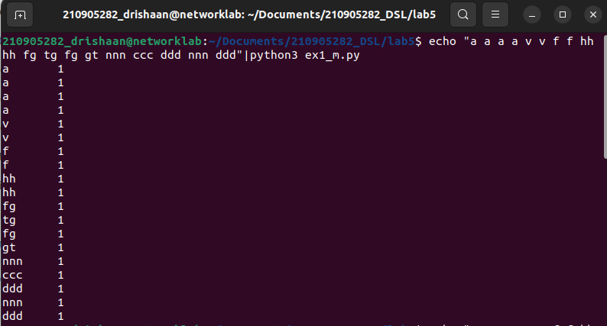
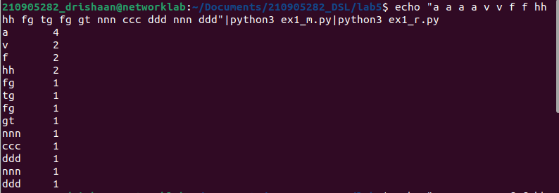

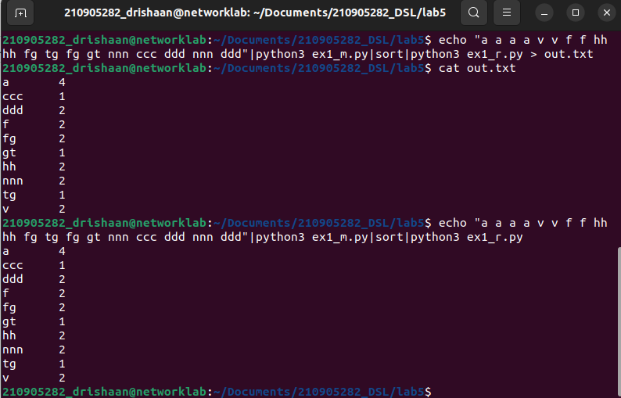
2. MapReduce program to find frequent words
#freqmap1.py
from __future__ import print_function
import sys
for line in sys.stdin:
L = [ (word.strip().lower(), 1) for word in line.strip().split() ]
for word, n in L:
print("{}\t{}".format(word, n))

#freqred1.py
from __future__ import print_function
import sys
lastWord = None
sum = 0
for line in sys.stdin:
word, count = line.strip().split('\t', 1)
count = int(count)
if lastWord == None:
lastWord = word
sum = count
continue
if word == lastWord:
sum += count
else:
print("{}\t{}".format(lastWord, sum))
sum = count
lastWord = word
# output last word
if lastWord == word:
print("{}\t{}".format(lastWord, sum))

#freqmap2.py
# echo "foo foo foo labs quux labs foo bar quux" | python3 freqmap1.py | sort | python3 freqred1.py | python3 freqmap2.py | sort | python3 freqred2.py
from __future__ import print_function
import sys
for line in sys.stdin:
word, count = line.strip().split('\t', 1)
count = int(count)
print("{}\t{}".format(word, count))

#freqred2.py
from __future__ import print_function
import sys
mostFreq = []
currentMax = -1
for line in sys.stdin:
word, count = line.strip().split('\t', 1)
count = int(count)
if count > currentMax:
currentMax = count
mostFreq = [ word ]
elif count == currentMax:
mostFreq.append(word)
for word in mostFreq:
print("{}\t{}".format(word, currentMax))

Output:
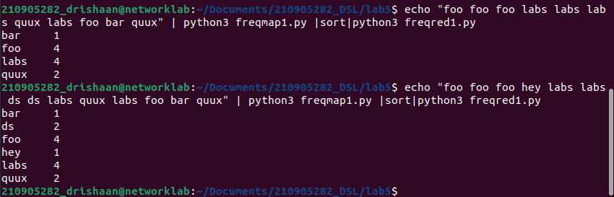
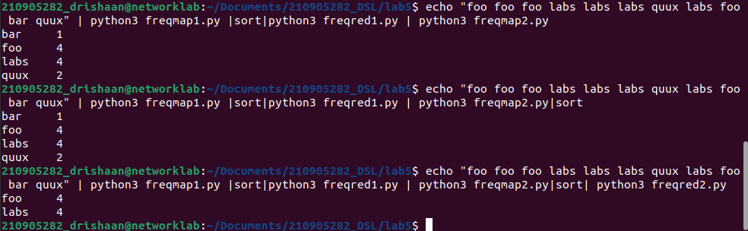
3. MapReduce program to explore the dataset and perform the filtering (typically
creating key/value pairs) by mapper and perform the count and summary
operation on the instances.
#itemmap.py
import fileinput
for line in fileinput.input():
data = line.strip().split("\t")
if len(data) == 6:
date, time, location, item, cost, payment = data
print("{}\t{}".format(payment, cost))

#itemred.py
import fileinput
transaction_count = 0
sales_total = 0
for line in fileinput.input():
data = line.strip().split("\t")
if len(data) != 2:
continue
current_key, current_value = data
transaction_count += 1
sales_total += float(current_value)
print("{}\t{}".format(transaction_count, sales_total))

Output:
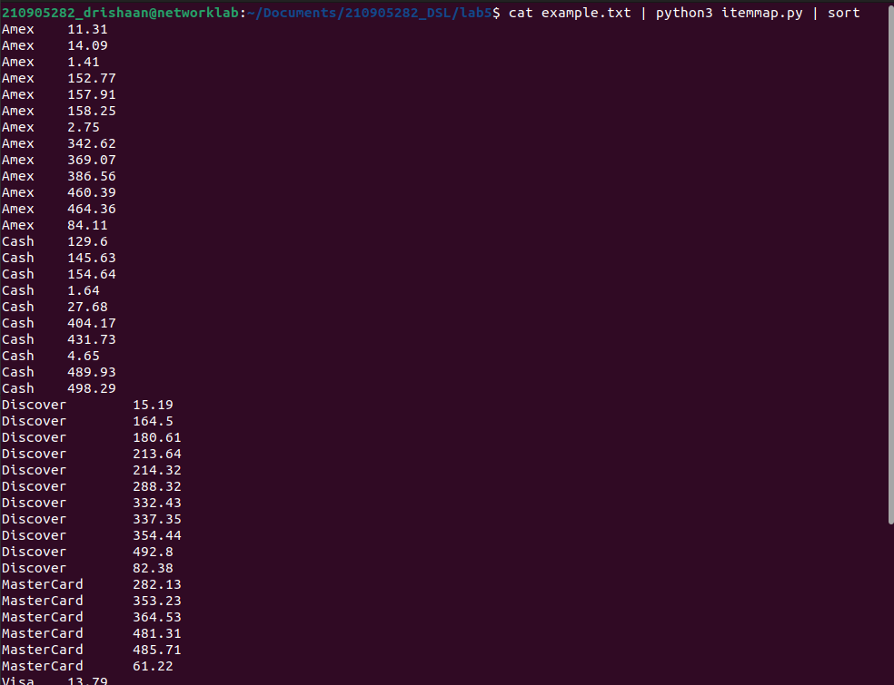
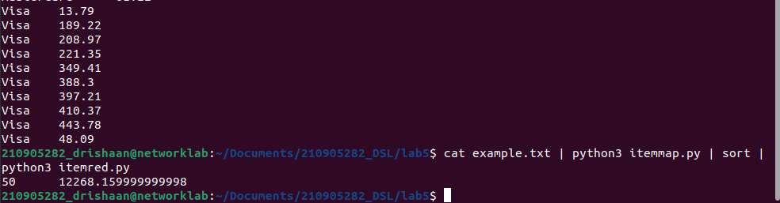

4. Write a mapper and reducer program for word count by defining separator
instead of using “\t”
#sepmap.py
#A more advanced Mapper, using Python iterators and generators
import sys
def read_input(file):
for line in file:
# split the line into words
yield line.split()
def main(separator='\t'):
# input comes from STDIN (standard input)
data = read_input(sys.stdin)
for words in data:
# write the results to STDOUT (standard output);
# what we output here will be the input for the
# Reduce step, i.e. the input for reducer.py
# tab-delimited; the trivial word count is 1
for word in words:
print('%s%s%d' % (word, separator, 1))
if __name__=="__main__":
main()

#sepred.py
#more advanced Reducer, using Python iterators and generators
from itertools import groupby
from operator import itemgetter
import sys
def read_mapper_output(file, separator='\t'):
for line in file:
yield line.rstrip().split(separator, 1)
def main(separator='\t'):
# input comes from STDIN (standard input)
data = read_mapper_output(sys.stdin, separator=separator)
# groupby groups multiple word-count pairs by word,
# and creates an iterator that returns consecutive keys and their group:
# current_word - string containing a word (the key)
# group - iterator yielding all ["&lt;current_word&gt;", "&lt;count&gt;"] items
for current_word, group in groupby(data, itemgetter(0)):
try:
total_count = sum(int(count) for current_word, count in group)
print ("%s%s%d" % (current_word, separator, total_count))
except ValueError:
# count was not a number, so silently discard this item
pass
if __name__=="__main__":
main()

Output:
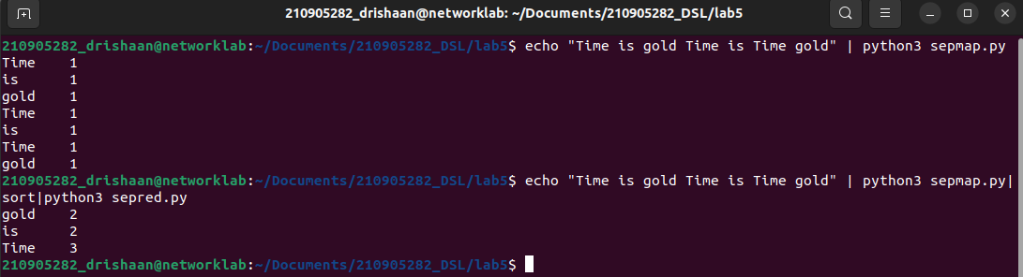
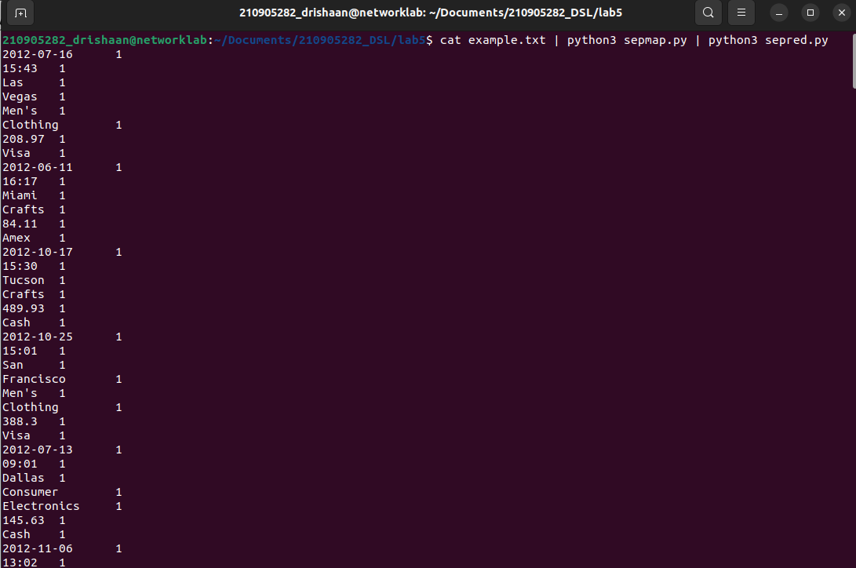
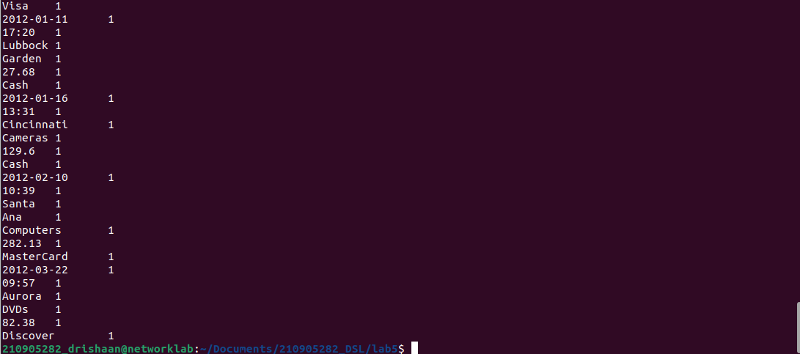

5. Write a map reduce program that returns the cost of the item that is most
expensive, for each location in the dataset example.txt

#costmap.py
import fileinput
for line in fileinput.input():
data = line.strip().split("\t")
if len(data) == 6:
date, time, location, item, cost, payment = data
print("{}\t{}".format(location, cost))

#costred.py
sh = '''
cat home/dir/eample.txt | python3 costmap.py | sort | python3 costred.py
'''
import fileinput
max_val = 0
old_key = None
for line in fileinput.input():
data = line.strip().split("\t")
if len(data) != 2:
continue
current_key, current_value = data
if old_key and (old_key != current_key):
print("{}\t{}".format(old_key, max_val))
old_key = current_key
max_val = 0
old_key = current_key
if float(current_value) > float(max_val):
max_val = float(current_value)
if old_key != None:
print("{}\t{}".format(old_key, max_val))

Output:
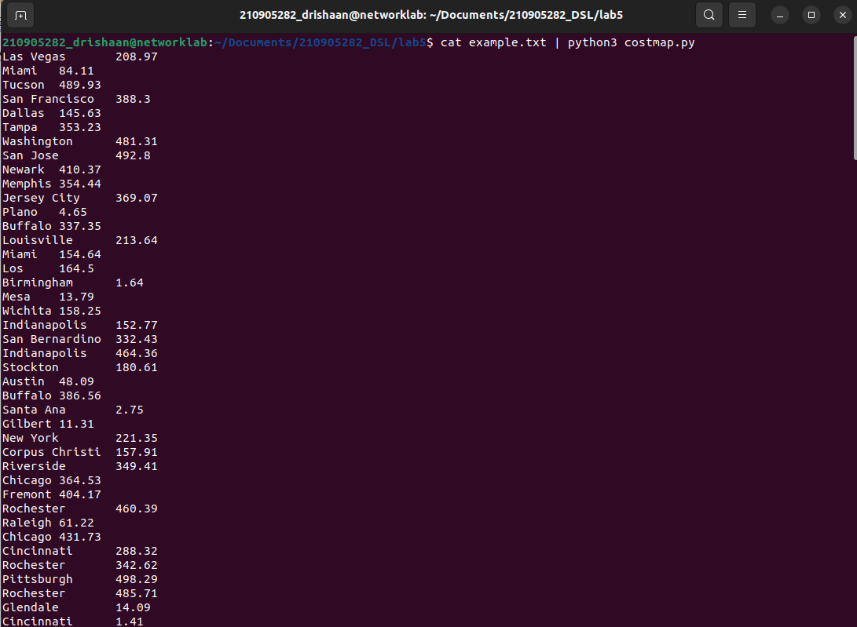
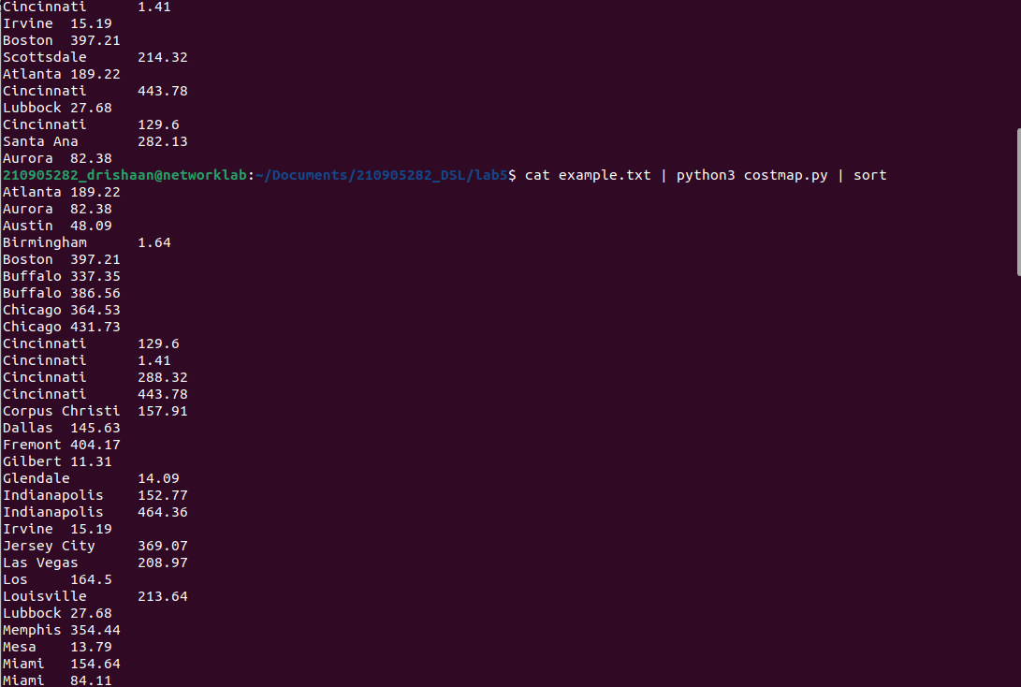

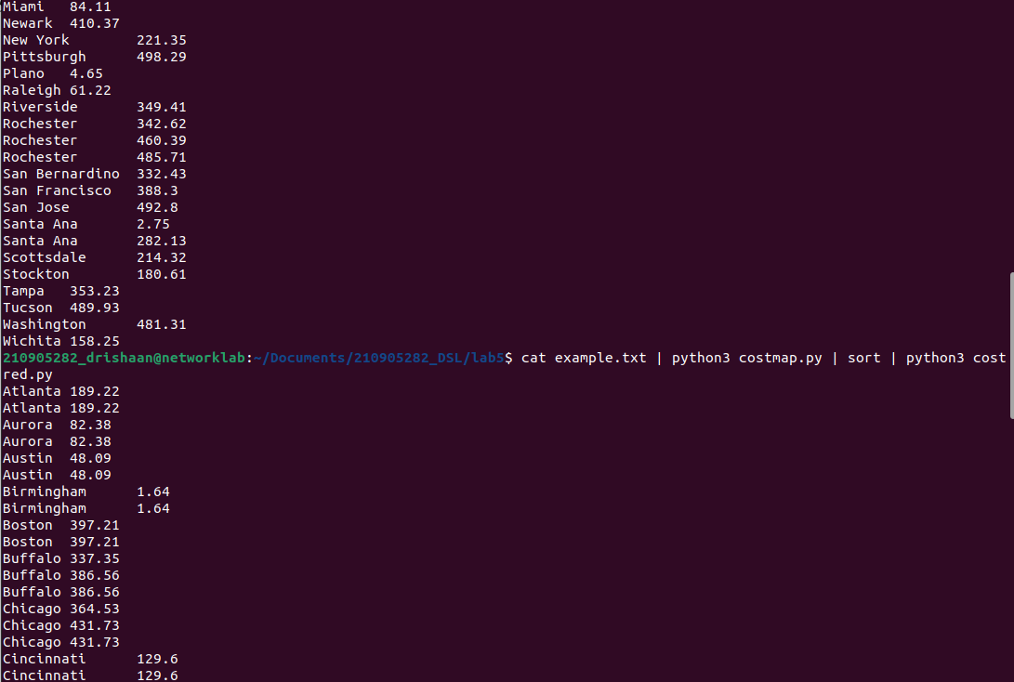
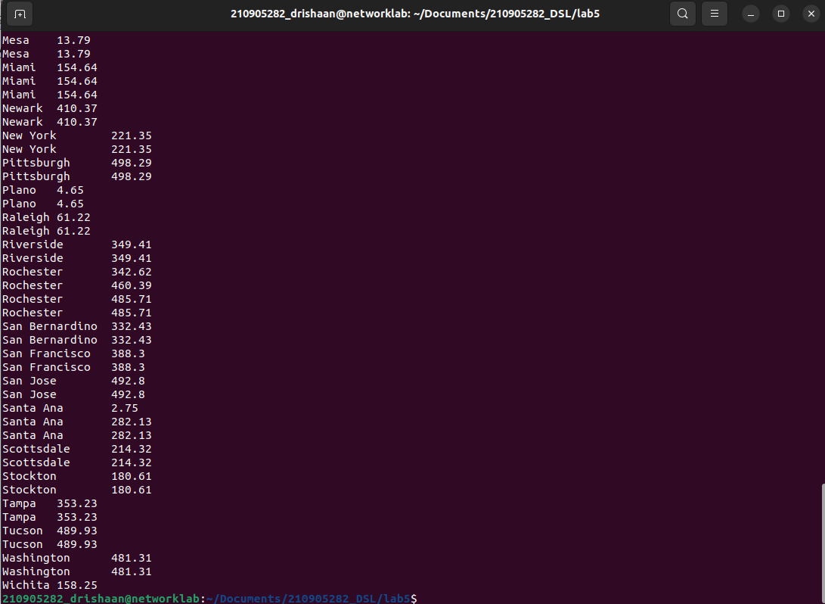

6. Write a mapreduce program to evaluate the PI.
#mapper_pi.py
import sys
def f(x):
return 4 / (1 + x**2)
for line in sys.stdin:
words = line.strip().split()
N = int(words[0])
deltaX = (1.0 / N)
for i in range(N):
print("1\t%1.10f" % ( f(i * deltaX) * deltaX ) )

#reducer_pi.py
from __future__ import print_function
from operator import itemgetter
import sys
sum = 0
for line in sys.stdin:
line = line.strip()
word, count = line.split('\t', 1)
try:
count = float(count)
except ValueError:
continue
sum += count
print("%1.10f\t0" %(sum))

Output:
