Matter Is Everywhere
  - Grade 3 Unit 1 • Chapter 1 • Matter Materials and Making
Learning goal I can explain that matter has mass and takes up space, and I can identify solids, liquids and gases.
Your mitten, the snow on the playground and the air inside a bicycle tire are all made of matter.

How do we know matter is there?
Matter is the stuff that makes up everything around us. A desk is matter. Water is matter. Even air is matter, although we cannot usually see it.
Scientists use two clues to decide whether something is matter. Matter has mass, and matter takes up space. Blow air into a balloon and the balloon grows. The invisible air needs room, so it pushes against the balloon.
Light and sound are not matter. They carry energy, but they do not have mass or take up space in the same way objects and substances do.
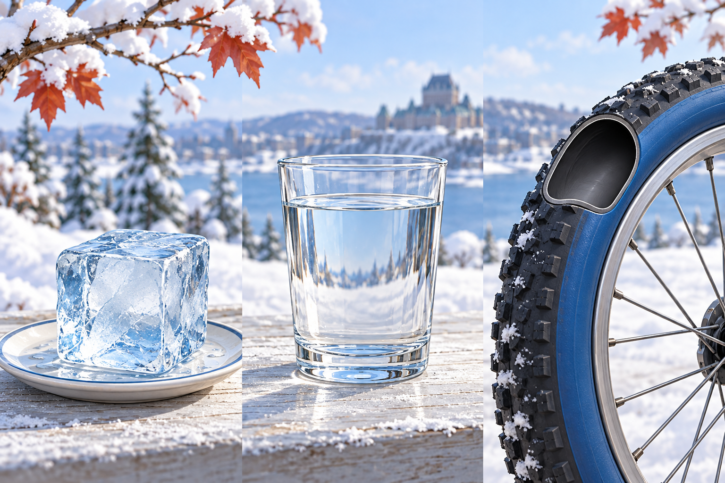
Ice is solid, water in the glass is liquid, and the tire contains invisible gas.

Three familiar states
A solid keeps its own shape. An ice cube stays cube-shaped when you place it on a plate.
A liquid flows and takes the shape of its container. Maple sap can be poured from a pail into a pan.
A gas spreads out in every direction. Air fills a classroom, a bicycle tire or a balloon.
The same substance can sometimes be found in different states. On a cold Québec morning, water may be solid ice on a pond, liquid under the ice and invisible water vapour in the air.

Stop and think
Look around your room. Name one solid, one liquid and one gas. What evidence shows that each one is matter?

What to remember
- Matter has mass and takes up space.
- Solids keep their shape; liquids flow; gases spread out.
- Water can be a solid, liquid or gas.

Check your understanding
Explain aloud, sketch, or write. Use ideas and examples from the chapter as evidence.
1 A classmate says air cannot be matter because we cannot see it. How could a balloon help you explain your thinking?
My thinking
2 You pour the same water from a tall glass into a wide bowl. What changes, and what stays the same?
My thinking
3 Ice and liquid water can be in the same Québec pond. How can they be the same substance but behave differently?
My thinking

Practise the words
Cover the meanings and explain each word. Then cover the words and name each meaning. Give an example.
matter anything that has mass and takes up space
mass the amount of matter in an object or substance
state a form that matter can take
solid matter with its own shape
liquid matter that flows and takes the shape of its container
gas matter that spreads out to fill its container
Adapted from Core Knowledge Foundation science materials. CC BY NC SA 4.0. Generated illustrations accompany this adaptation.

