Property Detectives
  - Grade 3 Unit 1 • Chapter 2 • Matter Materials and Making
Learning goal I can use shape, colour, texture and other observable properties to describe and compare materials.
Scientists observe carefully. They use precise property words so another person can recognize the same material.

Describe what you observe
A property is a characteristic of matter. Colour, shape and texture are properties you can observe.
A classroom object might be smooth, rough, bumpy or fuzzy. It might be shiny or dull, flexible or stiff, transparent or opaque.
Scientists choose safe ways to observe. They do not taste an unknown material. They may use a hand lens, a ruler or a simple test instead.
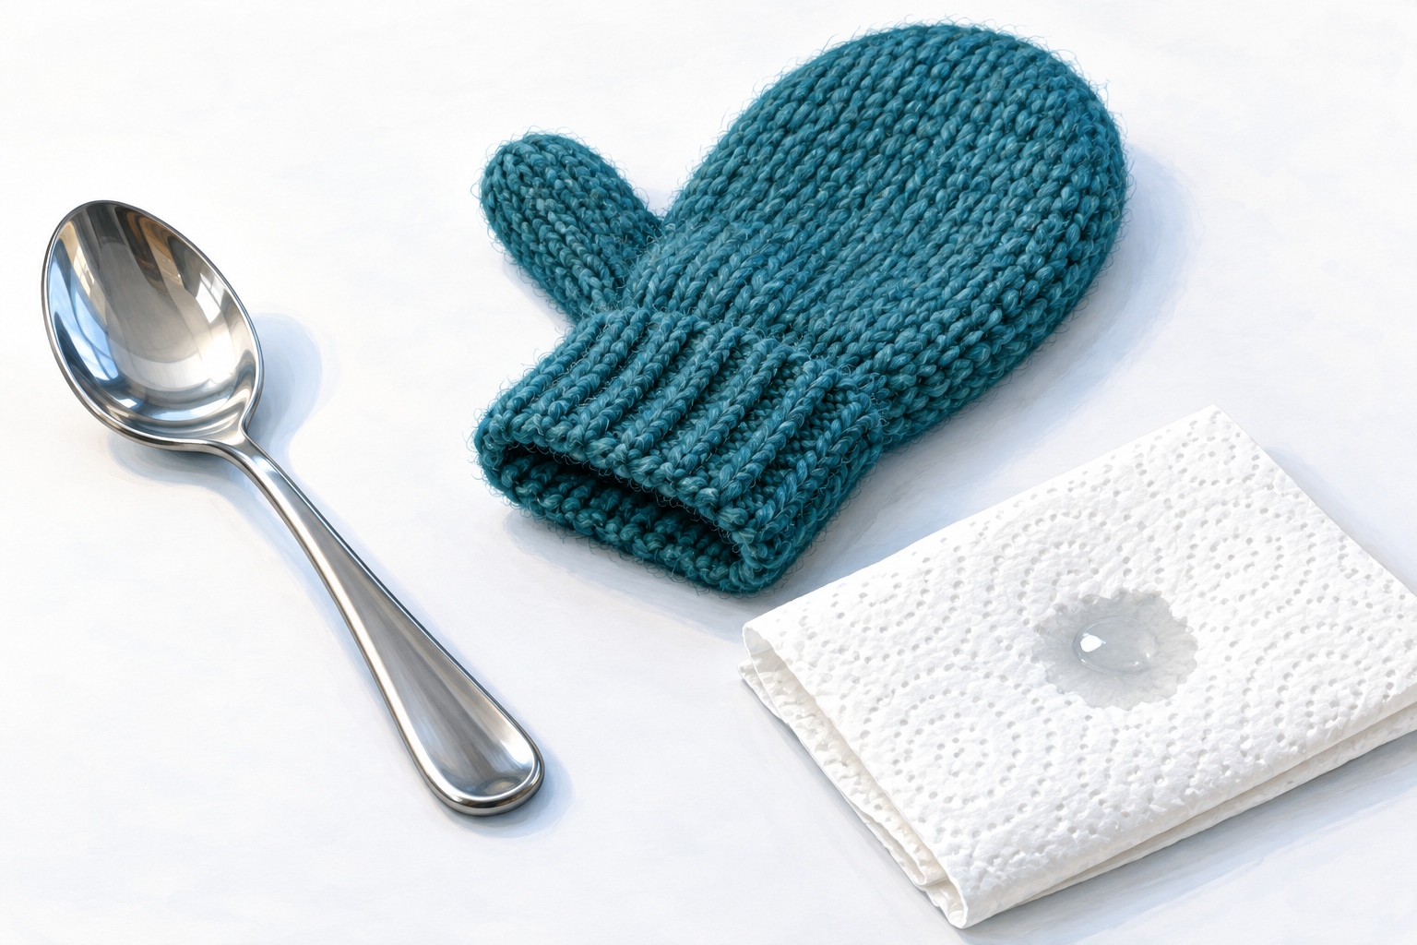
Compare the surfaces. Each material has properties that make it useful for different jobs.

Properties help us choose materials
A material's properties can make it useful for one job and poor for another. A classroom window is made from transparent material because people need to see through it.
Winter boots need a waterproof outer layer and a warm inner layer. A paper towel is useful because it is soft and absorbent.
Engineers compare properties before choosing materials. They ask what the object must do, then look for matter with the right combination of properties.

Stop and think
Compare a metal spoon and a wooden craft stick. Use at least four property words. Which would be better for stirring hot soup, and why?

What to remember
- Properties describe matter.
- Useful property words are specific and observable.
- Engineers match material properties to a purpose.

Check your understanding
Explain aloud, sketch, or write. Use ideas and examples from the chapter as evidence.
1 Could a paper towel make a useful raincoat? Use two properties to explain your answer.
My thinking
2 A clear plastic sheet and a wool mitten are both flexible. Why would one work better for a window and the other for a winter hand covering?
My thinking
3 How could you find out which of two paper towels is more absorbent?
My thinking

Practise the words
Cover the meanings and explain each word. Then cover the words and name each meaning. Give an example.
property a characteristic used to describe or identify matter
texture how a surface feels or appears to feel
transparent allowing light to pass through clearly
flexible able to bend without breaking
absorbent able to soak up liquid
Adapted from Core Knowledge Foundation science materials. CC BY NC SA 4.0. Generated illustrations accompany this adaptation.

