Measuring Matter
  - Grade 3 Unit 1 • Chapter 3 • Matter Materials and Making
Learning goal I can distinguish mass from weight and choose metric tools for measuring mass and volume.
Observation tells us what matter is like. Measurement gives us numbers that make comparisons clearer.

Mass and weight are related, but different
Mass tells how much matter an object contains. In class, we measure small masses in grams and larger masses in kilograms.
A balance compares mass. Many classroom scales display a mass in grams or kilograms.
Weight is a force caused by gravity pulling on mass. Your mass would stay the same on the Moon, but your weight would be less because the Moon's gravity is weaker.
In everyday speech, people often use mass and weight as if they mean the same thing. In science, keeping the meanings separate helps us explain measurements accurately.
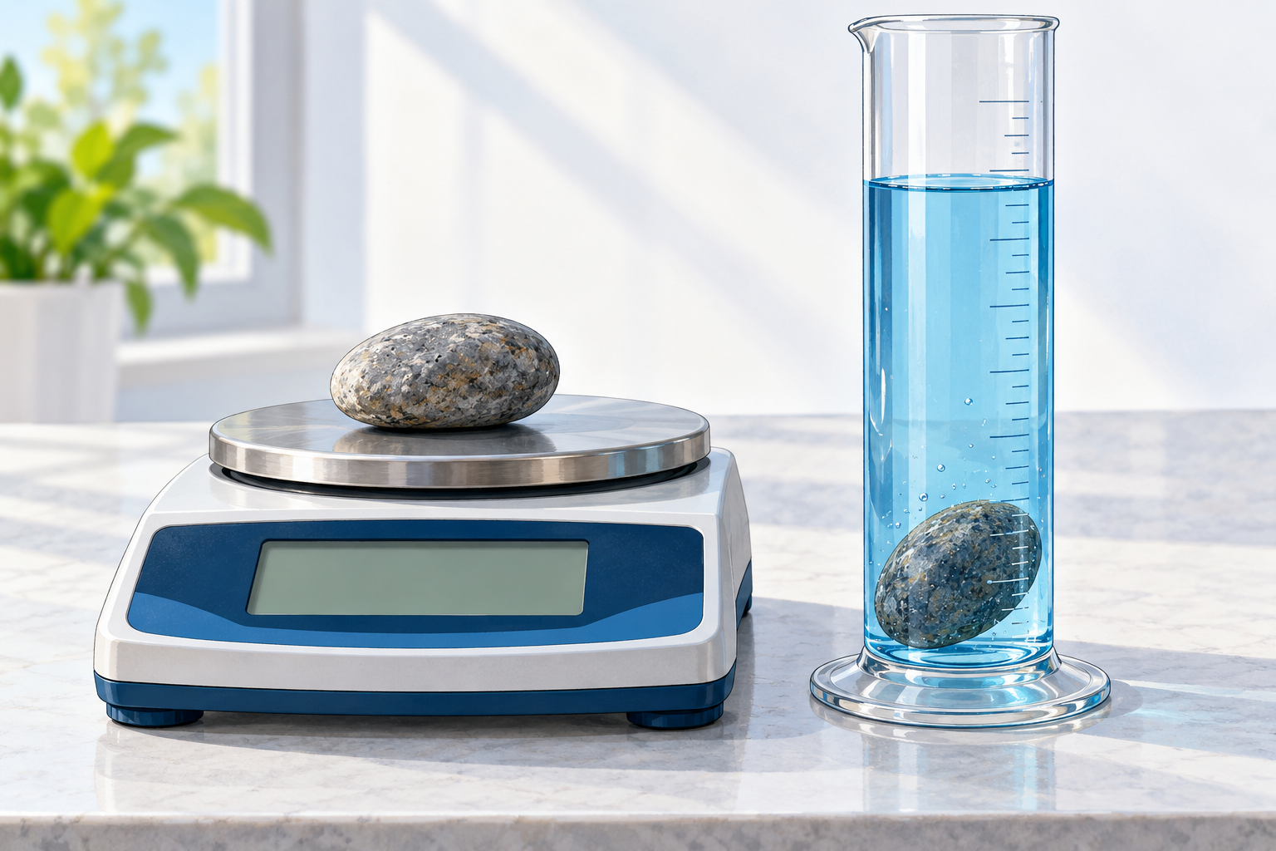
A balance measures mass. A rise in water level can help measure the volume of an irregular object.

Volume measures space
Volume tells how much space matter takes up. A graduated cylinder measures liquid volume in millilitres.
A millilitre is the same amount of space as one cubic centimetre. That link helps when we compare solid objects and liquids.
Two objects can have the same volume but different masses. A block of wood and an equal-sized block of metal take up the same space, but the metal usually contains more mass.

Stop and think
Imagine two sealed boxes that are the same size. One has a mass of 200 g and one has a mass of 800 g. What is the same? What is different?

What to remember
- Mass is the amount of matter; weight is gravity's force on that matter.
- Grams and kilograms measure mass.
- Millilitres and cubic centimetres measure volume.

Check your understanding
Explain aloud, sketch, or write. Use ideas and examples from the chapter as evidence.
1 A large empty box has less mass than a small stone. Why is that possible?
My thinking
2 Two containers have different shapes. How could you decide whether they hold the same volume of water?
My thinking
3 A stone raises the water level in a measuring cylinder. What does that rise tell us, and why?
My thinking

Practise the words
Cover the meanings and explain each word. Then cover the words and name each meaning. Give an example.
mass the amount of matter in an object or substance
weight the force of gravity pulling on an object's mass
volume the amount of space matter takes up
gram a metric unit used to measure mass
millilitre a metric unit used to measure liquid volume
Adapted from Core Knowledge Foundation science materials. CC BY NC SA 4.0. Generated illustrations accompany this adaptation.

