Why Things Float or Sink
  - Grade 3 Unit 1 • Chapter 4 • Matter Materials and Making
Learning goal I can compare density and use relative density to explain why an object floats or sinks in water.
A huge ship can float while a small metal bolt sinks. Size alone cannot explain what happens.

Density compares mass and volume
Density tells how tightly matter is packed. To compare density fairly, scientists can compare equal volumes.
Imagine two cubes that are exactly the same size. If one cube has more mass, it is denser.
Scientists can also compare equal masses. If the same mass is squeezed into a smaller volume, that sample is denser.
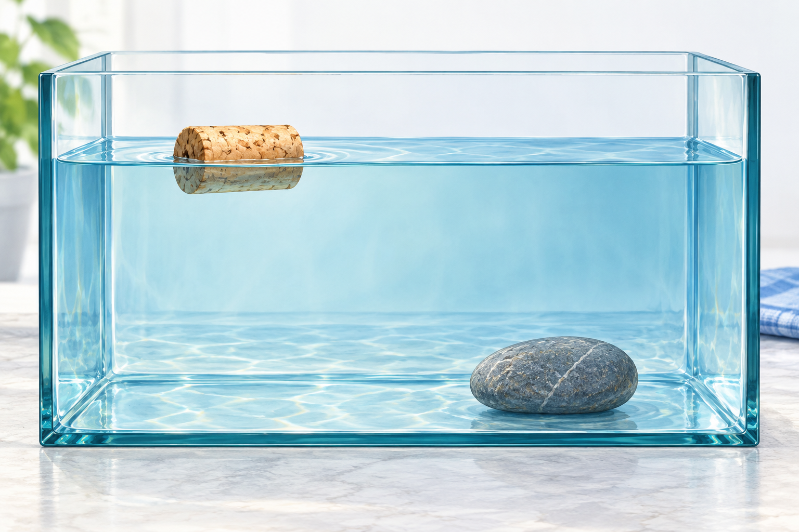
The cork is less dense than water; the pebble is denser. Water pushes upward on both.

Floating is a comparison
Water pushes upward on objects placed in it. This upward force is called buoyancy.
An object floats when its overall density is less than the density of the liquid around it. It sinks when its overall density is greater.
A steel ship contains large spaces filled with air. Steel and air together give the whole ship a lower average density than a solid block of steel.
Ships travel along the St. Lawrence River because their shape helps them displace enough water. Cargo must be loaded carefully so the ship stays balanced and buoyant.
Ice is less dense than liquid water, so ice floats. That is why winter ice can form at the surface of a Québec lake while liquid water remains underneath.

Stop and think
A ball of modelling clay sinks. How could you reshape the same clay so it might float? What would change: its mass, its volume or both?

What to remember
- Density compares mass with volume.
- Water exerts an upward buoyant force.
- Relative density helps explain floating and sinking.

Check your understanding
Explain aloud, sketch, or write. Use ideas and examples from the chapter as evidence.
1 Two solid cubes have exactly the same volume. One has more mass. Which is denser, and how do you know?
My thinking
2 A ball of modelling clay sinks. The same clay shaped into a wide hollow boat may float. How can changing its shape change the result?
My thinking
3 A classmate says only small things float. What example and explanation could you give?
My thinking

Practise the words
Cover the meanings and explain each word. Then cover the words and name each meaning. Give an example.
density how much mass is packed into a certain volume
buoyancy the upward force a fluid exerts on an object
relative compared with something else
float to remain at or near a fluid's surface
sink to move downward through a fluid
Adapted from Core Knowledge Foundation science materials. CC BY NC SA 4.0. Generated illustrations accompany this adaptation.

