Same Matter, New Form
  - Grade 3 Unit 1 • Chapter 5 • Matter Materials and Making
Learning goal I can identify a physical change and explain that the matter keeps its identity.
Matter can be cut, bent, melted, frozen or dissolved. A new form does not always mean a new substance.

Physical changes affect form
Tearing paper changes its size and shape, but each piece is still paper. Bending a metal paper clip changes its shape, but it is still metal.
Changes of state are physical changes too. When snow melts on a warm boot, solid water becomes liquid water.
Freezing reverses that change. Water in a puddle may become solid ice when the temperature falls below 0 °C.
Not every physical change is easy to reverse. A crushed can is still aluminum, but returning it to its exact old shape would be difficult.
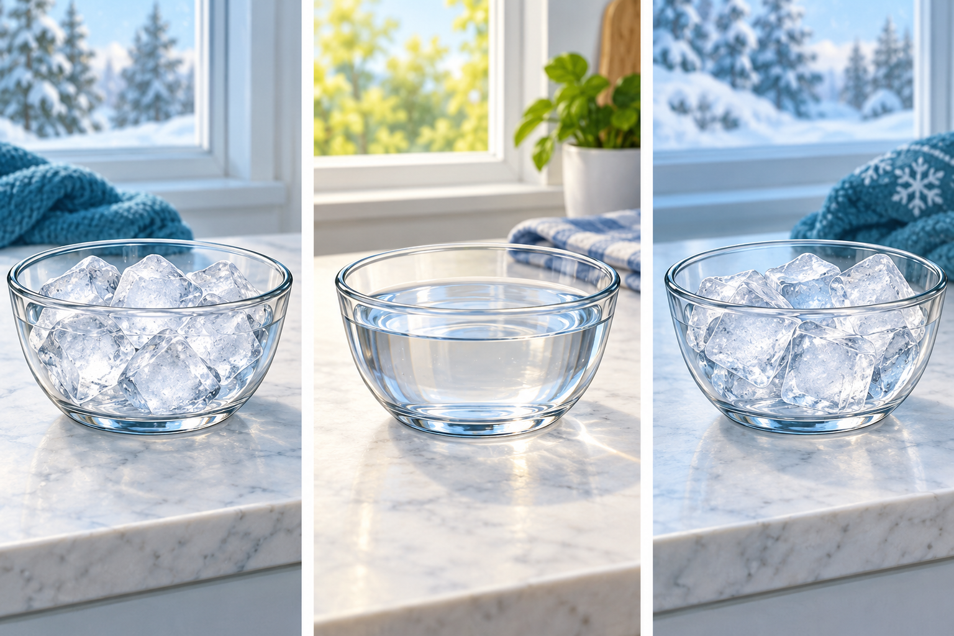
Melting and freezing change the state of water. The substance remains water.

Where did the salt go?
Road salt can dissolve in melted snow. The salt seems to disappear because its tiny particles spread evenly through the water.
The salt has not stopped being matter. If the water evaporates, solid salt can remain behind.
A clue to a physical change is that the substance keeps its identity. If a process creates a new substance with new properties, scientists call it a chemical change instead.

Stop and think
Classify each change: melting an ice cube, cutting cardboard, rusting a bicycle chain. Which are physical changes?

What to remember
- A physical change affects form, size or state.
- The substance keeps its identity during a physical change.
- Some physical changes are reversible and some are not easy to reverse.

Check your understanding
Explain aloud, sketch, or write. Use ideas and examples from the chapter as evidence.
1 An ice cube melts into a puddle. What evidence helps you decide whether a new substance has been made?
My thinking
2 Salt seems to disappear in water. What do you predict will remain if all the water evaporates? Explain.
My thinking
3 Torn paper is hard to put back exactly as it was. Does that mean tearing is a chemical change?
My thinking

Practise the words
Cover the meanings and explain each word. Then cover the words and name each meaning. Give an example.
physical change a change in form, size or state that does not make a new substance
melt to change from a solid to a liquid
freeze to change from a liquid to a solid
dissolve to mix evenly into a liquid
reversible able to change back to an earlier form
Adapted from Core Knowledge Foundation science materials. CC BY NC SA 4.0. Generated illustrations accompany this adaptation.

