From Materials to Useful Products
  - Grade 3 Unit 1 • Chapter 6 • Matter Materials and Making
Learning goal I can describe how familiar materials are changed and combined to make paper and soap.
The notebook on your desk and the soap by the sink both began as raw materials. Manufacturing turns materials into useful products.

How paper is made
Much of the paper used in Québec begins with wood fibre or recycled paper. Trees used for fibre are cut into logs and taken to a mill.
At the mill, bark is removed and the wood is cut into small chips. The chips are softened and separated into fibres to make wet pulp.
The pulp is cleaned and spread in a thin layer on a moving screen. Water drains away, and rollers press out more water.
Heated rollers dry and smooth the sheet. Large rolls of paper can then be cut into notebook pages, boxes or other products.
Recycled paper follows a similar path. It is mixed with water, cleaned and made into new pulp. Using recovered fibre can reduce the amount of new wood and waste needed for some products.
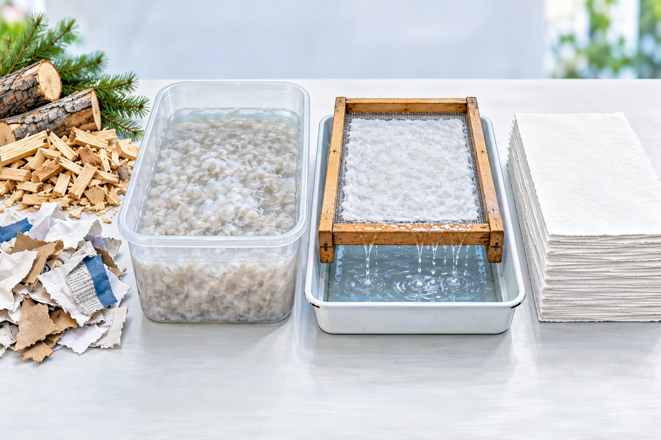
This simplified small-scale process shows fibres becoming pulp, then being formed and dried into paper.

How soap is made
Soap is manufactured from oils or fats and another carefully controlled material called a strong base. In a factory, these materials react and become soap and glycerin.
Workers measure the ingredients, temperature and time. They test the product to make sure it is safe and works as expected.
Making soap with a strong base is not a classroom activity. The materials can cause burns before the reaction is complete, so trained adults use protective equipment and controlled equipment.
Manufacturing changes matter in planned steps. Some steps are physical changes, such as cutting and pressing paper. Other steps can be chemical changes that create new substances, as in soap making.

Designing with responsibility
Manufacturers choose materials for their properties, cost and environmental effects. A package must protect its contents, but it should not use more material than needed.
Québec communities collect paper and cardboard for recycling. Sorting clean paper correctly helps the fibres return to the manufacturing cycle.
A good design works well and uses matter responsibly. That can mean making a product durable, repairable, reusable or recyclable.

Stop and think
Trace a sheet of used classroom paper. What steps could turn it into a new paper product? Where are properties important?

What to remember
- Manufacturing uses planned steps to turn raw materials into products.
- Paper is made by forming, pressing and drying plant fibres.
- Responsible design considers both useful properties and environmental effects.

Check your understanding
Explain aloud, sketch, or write. Use ideas and examples from the chapter as evidence.
1 Why must water be removed from pulp before it becomes a useful notebook page?
My thinking
2 Why might a manufacturer choose recovered paper for a new box? What would still need to be tested?
My thinking
3 Pressing paper pulp and making soap both change materials. How are the changes different?
My thinking

Practise the words
Cover the meanings and explain each word. Then cover the words and name each meaning. Give an example.
raw material matter used to make a product
manufacture to make a product using tools, machines and planned steps
pulp a wet mixture of small plant fibres used to make paper
fibre a long, thin strand of material
recycle to process used material so it can be used again
Adapted from Core Knowledge Foundation science materials. CC BY NC SA 4.0. Generated illustrations accompany this adaptation.

