Energy Has Many Forms
  - Grade 3 Unit 2 • Chapter 1
Learning goal I can distinguish an energy form from its source.
A school bus moves, a lamp shines and a bell rings. These changes involve energy.

Look for a change
Mechanical energy is linked to motion and position. Electrical energy involves electric charges. Light travels from a source. Sound comes from vibrations. Thermal energy is linked to the motion of tiny particles in matter.
Food and batteries store chemical energy. Nuclear energy is stored in the centres of atoms. We do not see energy itself; we observe its effects.
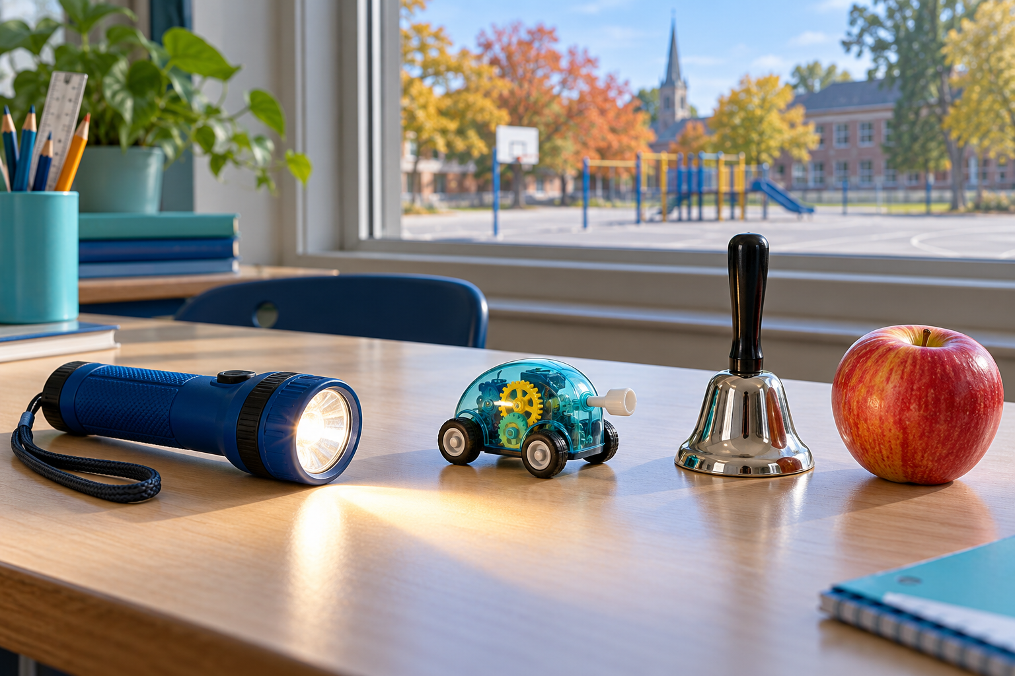
A lit flashlight, a small mechanical toy, a handbell and an apple on a classroom table. Energy can take several forms, including motion, light, sound and chemical energy. Generated contextual illustration; not a scale model.

Forms are not sources
The Sun is a source of light and thermal energy. A battery supplies energy to a flashlight. Moving water can turn a turbine.
A source tells us where the energy comes from. A form tells us how the energy is involved. One source can supply energy that changes into several forms. In Québec, moving water is an important source used to generate electricity.

What to remember
- Energy can take several forms, including motion, light, sound and chemical energy.
- An energy source supplies energy; an energy form describes how it is involved.

Check your understanding
Explain aloud, sketch, or write. Use evidence from the chapter.
1 Is a battery an energy form or a source? Explain.
My thinking
2 How can one lamp show more than one energy form?
My thinking

Practise the words
Cover the meanings and explain the words. Then cover the words and name the meanings. Give an example.
energy the ability to cause change
source where something comes from
mechanical energy energy of motion or position
chemical energy energy stored in substances

Lesson connection
Lesson 1 · Forms and sources
Original adaptation informed by Core Knowledge Foundation science materials including Energy Transfer and Transformation, Exploring Light and Sound. Shared under CC BY NC SA 4.0. Generated contextual illustration.

