Finding Evidence of Energy
  - Grade 3 Unit 2 • Chapter 2
Learning goal I can use an observed change as evidence of energy transfer.
Imagine watching a hockey puck slide across an outdoor rink. What changes could you observe?

Changes give us clues
A moving stick transfers energy to the puck when they collide. The puck changes speed. Friction between the puck and ice gradually slows it. Some energy spreads into the surroundings as thermal energy.
A drum gives another clue. Its surface vibrates when struck. Nearby air vibrates too, and sound travels to a listener.
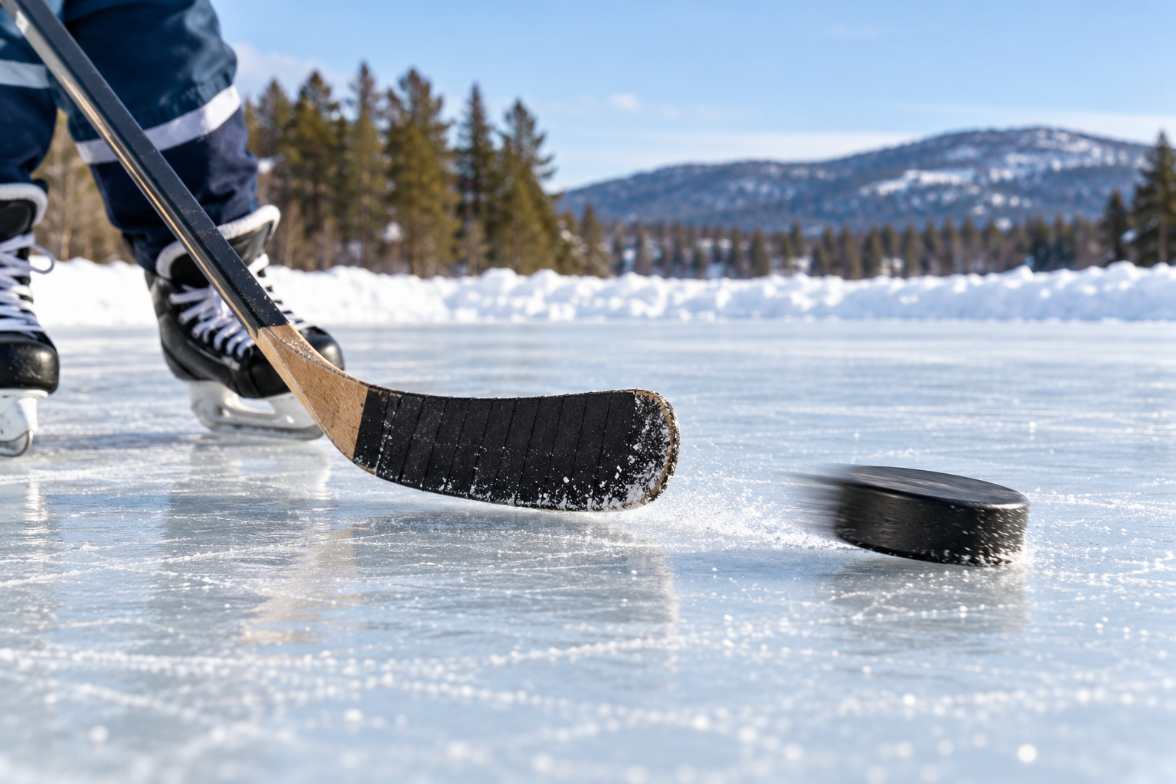
A hockey stick and puck on an outdoor ice rink. Changes in motion, shape, sound or temperature can provide evidence of energy transfer. Generated contextual illustration; not a scale model.

Make an explanation
Good evidence is more precise than saying that something happened. Describe the object, the change and what caused it.
Compare the same toy car after gentle and stronger pushes. Start from the same place on the same surface. A change in travel distance can help you compare the effects of the pushes.
Do not assume an object has no energy because it is still. A stretched elastic stores energy that can later cause motion.

What to remember
- Changes in motion, shape, sound or temperature can provide evidence of energy transfer.
- Still objects can store energy that later causes a change.

Check your understanding
Explain aloud, sketch, or write. Use evidence from the chapter.
1 Why is a moving puck evidence of an energy transfer?
My thinking
2 Does an unmoving stretched elastic have energy? Explain.
My thinking

Practise the words
Cover the meanings and explain the words. Then cover the words and name the meanings. Give an example.
evidence observations that support an explanation
transfer movement from one object or place to another
vibration a repeated back and forth movement

Lesson connection
Lesson 2 · Evidence of energy
Original adaptation informed by Core Knowledge Foundation science materials including Energy Transfer and Transformation, Exploring Light and Sound. Shared under CC BY NC SA 4.0. Generated contextual illustration.

