What Makes Sounds Different
  - Grade 3 Unit 2 • Chapter 3
Learning goal I can explain volume, timbre and echo using vibrations.
A violin and a drum can play equally loud sounds, yet we can tell them apart.

Vibrations reach our ears
A vibrating object makes nearby matter vibrate. Sound travels through air, water and solids. Stronger vibrations usually produce greater volume. Keep classroom sounds comfortable; louder is not always better.
Timbre is a sound’s distinctive quality. Different instruments make different combinations of vibrations, even when they play the same musical note.
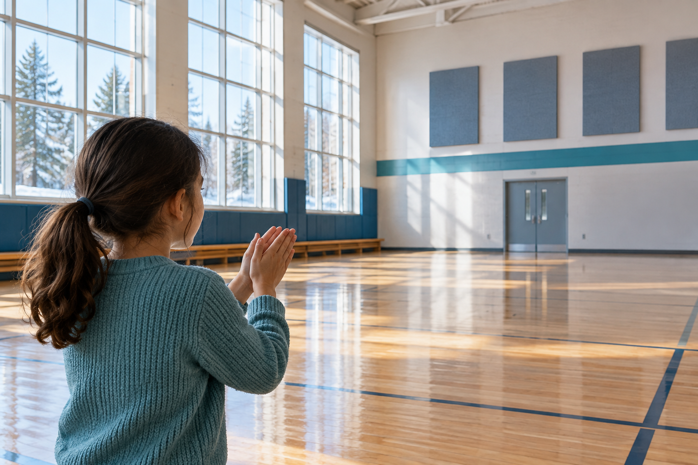
A student clapping in a large gym with hard surfaces and acoustic panels. Sound travels through matter as vibrations. Generated contextual illustration; not a scale model.

Sound can reflect
In a large empty gym, a clap may return as an echo. Sound travels to a surface, reflects and returns to our ears. Soft materials can absorb some sound instead of reflecting it strongly.
A carpeted classroom may sound quieter than a room with hard bare walls. The materials affect how sound travels and reflects. Comparing spaces helps us explain what we hear.

What to remember
- Sound travels through matter as vibrations.
- Volume, timbre and reflection help explain differences between sounds.

Check your understanding
Explain aloud, sketch, or write. Use evidence from the chapter.
1 Why can two equally loud instruments still sound different?
My thinking
2 Why might curtains reduce echoes in a classroom?
My thinking

Practise the words
Cover the meanings and explain the words. Then cover the words and name the meanings. Give an example.
sound energy carried by vibrations through matter
volume how loud or quiet a sound seems
timbre the quality that distinguishes sounds
echo a reflected sound heard again

Lesson connection
Lesson 3 · Sound
Original adaptation informed by Core Knowledge Foundation science materials including Energy Transfer and Transformation, Exploring Light and Sound. Shared under CC BY NC SA 4.0. Generated contextual illustration.

