Warm Matter on the Move
  - Grade 3 Unit 2 • Chapter 5
Learning goal I can explain how convection transfers thermal energy in liquids and gases.
Near a warm classroom radiator, the air begins to move even when no fan is running.

Movement carries energy
When air is warmed, it usually expands and becomes less dense than the cooler air nearby. The warmer air rises. Cooler, denser air moves down to replace it. This movement is convection.
Convection also happens in liquids. In a pot warmed from below, warmer water rises and cooler water moves down. Moving water carries thermal energy through the pot.
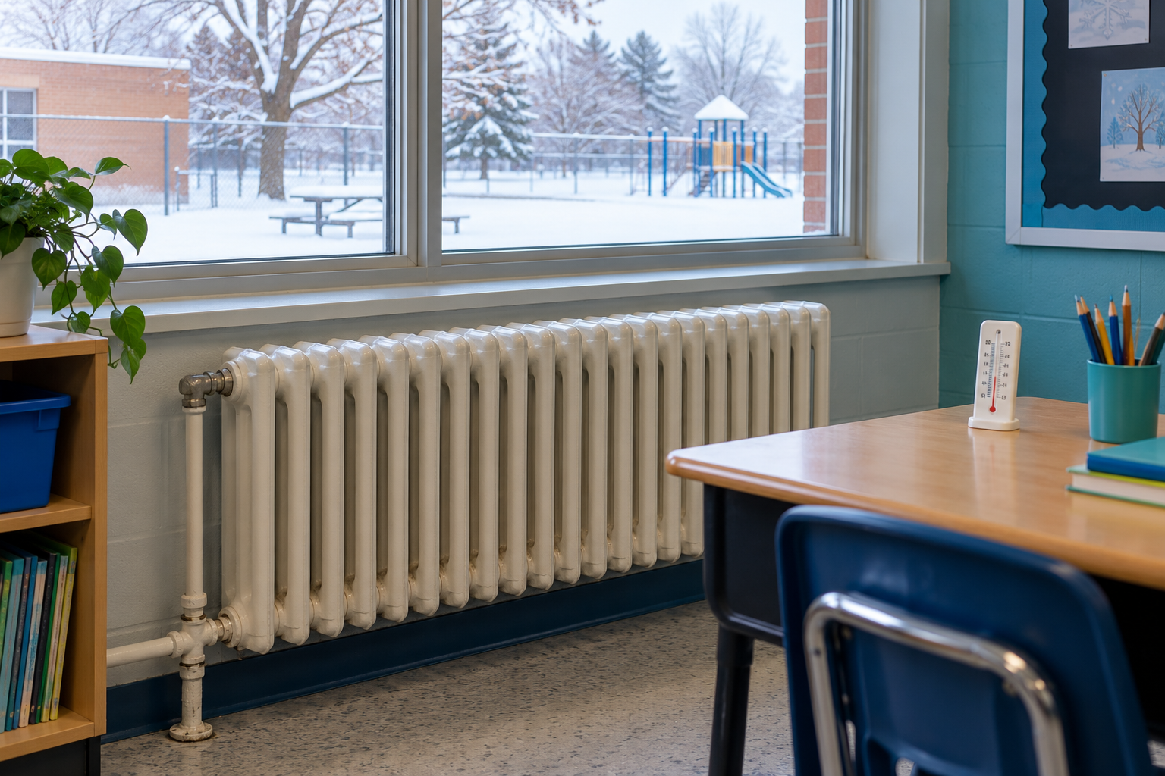
A white radiator below a classroom window overlooking a snowy schoolyard. Convection carries thermal energy through movement in a liquid or gas. Generated contextual illustration; not a scale model.

Explain the whole loop
It is the warmed matter that rises, not a special substance called heat. Thermal energy can also travel in other ways, including through solid matter.
Describe where warming happens, why the warmed liquid or gas moves, and where cooler matter moves. A model needs both rising and returning parts.
Observe only a teacher’s safe demonstration. Hot water and heaters can burn; you can explain the pattern without touching them.

What to remember
- Convection carries thermal energy through movement in a liquid or gas.
- Warmer, less dense matter can rise while cooler matter replaces it.

Check your understanding
Explain aloud, sketch, or write. Use evidence from the chapter.
1 Why is saying heat rises an incomplete explanation?
My thinking
2 Why does convection not happen inside a solid metal spoon?
My thinking

Practise the words
Cover the meanings and explain the words. Then cover the words and name the meanings. Give an example.
convection thermal energy transfer by movement in a liquid or gas
density mass compared with the space matter occupies
thermal energy energy associated with particle motion in matter

Lesson connection
Lesson 5 · Heat and convection
Original adaptation informed by Core Knowledge Foundation science materials including Energy Transfer and Transformation, Exploring Light and Sound. Shared under CC BY NC SA 4.0. Generated contextual illustration.

