The Sun and Renewable Sources
  - Grade 3 Unit 2 • Chapter 6
Learning goal I can explain how sunlight, wind and moving water supply renewable energy.
Sunlight warms a schoolyard, helps plants make food and drives much of Earth’s water cycle.

Begin with the Sun
The Sun is Earth’s main energy source. Uneven warming helps create winds. Solar energy evaporates water; precipitation supplies rivers. Wind and moving water therefore connect to sunlight, although not every energy source comes from the Sun.
Solar panels transform sunlight into electrical energy. Wind turns turbine blades. At hydroelectric dams, moving water turns turbines connected to generators.
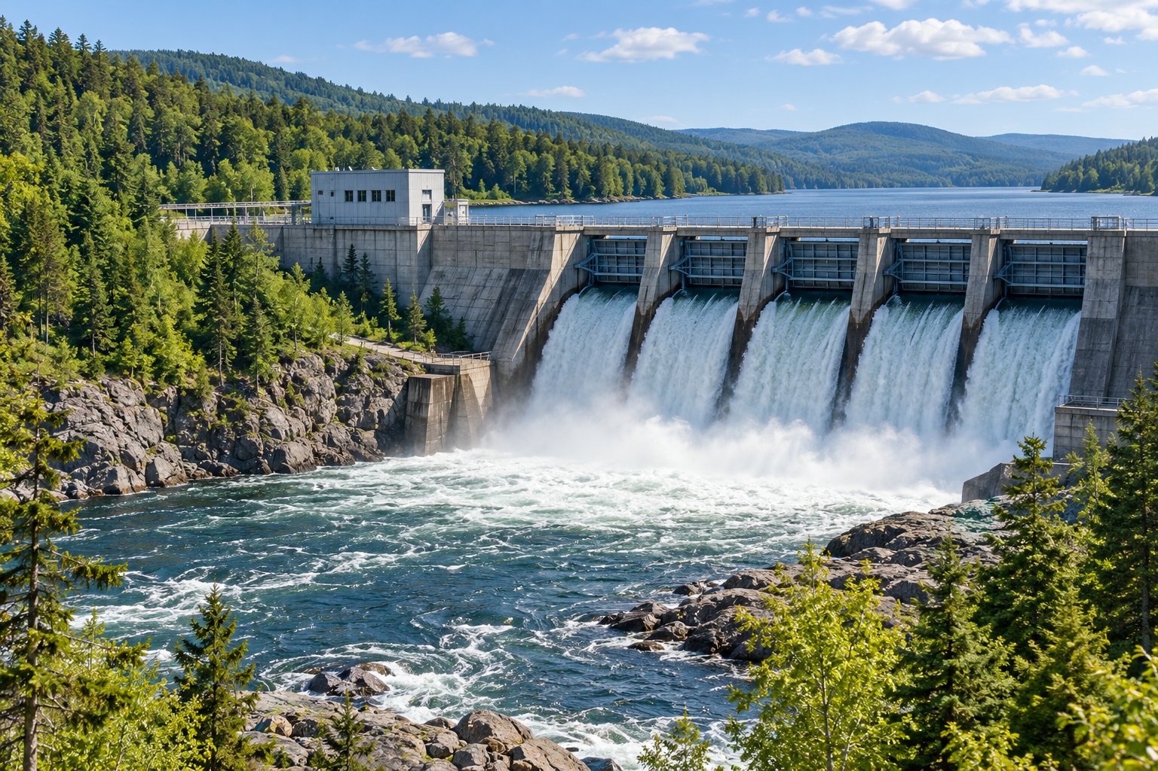
Water flowing through a dam surrounded by a forested landscape. The Sun supplies much of the energy driving winds, water cycling and plant food production. Generated contextual illustration; not a scale model.

Renewable does not mean unlimited
Sunlight, wind and flowing water are renewable sources because natural processes replenish them. A cloudy day or a calm afternoon still affects how much a device can produce.
Hydroelectricity is important in Québec. Dams also change rivers and habitats. Choosing a technology means considering both its useful energy and its effects on living things.
Reducing unnecessary energy use matters even when the source is renewable.

What to remember
- The Sun supplies much of the energy driving winds, water cycling and plant food production.
- Renewable technologies still use materials and affect surroundings.

Check your understanding
Explain aloud, sketch, or write. Use evidence from the chapter.
1 How does a hydroelectric station connect indirectly to the Sun?
My thinking
2 Why should we conserve energy from renewable sources?
My thinking

Practise the words
Cover the meanings and explain the words. Then cover the words and name the meanings. Give an example.
renewable a source naturally replenished on human timescales
turbine a wheel with blades turned by a moving fluid
solar panel a device that can transform sunlight into electrical energy

Lesson connection
Lesson 6 · The Sun and renewable energy
Original adaptation informed by Core Knowledge Foundation science materials including Energy Transfer and Transformation, Exploring Light and Sound. Shared under CC BY NC SA 4.0. Generated contextual illustration.

