An Energy Audit at School
  - Grade 3 Unit 2 • Chapter 7
Learning goal I can justify an energy-saving change using evidence.
An empty classroom with lights on gives us a question: who is using that light?

Find the real need
An energy audit checks where energy is used, what job it does and whether that job is needed. Record observations at several times. An occupied classroom may need lighting even during the day.
Warm indoor air transfers energy to colder surroundings in winter. Insulation slows that transfer. A door left open can increase energy needed for heating.
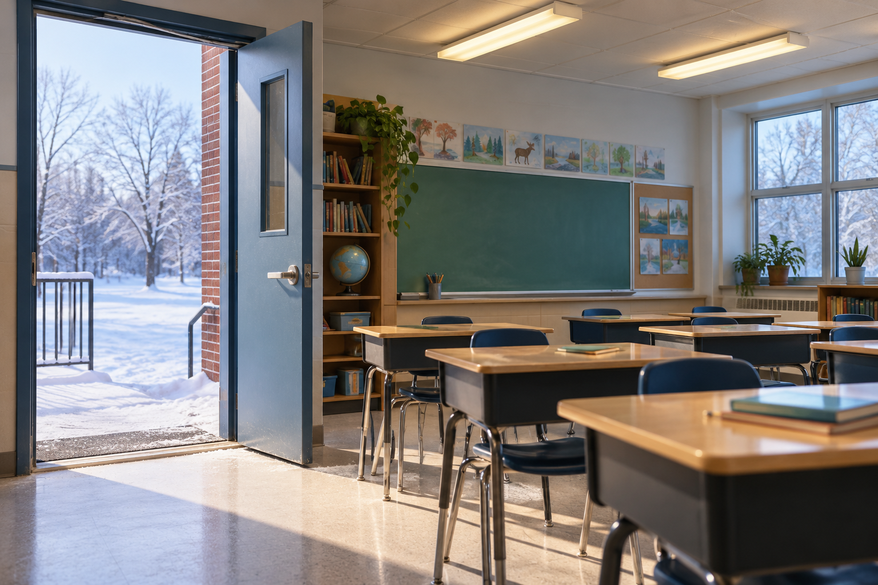
A lit empty classroom with an open door to a snowy yard. An energy audit links observations of use to real needs. Generated contextual illustration; not a scale model.

Choose and test a change
Propose a change that still meets people’s needs. Turning off unused lights is different from leaving students without enough light to read.
Ask an adult before changing school equipment. Do not cover heaters or block ventilation. Your class can collect evidence, explain energy transformations and share a proposal.
After a change, check again. Did it reduce unnecessary use? Did the classroom remain comfortable and useful? A good solution works for people as well as for energy use.

What to remember
- An energy audit links observations of use to real needs.
- Energy conservation should avoid unnecessary use while preserving safe, useful conditions.

Check your understanding
Explain aloud, sketch, or write. Use evidence from the chapter.
1 Why is switching off every classroom light not always a good plan?
My thinking
2 What evidence would support a proposal to turn off lights at lunch?
My thinking

Practise the words
Cover the meanings and explain the words. Then cover the words and name the meanings. Give an example.
audit a careful check of how something is used
conserve to avoid unnecessary use
insulation material that slows thermal energy transfer

Lesson connection
Lesson 7 · Energy design and audit
Original adaptation informed by Core Knowledge Foundation science materials including Energy Transfer and Transformation, Exploring Light and Sound. Shared under CC BY NC SA 4.0. Generated contextual illustration.

