What Is in Soil
  - Grade 3 Unit 3 • Chapter 1
Learning goal I can compare soils by describing their ingredients.
The soil in a school garden is more than ground-up rock.

A mixture beneath our feet
Soil contains mineral particles, organic matter, air, water and living things. Some mineral particles are large like sand; others, such as clay particles, are much smaller. Decaying leaves add organic matter.
Roots and worms live in spaces within soil. A dry sample may still have small spaces that can hold air and later fill with water.
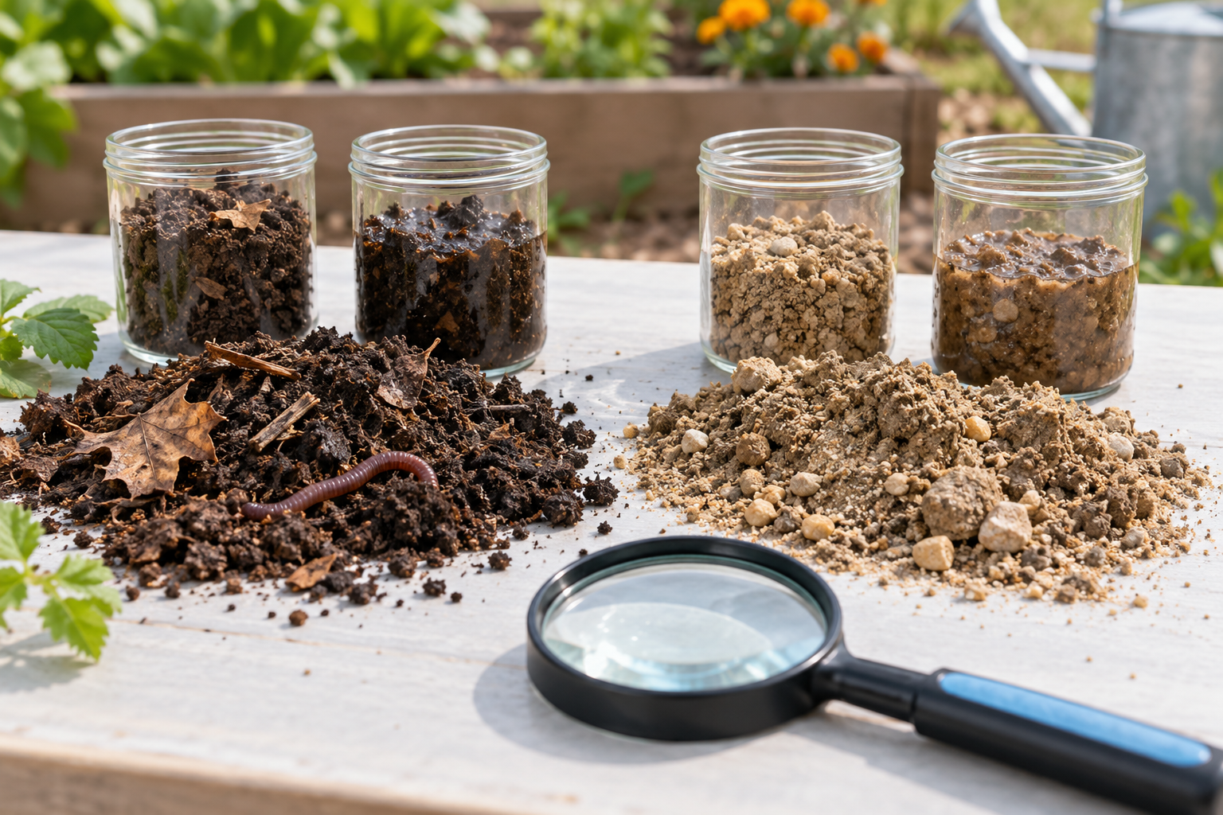
Different soil mixtures, plant remains and a hand lens on a table. Soil contains mineral particles, organic matter, air, water and living things. Generated contextual illustration; not a scale model.

Compare samples fairly
Two soils can have different colours and textures because their mixtures differ. Use a hand lens to observe teacher-approved samples, not taste or smell unknown materials closely.
Compare equal amounts. Record visible grains, plant remains and how the soil feels through a safe observation routine. Wet and dry versions of the same soil may look different.
A description is evidence. Saying dark soil is always best is a conclusion that needs more testing; different plants need different conditions.

What to remember
- Soil contains mineral particles, organic matter, air, water and living things.
- A soil description uses several observable features rather than colour alone.

Check your understanding
Explain aloud, sketch, or write. Use evidence from the chapter.
1 Why is soil a mixture rather than one substance?
My thinking
2 Can colour alone tell you which soil will support a plant best?
My thinking

Practise the words
Cover the meanings and explain the words. Then cover the words and name the meanings. Give an example.
soil a mixture of mineral particles organic matter water air and living things
organic matter material from living or once living organisms
mineral natural solid material with characteristic properties

Lesson connection
Lesson 1 · What soil contains
Original adaptation informed by Core Knowledge Foundation science materials including Exploring Land and Water, Weather Climate and Water Cycling. Shared under CC BY NC SA 4.0. Generated contextual illustration.

