Where Does the Water Go
  - Grade 3 Unit 3 • Chapter 2
Learning goal I can compare water and heat retention using a fair test.
After rain, one patch of a school garden stays wet while another dries quickly.

Water between particles
Water enters spaces between soil particles. Large connected spaces often allow faster drainage. Smaller spaces and organic matter can help soil retain water. Water retention is not the same as being waterproof.
Too little retained water may dry roots. Too much water can leave too little air around roots. Plants need a suitable balance.
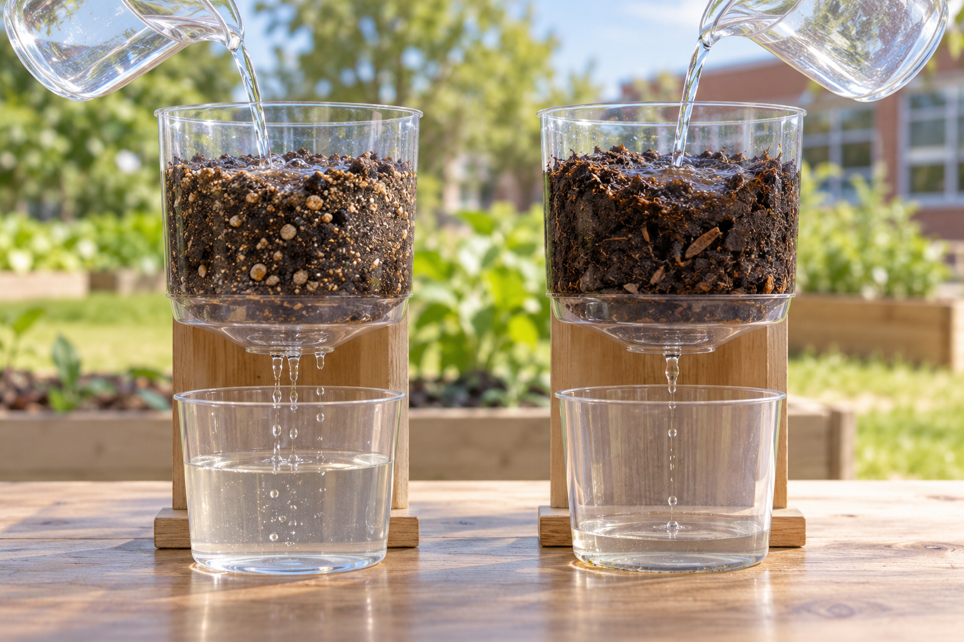
Two soil-filled containers receiving water and draining into collection cups. Soil composition affects drainage, water retention and warming or cooling. Generated contextual illustration; not a scale model.

Test more than one property
Use equal soil amounts in matching containers. Add equal water volumes and collect drainage for the same time. The comparison gives evidence about retention, not a verdict about every plant.
Soils also warm and cool differently. Their moisture, colour and composition can affect heat retention. Compare samples under the same warming conditions, then measure temperatures as they cool.
Repeat observations. A surprising result can mean your explanation needs revising or your test conditions differed.

What to remember
- Soil composition affects drainage, water retention and warming or cooling.
- A fair comparison uses matching amounts, containers and observation conditions.

Check your understanding
Explain aloud, sketch, or write. Use evidence from the chapter.
1 Why must the same amount of water be added to each soil sample?
My thinking
2 Why is the soil holding most water not always the best for roots?
My thinking

Practise the words
Cover the meanings and explain the words. Then cover the words and name the meanings. Give an example.
retention holding something rather than letting it leave
drainage movement of water out of a material
fair test a comparison that changes one factor while keeping others alike

Lesson connection
Lesson 2 · Soil properties
Original adaptation informed by Core Knowledge Foundation science materials including Exploring Land and Water, Weather Climate and Water Cycling. Shared under CC BY NC SA 4.0. Generated contextual illustration.

