Rocks Carry Clues
  - Grade 3 Unit 3 • Chapter 3
Learning goal I can distinguish fossils from ordinary rock patterns and describe crystals.
A shell-shaped mark in a Québec limestone sample may be a clue to life long ago.

Look for evidence of past life
A fossil can preserve part of an organism, such as a shell, or a trace, such as a footprint. A rock’s stripe is not automatically a fossil. We need evidence that a living thing made the feature.
Fossils help scientists investigate past environments. An organism that lived in water can leave remains in rock now found on land.
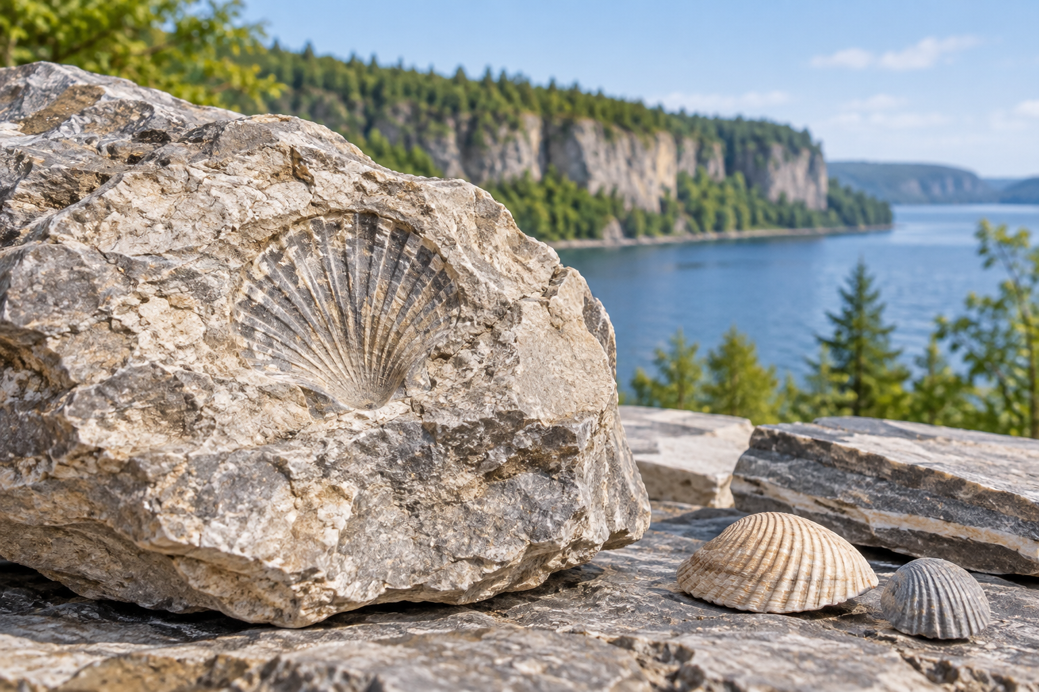
A shell-shaped fossil in rock beside a shell at a lakeside. Fossils preserve remains or traces of past life. Generated contextual illustration; not a scale model.

Crystals have observable properties
Crystals can have flat faces and repeating shapes because of their internal arrangement. Compare colour, lustre, shape and size. A crystal is not necessarily a gemstone.
A rock may contain several minerals, some visible as crystals. Not every rock has large crystals you can see without a lens.
Do not break or collect protected specimens. Draw observations and compare them with reliable references. A careful description is more useful than guessing from one feature.

What to remember
- Fossils preserve remains or traces of past life.
- Crystal shape, colour, size and lustre provide observable evidence for comparison.

Check your understanding
Explain aloud, sketch, or write. Use evidence from the chapter.
1 Why is a stripe in rock not enough evidence for a fossil?
My thinking
2 Could two crystals of different sizes be the same mineral?
My thinking

Practise the words
Cover the meanings and explain the words. Then cover the words and name the meanings. Give an example.
fossil preserved remains or traces of past life
crystal a solid with particles arranged in an orderly pattern
lustre how a surface reflects light

Lesson connection
Lesson 3 · Rocks, fossils and crystals
Original adaptation informed by Core Knowledge Foundation science materials including Exploring Land and Water, Weather Climate and Water Cycling. Shared under CC BY NC SA 4.0. Generated contextual illustration.

