Water Travels in a Cycle
  - Grade 3 Unit 3 • Chapter 4
Learning goal I can connect evaporation, condensation, precipitation, runoff and infiltration.
A puddle can shrink on a mild day without anyone pouring it away.

Changes of state
During evaporation, liquid water becomes invisible water vapour in the air. When water vapour cools sufficiently, condensation forms droplets. Clouds contain tiny droplets or ice crystals, not just invisible vapour.
Drops or crystals can grow and fall as precipitation, such as rain or snow. Snow on a Québec schoolyard can later melt.
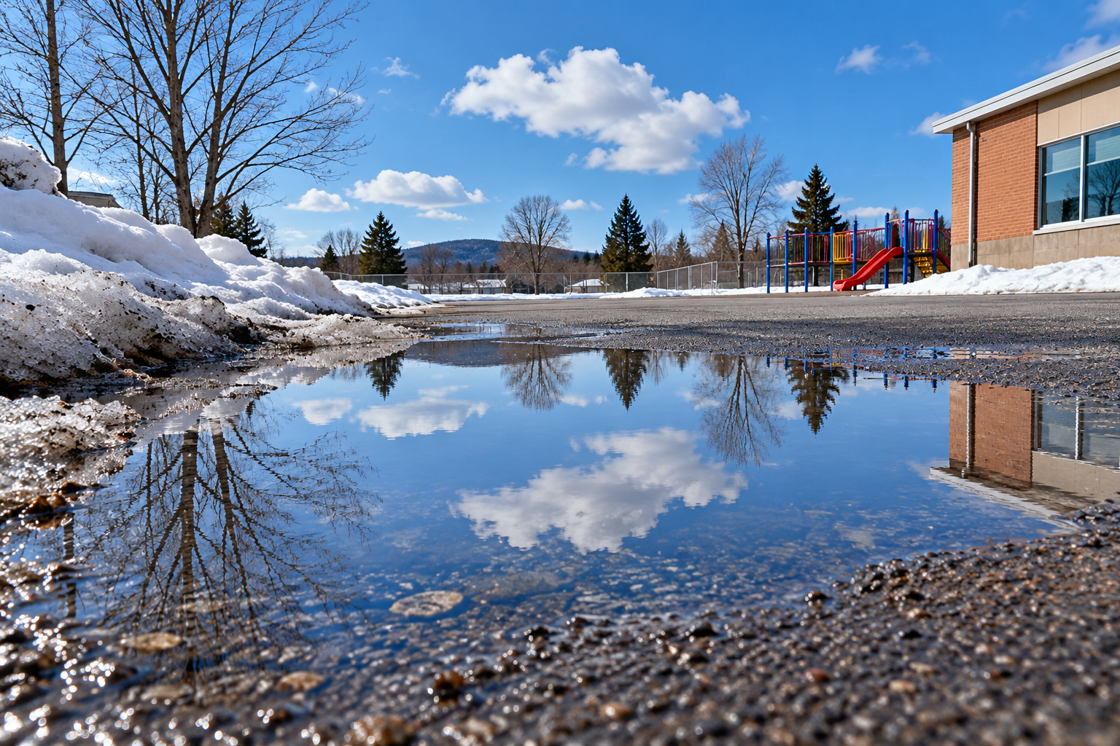
A shallow puddle reflecting sky and clouds beside melting snow in a schoolyard. Evaporation and condensation change water’s state. Generated contextual illustration; not a scale model.

Water takes several paths
Water may flow downhill as runoff into streams and rivers. Some enters soil by infiltration and can move underground. Plants take up water and release water vapour from leaves.
The Sun supplies energy for much evaporation. Gravity helps water fall and flow. There is no single starting place or fixed route for every drop.
Sketch several possible paths from a schoolyard puddle. Include changes of state as well as changes of location.

What to remember
- Evaporation and condensation change water’s state.
- Precipitation, runoff and infiltration connect several possible water-cycle routes.

Check your understanding
Explain aloud, sketch, or write. Use evidence from the chapter.
1 Is a cloud made only of invisible water vapour? Explain.
My thinking
2 How might pavement change water’s route after rain?
My thinking

Practise the words
Cover the meanings and explain the words. Then cover the words and name the meanings. Give an example.
evaporation liquid water changing to water vapour
condensation water vapour changing to liquid
precipitation water falling from clouds
runoff water flowing across land
infiltration water entering soil

Lesson connection
Lesson 4 · Water changes state / Lesson 5 · Water-cycle processes
Original adaptation informed by Core Knowledge Foundation science materials including Exploring Land and Water, Weather Climate and Water Cycling. Shared under CC BY NC SA 4.0. Generated contextual illustration.

