Healthy Water Soil and Air
  - Grade 3 Unit 3 • Chapter 5
Learning goal I can explain how environmental quality affects living things and justify a design.
Rain can carry soil and other materials from a schoolyard into a nearby stream.

Connected surroundings
Living things depend on suitable water, soil and air. Too much sediment can make water cloudy and affect organisms. Some pollutants dissolve, so harmful water can look clear.
Air pollution can affect organisms too. Environmental quality is not judged by appearance alone; observations and tests answer different questions.
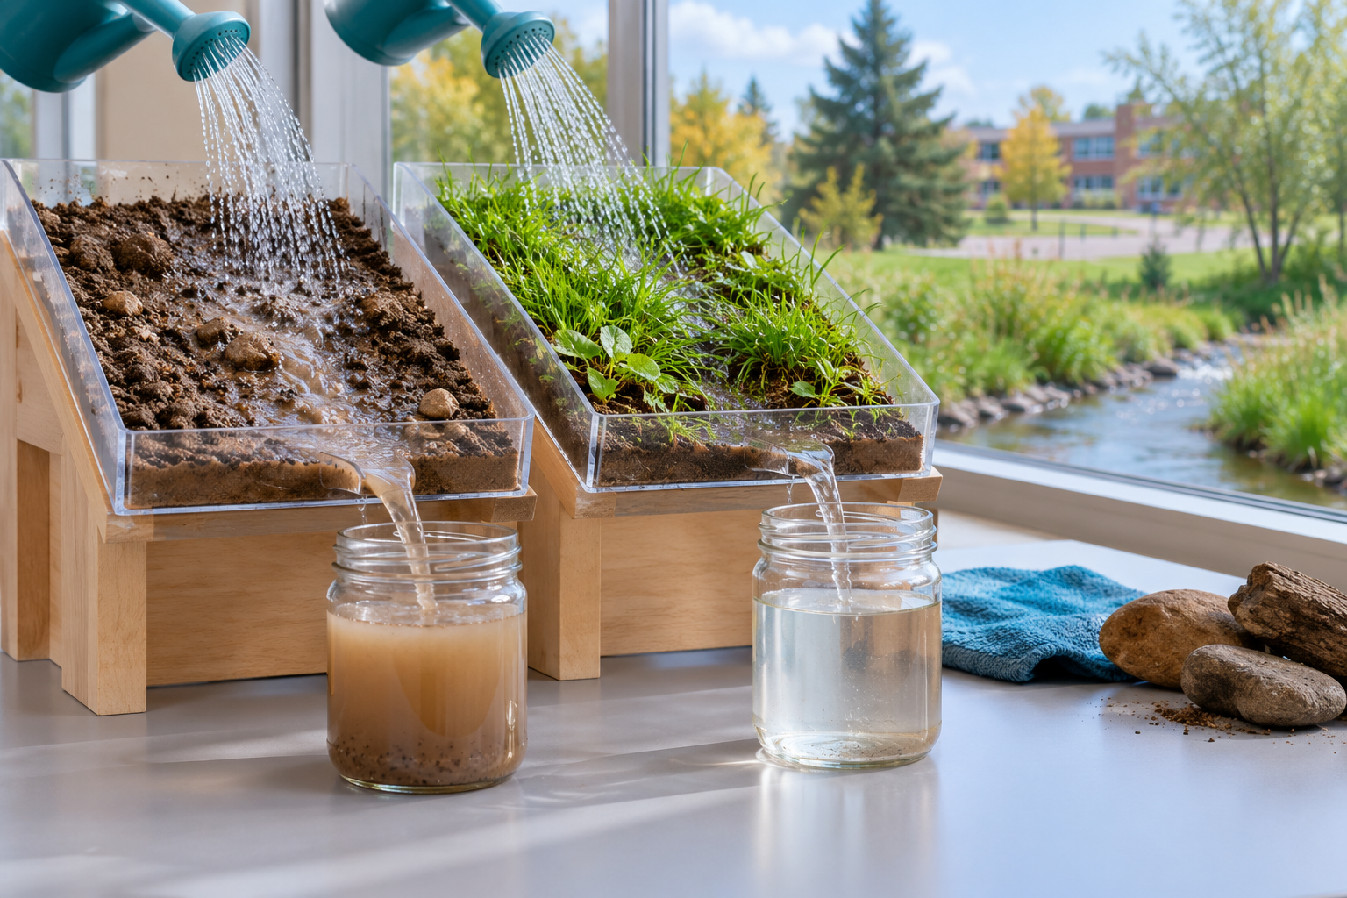
Bare and planted soil trays draining cloudy and clearer water into jars. Water, soil and air quality affect organisms and their habitats. Generated contextual illustration; not a scale model.

Use evidence to design
Plant cover can help hold soil and slow runoff. A classroom model can compare water flowing over bare soil and covered soil under matching conditions.
A model filter may trap some particles. It does not guarantee removal of dissolved substances or microorganisms. Never drink water from a classroom filter.
Choose a local problem, name the need and explain how your design responds. Record both what your evidence supports and what your test cannot show.

What to remember
- Water, soil and air quality affect organisms and their habitats.
- A classroom filter can remove some particles without making water safe to drink.

Check your understanding
Explain aloud, sketch, or write. Use evidence from the chapter.
1 Does clear filtered water prove that it is safe to drink?
My thinking
2 Why might covering bare soil with plants reduce muddy runoff?
My thinking

Practise the words
Cover the meanings and explain the words. Then cover the words and name the meanings. Give an example.
pollution harmful materials or changes introduced into an environment
habitat the place where an organism meets its needs
filter a material or device that removes some particles

Lesson connection
Lesson 6 · Environmental quality / Lesson 7 · Earth materials investigation and design
Original adaptation informed by Core Knowledge Foundation science materials including Exploring Land and Water, Weather Climate and Water Cycling. Shared under CC BY NC SA 4.0. Generated contextual illustration.

