What Living Things Need
  - Grade 3 Unit 4 • Chapter 1
Learning goal I can explain how nutrition and respiration help living things survive.
A maple seedling and a squirrel look different, but both need materials and energy to live.

Needs are not wishes
Animals obtain food by eating. Green plants make sugars using light, water and carbon dioxide. Plants also need mineral nutrients; soil is not their food.
Respiration releases usable energy from food in cells. Most familiar plants and animals use oxygen for this process. Breathing moves air in and out; it helps many animals obtain oxygen, but it is not the whole process of respiration.
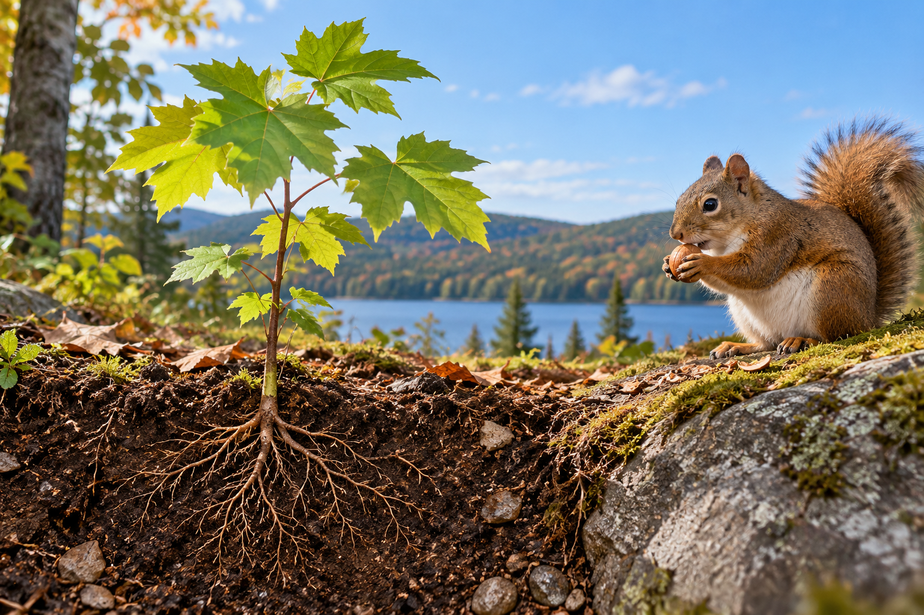
A maple seedling with roots shown below the soil and a squirrel eating nearby. Nutrition supplies materials and food; respiration releases usable energy from food in cells. Generated contextual illustration; not a scale model.

Look beneath the surface
Living things grow, maintain their bodies and reproduce under suitable conditions. They need water and an environment that supports their processes.
A tree can be alive without walking. A fire can grow without being an organism. One visible feature is not enough to decide whether something is living.
Use several clues and explain how they connect to life processes. Observe classroom plants over time rather than making a conclusion from one moment.

What to remember
- Nutrition supplies materials and food; respiration releases usable energy from food in cells.
- Several connected life processes provide evidence that something is living.

Check your understanding
Explain aloud, sketch, or write. Use evidence from the chapter.
1 Why does a plant still need respiration if it makes its own food?
My thinking
2 Is growing larger enough to prove something is living?
My thinking

Practise the words
Cover the meanings and explain the words. Then cover the words and name the meanings. Give an example.
organism a living thing
nutrition obtaining and using materials needed for life
respiration a process in cells that releases energy from food

Lesson connection
Lesson 1 · Needs of life
Original adaptation informed by Core Knowledge Foundation science materials including Life Cycles, Structure and Functions, Plant and Animal Survival. Shared under CC BY NC SA 4.0. Generated contextual illustration.

