Grouping the Living World
  - Grade 3 Unit 4 • Chapter 2
Learning goal I can group organisms using shared features rather than size alone.
A mushroom, a maple and a mouse do not obtain food in the same way.

Groups help us compare
Plants, animals and fungi belong to different large groups often called kingdoms. Most plants make food by photosynthesis. Animals eat other organisms or their products. Fungi absorb nutrients from their surroundings.
Scientists group organisms using many shared features. Mushrooms are not plants simply because they grow in one place.
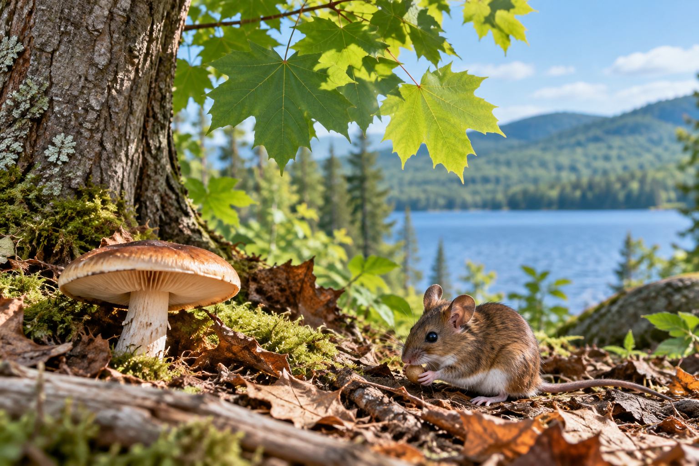
A mushroom, maple leaves and a mouse in a forest habitat. Classification uses shared features and life processes. Generated contextual illustration; not a scale model.

Small is not a kingdom
Microorganism describes size, not one kingdom. Microscopic organisms include bacteria and some fungi and other groups. A microscope makes features visible that eyes alone cannot resolve.
Different classification systems organize the largest groups somewhat differently. In this unit, use the classroom system while remembering that microscopic organisms do not all belong together.
A useful grouping rule can be explained and checked. If a new example does not fit, improve the rule instead of forcing it into the wrong group.

What to remember
- Classification uses shared features and life processes.
- Microorganisms belong to several groups; microscopic size is not a kingdom.

Check your understanding
Explain aloud, sketch, or write. Use evidence from the chapter.
1 Why is a mushroom not classified as a plant?
My thinking
2 Why should all microorganisms not be treated as one kingdom?
My thinking

Practise the words
Cover the meanings and explain the words. Then cover the words and name the meanings. Give an example.
classification grouping things by shared features
fungus an organism that absorbs nutrients rather than making food by photosynthesis
microorganism an organism too small to see clearly without magnification

Lesson connection
Lesson 2 · Kingdoms and classification
Original adaptation informed by Core Knowledge Foundation science materials including Life Cycles, Structure and Functions, Plant and Animal Survival. Shared under CC BY NC SA 4.0. Generated contextual illustration.

