Comparing Animal Groups
  - Grade 3 Unit 4 • Chapter 3
Learning goal I can classify familiar vertebrates using several shared features.
A whale swims, but that does not make it a fish.

Use features not location
Mammals have hair at some stage and produce milk for young. Birds have feathers. Reptiles have dry scaly skin. Fish breathe using gills for at least most of their lives. Amphibians include frogs and salamanders, usually with moist skin.
These are vertebrate groups. Insects, worms and many other animals do not have backbones and are outside these five groups.
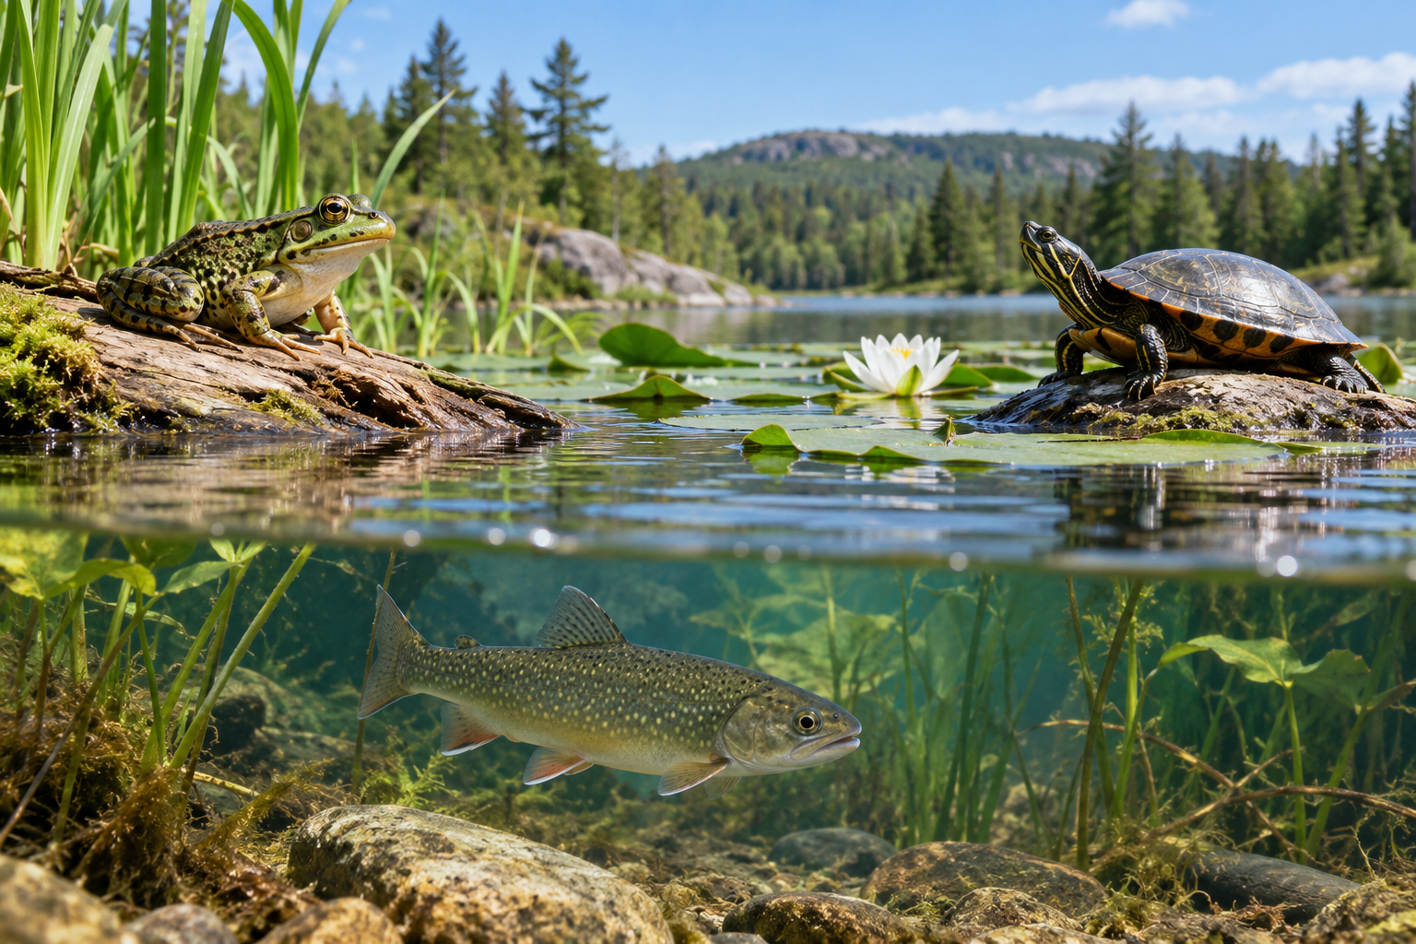
A frog and turtle beside a pond with a fish visible below the surface. Vertebrate groups can be compared using body features and life processes. Generated contextual illustration; not a scale model.

Check more than one clue
Québec ponds can contain frogs, fish and turtles. Sharing a habitat does not mean sharing a group.
Many birds fly, but penguins do not. Bats fly but are mammals. Use body features and life processes, not a single behaviour.
An unusual example tests a rule. Look for evidence about feathers, hair, skin, breathing and reproduction. A reference can help when the features are not visible.

What to remember
- Vertebrate groups can be compared using body features and life processes.
- Habitat or one behaviour is not enough to classify an animal.

Check your understanding
Explain aloud, sketch, or write. Use evidence from the chapter.
1 Why is flying not a reliable rule for identifying birds?
My thinking
2 Why can a whale and a fish live together but belong to different groups?
My thinking

Practise the words
Cover the meanings and explain the words. Then cover the words and name the meanings. Give an example.
vertebrate an animal with a backbone
mammal a vertebrate whose young receive milk from mammary glands
amphibian a vertebrate such as a frog often with aquatic young

Lesson connection
Lesson 3 · Animal groups
Original adaptation informed by Core Knowledge Foundation science materials including Life Cycles, Structure and Functions, Plant and Animal Survival. Shared under CC BY NC SA 4.0. Generated contextual illustration.

