Plant Parts Working Together
  - Grade 3 Unit 4 • Chapter 4
Learning goal I can connect roots, stems, leaves and flowers to their functions.
A bean plant on a classroom windowsill needs more than a green leaf.

From roots to leaves
Roots anchor the plant and absorb water and mineral nutrients. A stem supports parts and transports materials. Leaves take in light and exchange gases; many leaves make sugars by photosynthesis.
Flowers contain structures involved in reproduction. Fruits help protect seeds and can help disperse them. A plant’s structures work as a system.
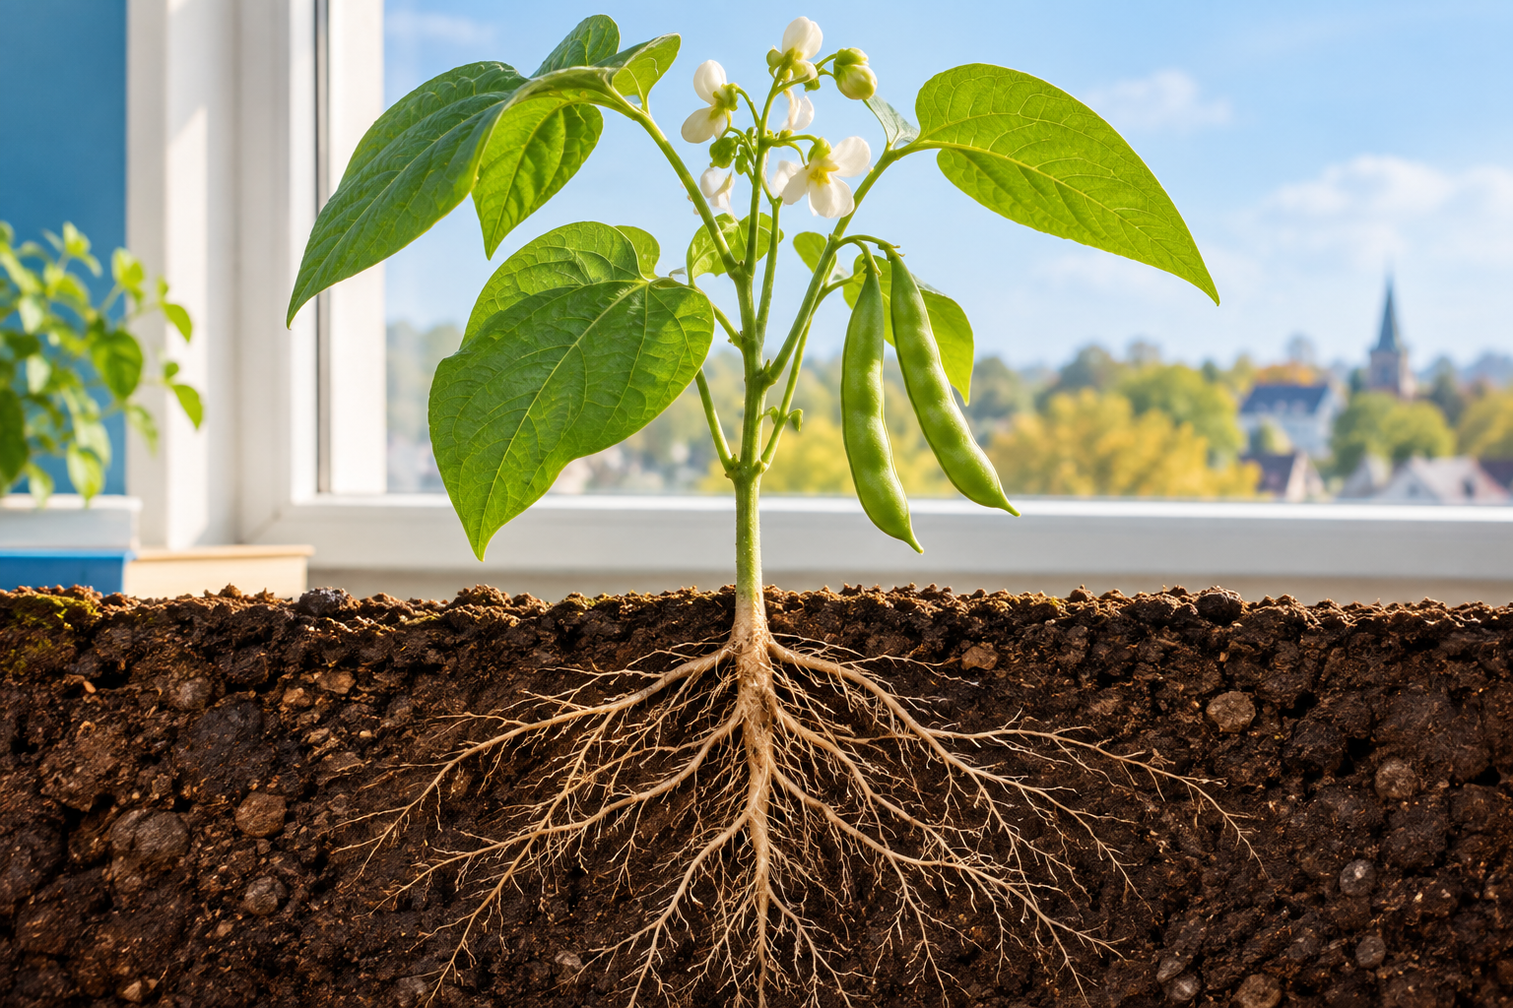
A flowering bean plant with leaves, stem, pods and roots shown in a soil cutaway. Roots, stems, leaves and reproductive structures perform connected functions. Generated contextual illustration; not a scale model.

Connect shape and job
A broad leaf can capture light. Branching roots contact more soil. A strong stem can hold leaves where light reaches them.
Not every plant has the same structures. Mosses and flowering plants differ. In this chapter, focus on familiar flowering plants rather than assuming every living plant has flowers.
If one structure is damaged, other functions may be affected. Observe without pulling up living plants unnecessarily. Draw arrows to show water moving through a plant and explain each part’s contribution.

What to remember
- Roots, stems, leaves and reproductive structures perform connected functions.
- A structure’s shape can help explain its job.

Check your understanding
Explain aloud, sketch, or write. Use evidence from the chapter.
1 Why would damaged roots affect leaves even when leaves receive light?
My thinking
2 How can a leaf’s broad shape help its function?
My thinking

Practise the words
Cover the meanings and explain the words. Then cover the words and name the meanings. Give an example.
structure a body part or arrangement of parts
function the job a part performs
root a plant part that usually anchors it and absorbs water and minerals

Lesson connection
Lesson 4 · Plant structures
Original adaptation informed by Core Knowledge Foundation science materials including Life Cycles, Structure and Functions, Plant and Animal Survival. Shared under CC BY NC SA 4.0. Generated contextual illustration.

