Flowers Seeds and New Plants
  - Grade 3 Unit 4 • Chapter 6
Learning goal I can explain pollination, fertilization and seed development.
An apple flower can become part of a new generation of apple trees.

Flowers do more than decorate
Pollen carries male reproductive cells. Pollination moves pollen to a flower’s stigma. In suitable conditions, a male cell can join a female cell inside an ovule. That joining is fertilization.
After fertilization, an ovule can develop into a seed. The flower’s ovary can develop into a fruit. Pollination and fertilization are connected but are not the same event.
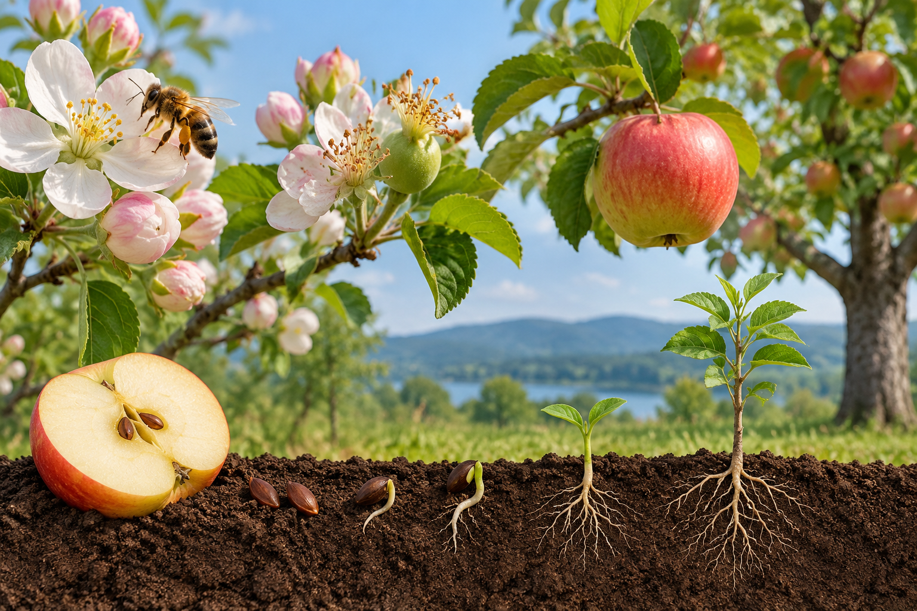
A composite illustration of a bee at apple blossoms, an apple with seeds, and germinating seedlings. Pollination transfers pollen, while fertilization joins reproductive cells. Generated contextual illustration; not a scale model.

A life cycle continues
A seed contains an embryo. With suitable water, oxygen and temperature, it can germinate. The young plant grows, forms mature structures and may later reproduce.
Bees can transfer pollen between flowers. Wind also pollinates some plants. Different structures help different plants reproduce.
A seed landing somewhere is not enough for growth. Its surroundings must meet its needs. Trace the stages and explain what is needed at each stage.

What to remember
- Pollination transfers pollen, while fertilization joins reproductive cells.
- Suitable conditions allow a seed to germinate and continue the plant life cycle.

Check your understanding
Explain aloud, sketch, or write. Use evidence from the chapter.
1 Why is pollination not the same as fertilization?
My thinking
2 Why might an apple seed fail to become a tree?
My thinking

Practise the words
Cover the meanings and explain the words. Then cover the words and name the meanings. Give an example.
pollination transfer of pollen to a flower’s receptive structure
fertilization joining of male and female reproductive cells
seed a plant structure containing an embryo and stored food

Lesson connection
Lesson 6 · Plant reproduction
Original adaptation informed by Core Knowledge Foundation science materials including Life Cycles, Structure and Functions, Plant and Animal Survival. Shared under CC BY NC SA 4.0. Generated contextual illustration.

