Different Ways to Begin Life
  - Grade 3 Unit 4 • Chapter 7
Learning goal I can compare animal development and connect stages in a life cycle.
A duckling hatches from an egg. A kitten is born alive. Both grow toward adulthood.

Young do not all begin alike
Oviparous animals lay eggs in which embryos develop. In viviparous animals, embryos develop inside a parent and receive nourishment from that parent. In ovoviviparous development, retained eggs chiefly provide nourishment through their yolks.
These are development patterns, not the same as animal groups. Reptiles, for example, include different patterns.
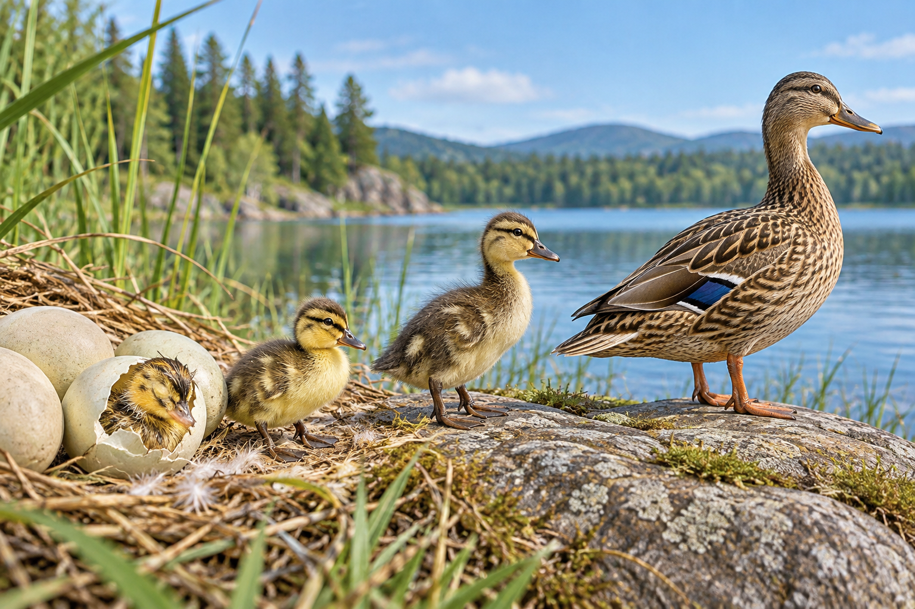
A duck, ducklings and a hatching egg beside a lake. Animal embryos can develop in laid eggs, retained eggs or through live-bearing patterns. Generated contextual illustration; not a scale model.

Compare a whole cycle
A frog begins as an egg, develops into a tadpole and changes into an adult frog. A butterfly develops through egg, larva, pupa and adult. These major changes are metamorphosis.
A kitten grows without a butterfly-like pupa stage. Each organism still has a life cycle involving growth, possible reproduction and eventual death.
A cycle diagram connects generations. An individual does not turn back into its own egg; adults can produce new offspring that begin another generation.

What to remember
- Animal embryos can develop in laid eggs, retained eggs or through live-bearing patterns.
- Life cycles connect successive generations, not a return of one individual to its beginning.

Check your understanding
Explain aloud, sketch, or write. Use evidence from the chapter.
1 Why does a life-cycle circle not mean one butterfly becomes an egg again?
My thinking
2 How does an egg retained inside a parent differ from typical live-birth development?
My thinking

Practise the words
Cover the meanings and explain the words. Then cover the words and name the meanings. Give an example.
life cycle stages from an organism’s beginning through growth reproduction and death
oviparous developing in eggs laid outside the parent
viviparous developing inside a parent before live birth
ovoviviparous developing in eggs retained inside a parent until hatching

Lesson connection
Lesson 7 · Life cycles
Original adaptation informed by Core Knowledge Foundation science materials including Life Cycles, Structure and Functions, Plant and Animal Survival. Shared under CC BY NC SA 4.0. Generated contextual illustration.

