Describe Motion Precisely
  - Grade 4 Unit 1 • Chapter 2
Learning goal I can describe motion by speed and direction and explain a change.
A bicycle can pass the school quickly or slowly. Both observations need a reference point.

Position changes over time
Motion is a change of position compared with something else. Speed describes how much distance is covered in a given time. Direction tells where the object is moving.
Forces can start or stop motion, increase or decrease speed, or change direction. Turning a bicycle changes motion even if its speed stays similar.
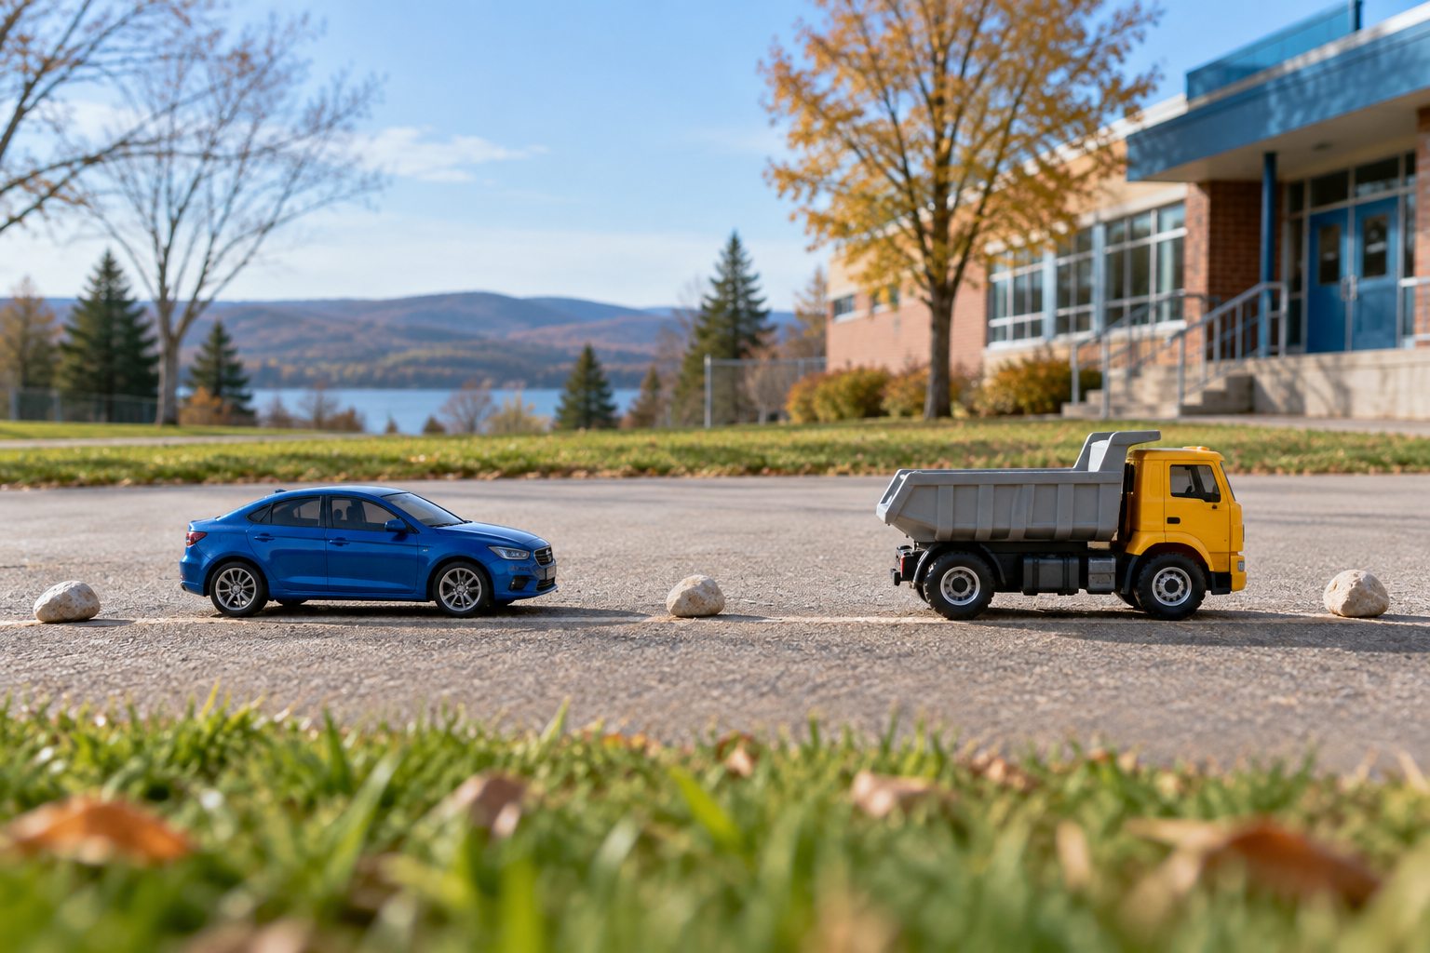
A toy car and toy truck positioned along a schoolyard path. Motion is described using position, speed and direction. Generated contextual illustration; not a scale model.

Make a useful comparison
Mark equal distances for two toy vehicles and compare travel times. Or compare distances travelled during equal times. Say what you kept alike.
Friction between tyres and a road helps a bicycle turn and stop. On slippery ice, less grip makes control harder. Forces are involved in both useful motion and stopping.
A complete description names the object, reference point, direction and time-based comparison rather than simply calling it fast.

What to remember
- Motion is described using position, speed and direction.
- A force can change speed, direction or both.

Check your understanding
Explain aloud, sketch, or write. Use evidence from the chapter.
1 Can a force change motion without changing speed?
My thinking
2 Why is travelled distance alone not enough to compare speed?
My thinking

Practise the words
Cover the meanings and explain the words. Then cover the words and name the meanings. Give an example.
motion a change in position
speed distance travelled in a given time
direction where movement is headed
friction a force that resists sliding between surfaces

Lesson connection
Lesson 2 · Describing motion
Original adaptation informed by Core Knowledge Foundation science materials including Investigating Forces, Simple Machines. Shared under CC BY NC SA 4.0. Generated contextual illustration.

