Forces Change Structures
  - Grade 4 Unit 1 • Chapter 3
Learning goal I can explain how compression and tension affect a structure.
A footbridge supports people even when it appears perfectly still.

A bridge must hold a load
Compression squeezes parts together. Tension pulls parts apart. Bending can involve both: one side is squeezed while another is stretched. Materials respond differently to these forces.
A strong material is not automatically a strong structure. Shape, joints and the arrangement of parts also matter. A folded paper beam may support more than a flat sheet made from the same paper.
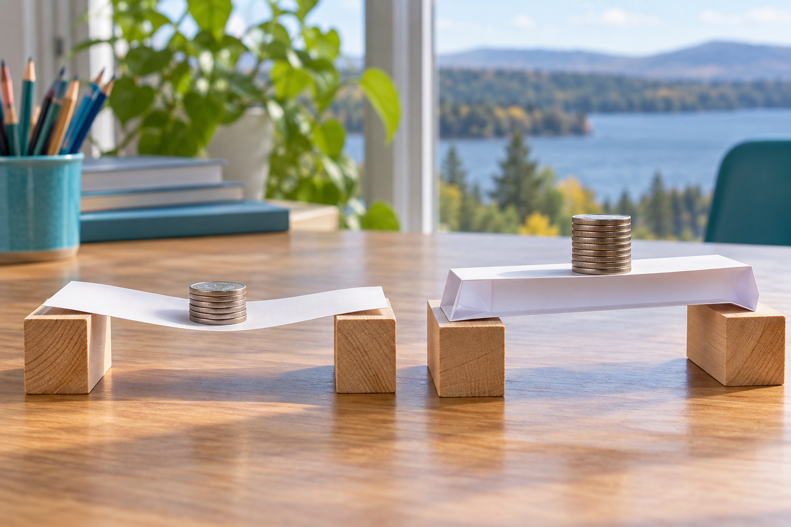
Flat and folded paper beams spanning blocks and supporting stacks of coins. Compression, tension and bending affect structures. Generated contextual illustration; not a scale model.

Test the design fairly
Compare paper beams using equal paper amounts and the same gap between supports. Add the same small loads carefully. Record bending as well as collapse.
A useful design must meet a need and its constraints. A model bridge may need to span a gap while using limited materials.
Model results do not prove that a real bridge is safe. Engineers also test materials, loads and conditions at much larger scales.

What to remember
- Compression, tension and bending affect structures.
- Shape, materials and connections influence a structure’s response to a load.

Check your understanding
Explain aloud, sketch, or write. Use evidence from the chapter.
1 Why can folding paper improve a beam without adding material?
My thinking
2 Why must model beams span the same gap in a fair comparison?
My thinking

Practise the words
Cover the meanings and explain the words. Then cover the words and name the meanings. Give an example.
structure parts arranged to support a load or perform a job
compression a squeezing force
tension a pulling force
load what a structure supports

Lesson connection
Lesson 3 · Forces on structures
Original adaptation informed by Core Knowledge Foundation science materials including Investigating Forces, Simple Machines. Shared under CC BY NC SA 4.0. Generated contextual illustration.

