Parts That Carry Motion
  - Grade 4 Unit 1 • Chapter 5
Learning goal I can recognize mechanical components and explain their jobs.
On a bicycle, turning pedals moves a chain and turns a wheel. Parts pass motion along.

Follow the connected parts
A fixed pulley can change the direction of a pull. Some pulley arrangements reduce the force needed by using a longer rope movement. A winch winds a rope onto a drum to pull a load.
Gears have teeth that fit together. They can change rotation direction or speed. Wheels can roll, support loads or transmit motion through an axle.
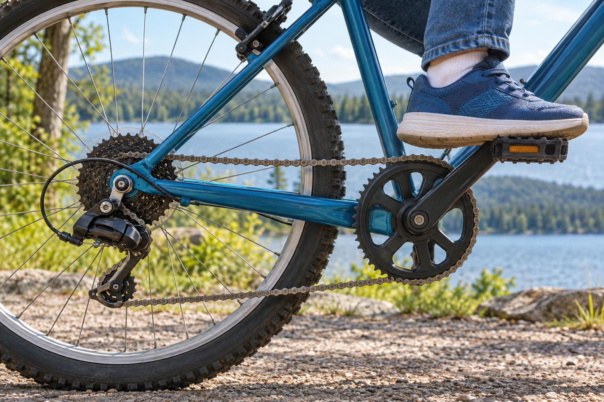
A close view of a bicycle’s pedal, chain and rear wheel components. Mechanical components transmit or transform forces and motion. Generated contextual illustration; not a scale model.

Parts can also change movement
A cam’s uneven shape can lift and lower a follower as it rotates. A connecting rod links moving parts. A spring stores energy when stretched or compressed and can return it when released.
A useful explanation identifies connections. Which part touches or links to the next? What happens when the first part moves?
Use stopped, safe models for inspection. Fingers, loose hair and clothing must stay away from moving gears or tight ropes.

What to remember
- Mechanical components transmit or transform forces and motion.
- An explanation identifies how connected parts affect one another.

Check your understanding
Explain aloud, sketch, or write. Use evidence from the chapter.
1 Why is a fixed pulley useful even if it does not reduce the force needed?
My thinking
2 How do a cam and a round wheel differ in their effect on a follower?
My thinking

Practise the words
Cover the meanings and explain the words. Then cover the words and name the meanings. Give an example.
pulley a grooved wheel that guides a rope
winch a drum that winds a rope or cable
gear a toothed wheel that engages another toothed part
cam a shaped rotating part that pushes another part

Lesson connection
Lesson 5 · Mechanical components
Original adaptation informed by Core Knowledge Foundation science materials including Investigating Forces, Simple Machines. Shared under CC BY NC SA 4.0. Generated contextual illustration.

