Designing Useful Technologies
  - Grade 4 Unit 1 • Chapter 7
Learning goal I can justify a mechanism and discuss a benefit and a tradeoff.
A cart can help move classroom books, but different carts suit different spaces.

Begin with a real need
Identify the load, route and people using the cart. Wheels reduce sliding friction, while handles let users apply forces. A narrow doorway creates a size constraint.
Transportation technologies can save effort and time. They can also use energy, require materials and change places through roads or other infrastructure.
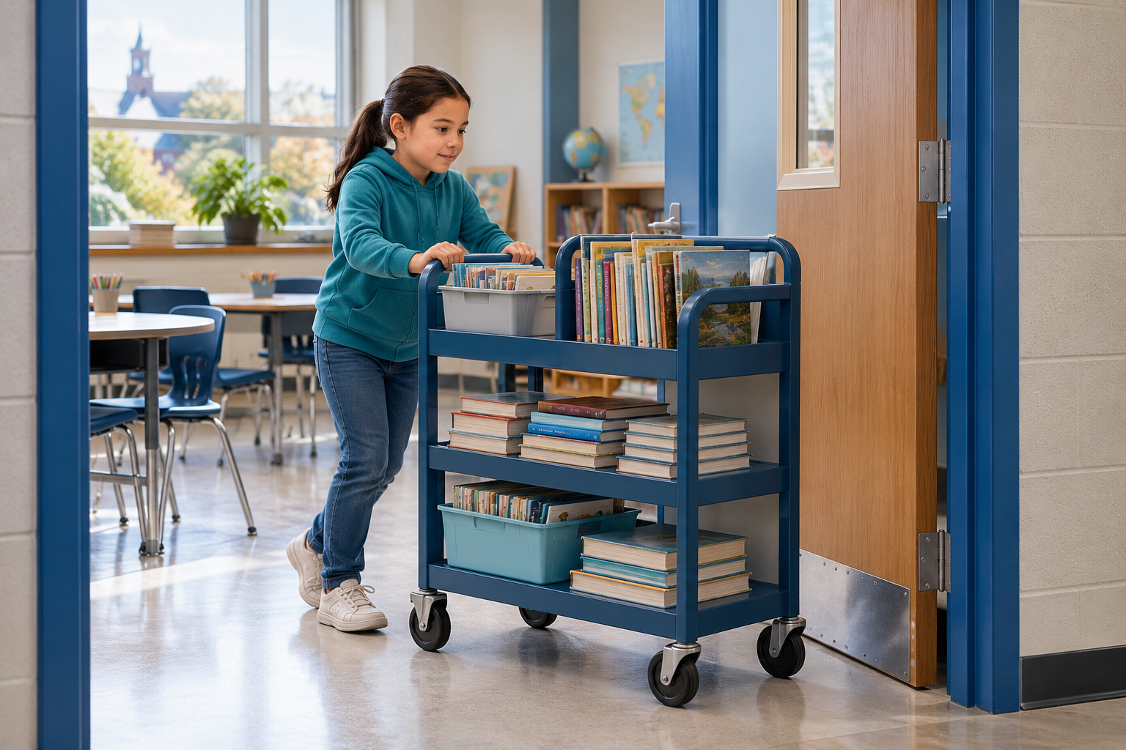
A student pushing a wheeled book cart through a classroom doorway. Designs must meet a need within constraints. Generated contextual illustration; not a scale model.

Test and improve
Build or examine a safe model. Describe its motion sequence and test one change at a time. Record what improved and what became less useful.
Electronic technologies can sense or control a system, but they also require energy and materials. A more complicated device is not always a better answer.
Explain your choice using evidence: what need is met, how the parts work and which tradeoff remains. Consider users with different needs.

What to remember
- Designs must meet a need within constraints.
- Technologies can provide benefits while using resources and changing surroundings.

Check your understanding
Explain aloud, sketch, or write. Use evidence from the chapter.
1 Why might a larger wheel help a cart on uneven ground but cause another problem?
My thinking
2 Why is a working prototype not enough to choose a design?
My thinking

Practise the words
Cover the meanings and explain the words. Then cover the words and name the meanings. Give an example.
technology tools and systems designed to meet needs
constraint a limit a design must meet
prototype a model made to test a design

Lesson connection
Lesson 8 · Technology and design
Original adaptation informed by Core Knowledge Foundation science materials including Investigating Forces, Simple Machines. Shared under CC BY NC SA 4.0. Generated contextual illustration.

