Earth and Moon Travel in Orbits
  - Grade 4 Unit 2 • Chapter 2
Learning goal I can distinguish rotation from revolution.
A globe can spin in one place or travel around a lamp. Those motions represent different ideas.

Turning is not orbiting
Earth rotates on its axis and revolves around the Sun. One revolution takes about a year. The Moon revolves around Earth and also rotates.
The Moon takes roughly a month to complete its familiar cycle in the sky. Its rotation and orbit are linked so nearly the same face points toward Earth.
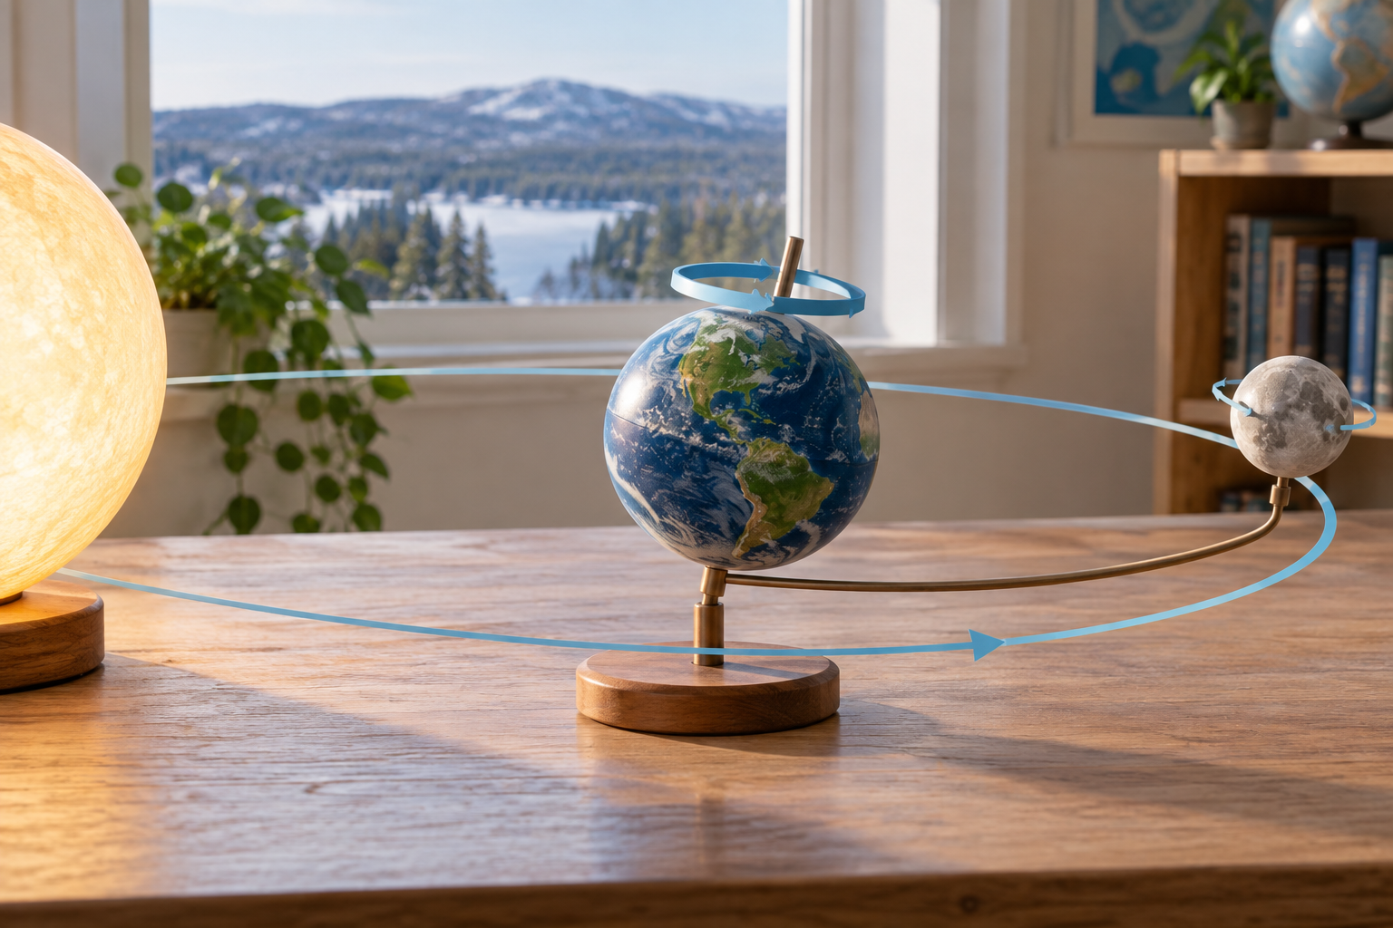
An unscaled Sun, Earth and Moon classroom model with motion guides. Rotation and revolution are different motions. Generated contextual illustration; not a scale model.

Connect the motions
Rotation helps explain daily changes in the sky. Revolution changes Earth’s position around the Sun. The Moon’s changing position helps explain its appearance over time.
Draw a path and mark the moving object. Add a separate symbol or explanation for spinning. One arrow without a label can confuse the two motions.
Classroom models are not to scale. Earth and the Moon are much smaller compared with their separation than many handheld models suggest.

What to remember
- Rotation and revolution are different motions.
- Earth orbits the Sun, and the Moon orbits Earth while also rotating.

Check your understanding
Explain aloud, sketch, or write. Use evidence from the chapter.
1 Could an object rotate without revolving around another object in your model?
My thinking
2 Why does seeing the same face of the Moon not prove that it never rotates?
My thinking

Practise the words
Cover the meanings and explain the words. Then cover the words and name the meanings. Give an example.
revolution movement around another object
orbit the path followed around another object
satellite an object that orbits another object

Lesson connection
Lesson 2 · Revolution and orbit
Original adaptation informed by Core Knowledge Foundation science materials including Astronomy, Weather Climate and Water Cycling. Shared under CC BY NC SA 4.0. Generated contextual illustration.

