Why the Moon Changes Shape
  - Grade 4 Unit 2 • Chapter 3
Learning goal I can explain four main Moon phases using reflected sunlight.
A thin Moon above a Québec evening sky is not a broken piece of the Moon.

The Moon remains round
Sunlight illuminates about half of the Moon. As it orbits Earth, we see different amounts of that illuminated half. The Moon’s own shape does not change.
At new moon, its sunlit side faces mostly away from Earth. At full moon, we see nearly the whole illuminated side. First quarter and last quarter show about half the Moon’s visible disk lit.
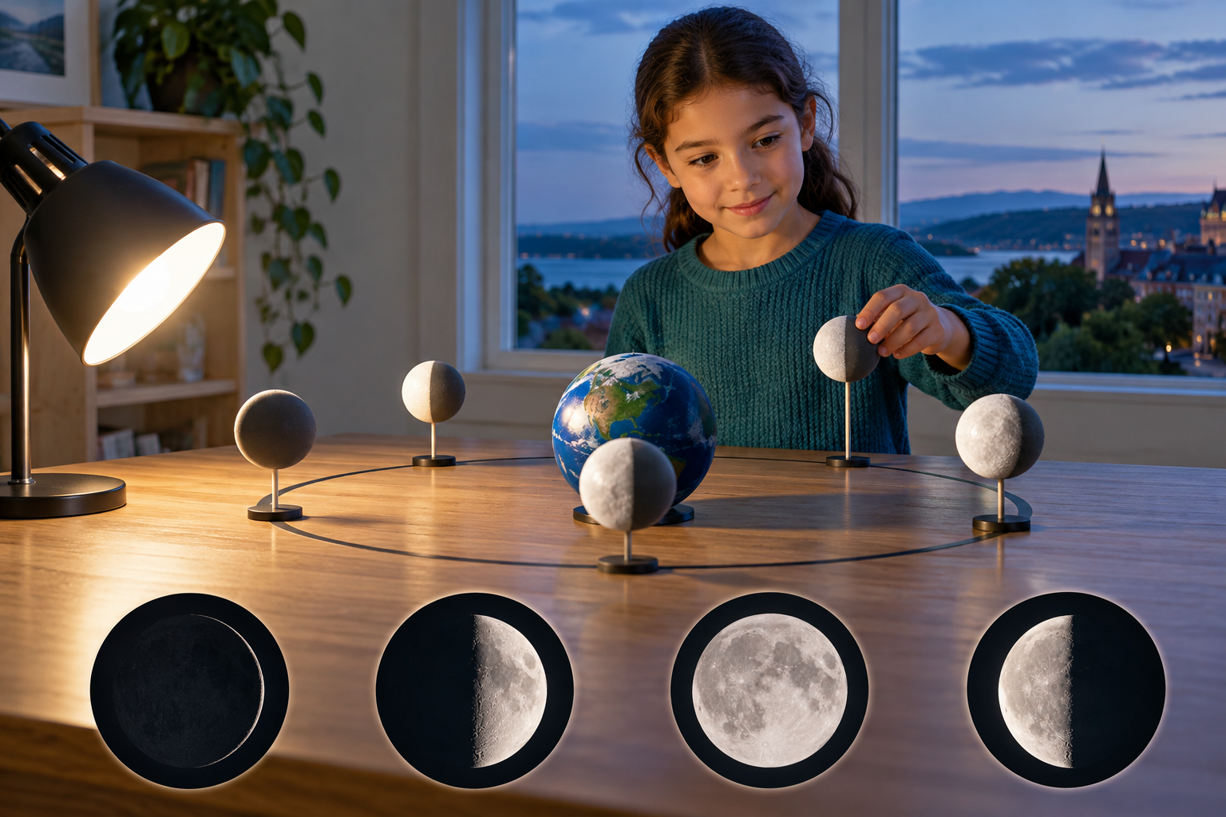
A composite of a lamp-and-ball activity with four illustrated Moon appearances. Moon phases reflect our changing view of its illuminated half. Generated contextual illustration; not a scale model.

Keep the cause clear
Ordinary phases are not Earth’s shadow crossing the Moon. A shadow explains a lunar eclipse, a different event.
A ball-and-lamp model can show phases when your viewing position represents Earth. Notice how the visible bright portion changes as the ball moves around you.
Draw new moon, first quarter, full moon and last quarter in sequence. State that quarter names refer to the cycle, not a quarter of the visible disk.

What to remember
- Moon phases reflect our changing view of its illuminated half.
- Ordinary phases are not produced by Earth’s shadow.

Check your understanding
Explain aloud, sketch, or write. Use evidence from the chapter.
1 Why is a half-lit Moon called a quarter phase?
My thinking
2 Why are ordinary phases not caused by Earth’s shadow?
My thinking

Practise the words
Cover the meanings and explain the words. Then cover the words and name the meanings. Give an example.
phase the appearance of the sunlit part of the Moon seen from Earth
new moon a phase with almost no sunlit surface visible from Earth
full moon a phase with the sunlit side facing Earth

Lesson connection
Lesson 3 · Moon phases
Original adaptation informed by Core Knowledge Foundation science materials including Astronomy, Weather Climate and Water Cycling. Shared under CC BY NC SA 4.0. Generated contextual illustration.

