When Shadows Make Eclipses
  - Grade 4 Unit 2 • Chapter 4
Learning goal I can compare solar and lunar eclipse alignments.
An eclipse needs a particular arrangement of the Sun, Earth and Moon.

Line up the bodies
In a solar eclipse, the Moon is between the Sun and Earth. Its shadow reaches part of Earth. In a lunar eclipse, Earth is between the Sun and Moon. Earth’s shadow falls on the Moon.
The Moon’s orbit is tilted relative to Earth’s orbit around the Sun. Most months, the shadows miss. That is why eclipses do not happen at every new and full moon.
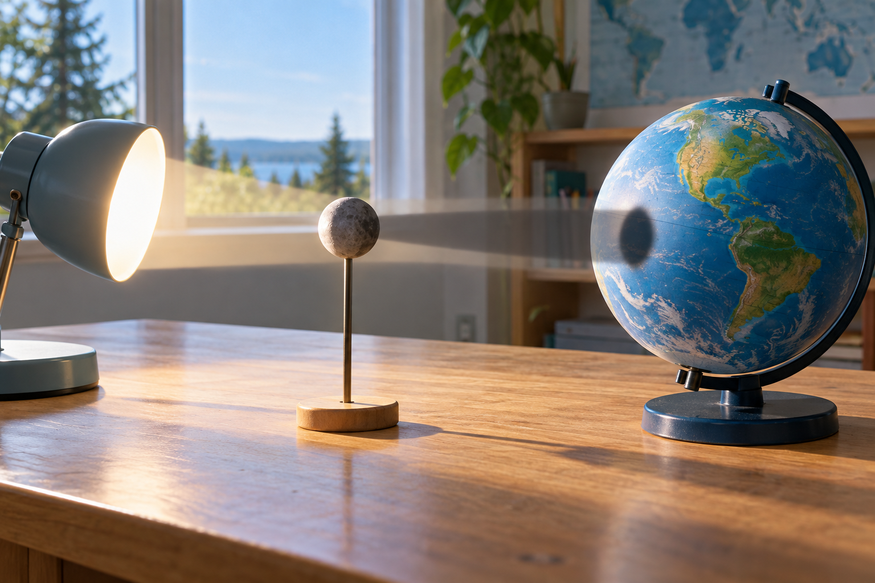
A small ball between a lamp and globe casting a shadow on the globe. Solar and lunar eclipses involve different shadow alignments. Generated contextual illustration; not a scale model.

Model without looking at the Sun
A lamp, globe and ball can show shadow positions safely. Identify which body casts the shadow and where it falls.
A lunar eclipse can be observed without special eye protection. Solar viewing needs approved equipment and knowledgeable adult supervision; ordinary sunglasses are not protection. Use recorded images for classroom study.
Neither eclipse changes the Moon’s shape. The change is in the light reaching us or the Moon.

What to remember
- Solar and lunar eclipses involve different shadow alignments.
- The Moon’s tilted orbit means the shadows usually miss at new and full moon.

Check your understanding
Explain aloud, sketch, or write. Use evidence from the chapter.
1 Why is there not a solar eclipse at every new moon?
My thinking
2 How do the shadows differ in solar and lunar eclipses?
My thinking

Practise the words
Cover the meanings and explain the words. Then cover the words and name the meanings. Give an example.
eclipse an event in which one body blocks light reaching or seen from another
solar eclipse the Moon blocking our view of part or all of the Sun
lunar eclipse Earth’s shadow falling on the Moon

Lesson connection
Lesson 4 · Eclipses
Original adaptation informed by Core Knowledge Foundation science materials including Astronomy, Weather Climate and Water Cycling. Shared under CC BY NC SA 4.0. Generated contextual illustration.

