Finding Patterns Among Stars
  - Grade 4 Unit 2 • Chapter 5
Learning goal I can use a star map and distinguish a constellation from a physical group.
Away from bright city lights, more stars can become visible above Québec.

Patterns help us find our way
Stars produce light. They can look like nearby dots even when they are very far apart in space. A constellation is a named sky region associated with a pattern, not necessarily a group of neighbouring stars.
The Big Dipper is a familiar pattern within the constellation Ursa Major. Its stars can help observers locate other parts of the sky.
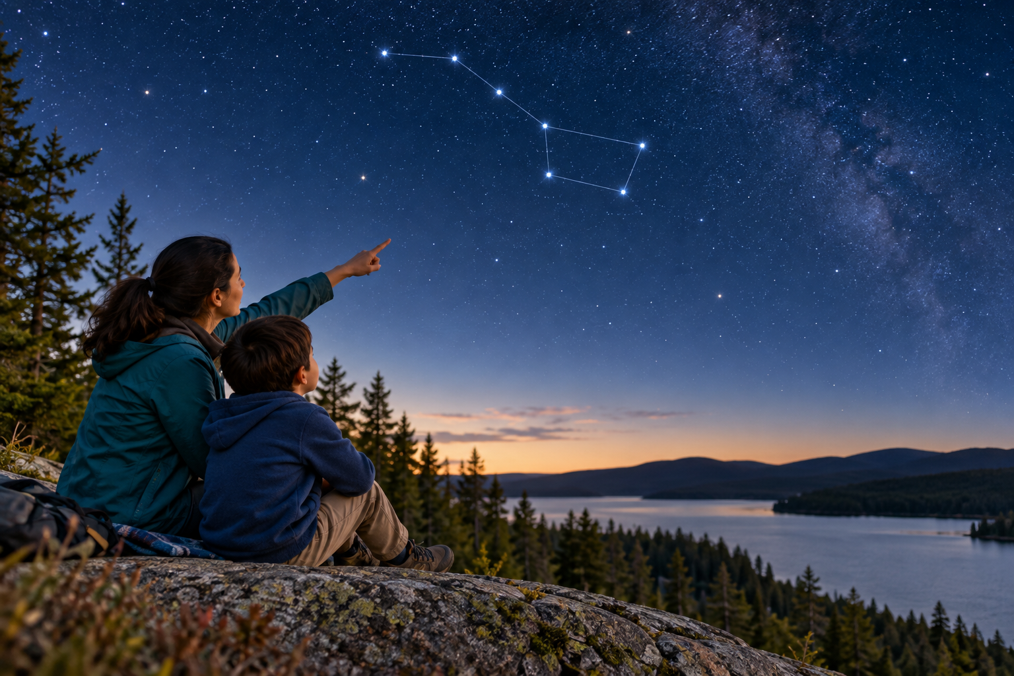
Observers looking at a night sky with a drawn Big Dipper guide. Constellation patterns describe apparent positions, not necessarily nearby stars. Generated contextual illustration; not a scale model.

Read a map from your place
A star map needs the observer’s location, date and time because the visible sky changes. Match the map’s directions to the horizon.
Earth’s rotation makes stars appear to move across the sky during a night. Earth’s revolution changes the night sky we see through the year.
Patterns are useful guides, but a flat map does not show stars’ true distances. Different cultures also describe sky patterns in different ways.

What to remember
- Constellation patterns describe apparent positions, not necessarily nearby stars.
- A useful star map matches the observer’s place and time.

Check your understanding
Explain aloud, sketch, or write. Use evidence from the chapter.
1 Why might two stars beside one another on a map be far apart in space?
My thinking
2 Why must you choose a map for the right time and location?
My thinking

Practise the words
Cover the meanings and explain the words. Then cover the words and name the meanings. Give an example.
star a luminous ball of hot gas that produces its own light
constellation a named region or familiar pattern in the sky
star map a chart showing where stars appear

Lesson connection
Lesson 5 · Stars and constellations
Original adaptation informed by Core Knowledge Foundation science materials including Astronomy, Weather Climate and Water Cycling. Shared under CC BY NC SA 4.0. Generated contextual illustration.

