Clouds Weather and Observing Tools
  - Grade 4 Unit 2 • Chapter 6
Learning goal I can use cloud observations and instruments as evidence about weather.
A cloud’s shape can help us describe the sky, but it does not guarantee tomorrow’s weather.

Clouds offer clues
Cumulus clouds often look piled and puffy. Stratus clouds form broad layers. Cirrus clouds are high and wispy, mainly made of ice crystals. Tall cumulonimbus clouds can bring thunderstorms.
Clouds form when conditions allow water vapour to condense or form ice. A dark appearance can come from a thick cloud blocking light; it is not a measurement of pollution.
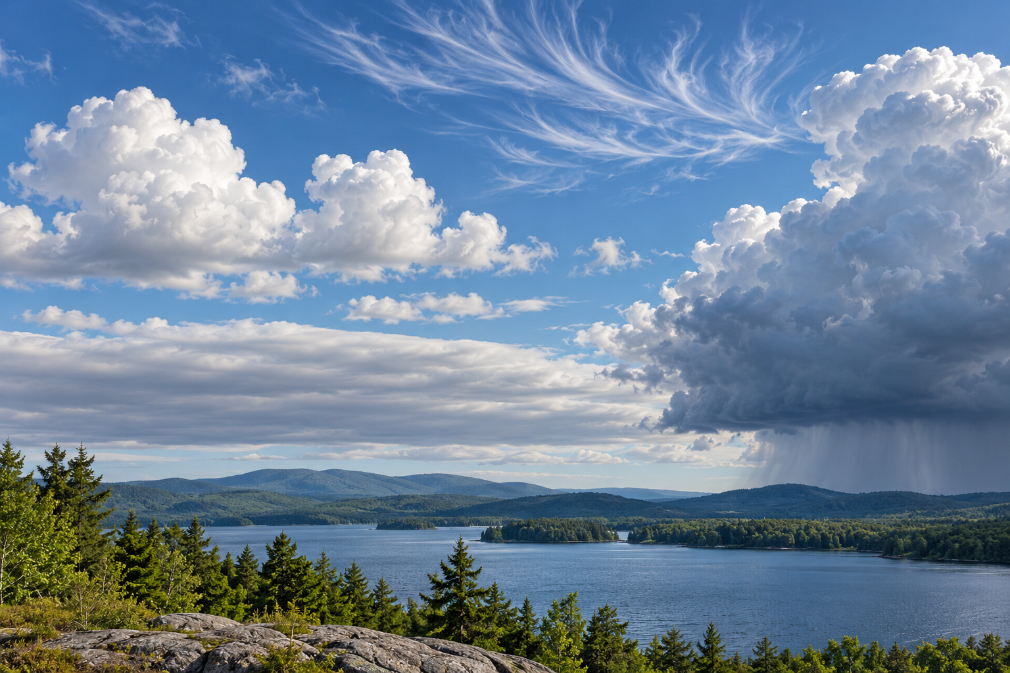
Different cloud forms in a composite sky above a forested lake. Cloud types provide clues but do not determine a forecast alone. Generated contextual illustration; not a scale model.

Combine observations
Thermometers measure temperature, rain gauges measure rainfall and weather stations collect several observations. Satellites observe broad patterns from above.
Technologies improve forecasts and help people plan travel or protect crops. Their predictions still have uncertainty. One cloud observation is only part of the evidence.
Observe from a safe place and follow school procedures during storms. Record the time as well as cloud type so comparisons are meaningful.

What to remember
- Cloud types provide clues but do not determine a forecast alone.
- Local instruments and broad observations provide complementary weather evidence.

Check your understanding
Explain aloud, sketch, or write. Use evidence from the chapter.
1 Why should a forecast use more than cloud shape alone?
My thinking
2 How can a satellite and a school weather station provide different useful evidence?
My thinking

Practise the words
Cover the meanings and explain the words. Then cover the words and name the meanings. Give an example.
weather atmospheric conditions at a place and time
cloud tiny water droplets or ice crystals suspended in air
forecast an evidence based prediction of future conditions

Lesson connection
Lesson 6 · Clouds and weather / Lesson 7 · Observation technologies
Original adaptation informed by Core Knowledge Foundation science materials including Astronomy, Weather Climate and Water Cycling. Shared under CC BY NC SA 4.0. Generated contextual illustration.

