Food Supplies More Than Energy
  - Grade 4 Unit 3 • Chapter 1
Learning goal I can explain why animals need varied nutrients and water.
A squirrel eating seeds obtains materials as well as energy.

Food has several jobs
Sugars provide energy and building material. Lipids store energy and help form body structures. Proteins support growth and repair. Vitamins and minerals help many body processes, while water transports substances and supports reactions.
Animals have common types of nutritional needs, but they do not all need the same foods or amounts. A varied diet can provide different useful nutrients.
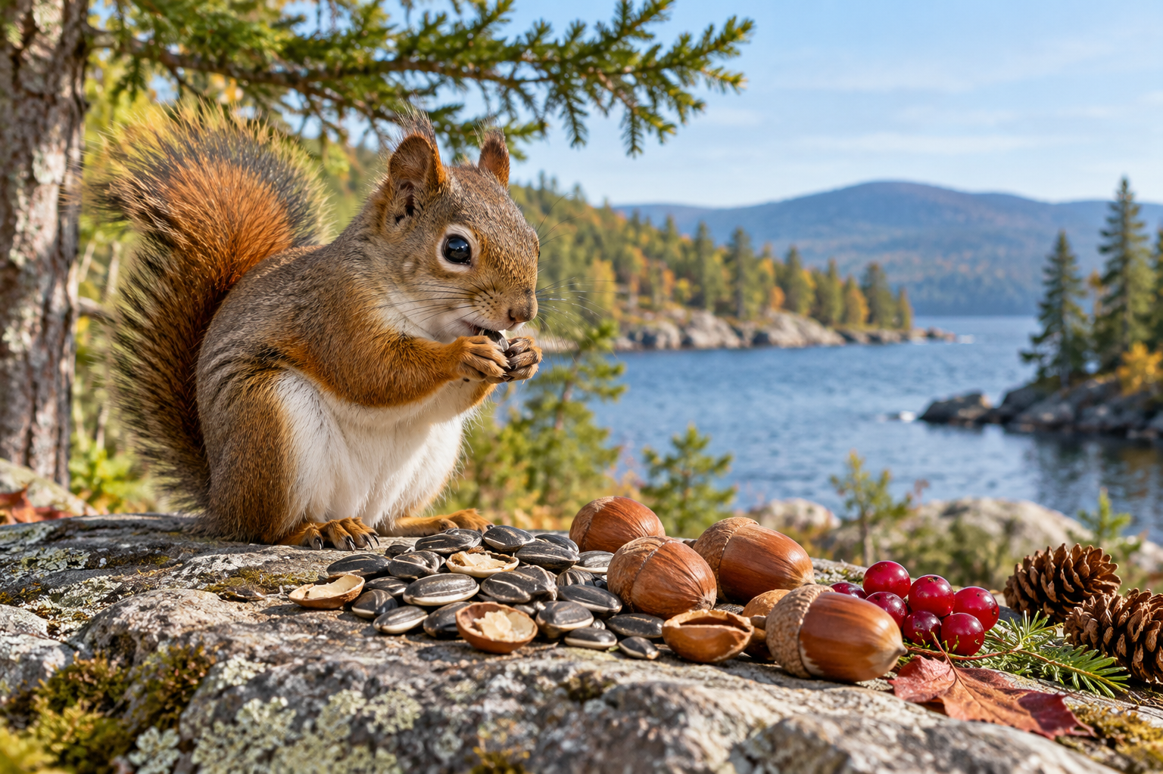
A squirrel eating among nuts, seeds and berries. Animals need both food energy and materials for body processes. Generated contextual illustration; not a scale model.

Compare needs carefully
An animal can get enough energy and still lack an important nutrient. Food quality cannot be judged only by how much energy it contains.
Observe what familiar animals eat using safe distance and reliable references. Do not feed wildlife to test an idea. Feeding can change behaviour or harm animals.
Nutrition is connected to habitat: an animal must find food and water it can use. This chapter explains common biological needs, not a personal diet plan.

What to remember
- Animals need both food energy and materials for body processes.
- Different nutrients and water support different functions.

Check your understanding
Explain aloud, sketch, or write. Use evidence from the chapter.
1 Why might food supplying enough energy still be insufficient for an animal?
My thinking
2 Why do two animal species not need exactly the same menu?
My thinking

Practise the words
Cover the meanings and explain the words. Then cover the words and name the meanings. Give an example.
nutrient a substance needed for growth maintenance or energy
protein a nutrient used to build and repair body structures
lipid a fat or oil used in energy storage and body structures

Lesson connection
Lesson 1 · Animal nutrition
Original adaptation informed by Core Knowledge Foundation science materials including Organisms and their Habitats, Habitats and Change, Energy and Matter in Ecosystems. Shared under CC BY NC SA 4.0. Generated contextual illustration.

