Different Diets Different Evidence
  - Grade 4 Unit 3 • Chapter 2
Learning goal I can classify animal diets using evidence about what animals eat.
A deer, a fox and a black bear may share a Québec landscape but obtain food differently.

Diet is a pattern
Herbivores mainly eat plant foods. Carnivores mainly eat animal foods. Omnivores eat both. These labels describe feeding patterns, not whether an animal is friendly or dangerous.
A bear can eat berries, insects and other animals. Its varied diet makes it an omnivore. A deer mainly browses plants and is a herbivore.
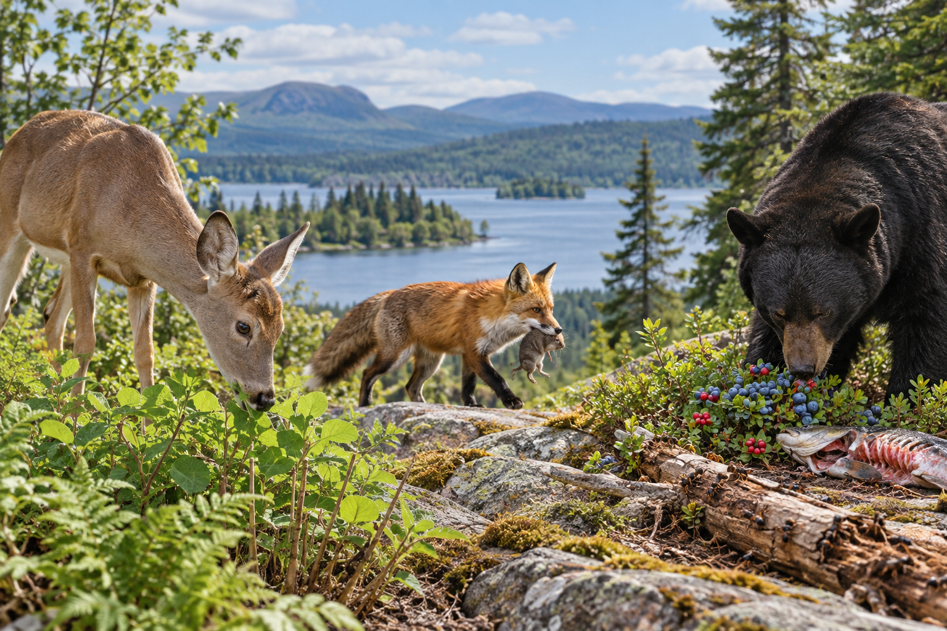
A composite habitat scene with a deer eating plants, a fox and a bear eating berries. Herbivore, carnivore and omnivore describe feeding patterns. Generated contextual illustration; not a scale model.

Look beyond one meal
One observation may not reveal the full diet. Foods can change with season, location and availability. Use several observations and reliable information.
Teeth and digestive structures can give clues, but an explanation should connect them to actual food use. Classification is stronger when several kinds of evidence agree.
All these animals depend on other organisms for food. Even a carnivore’s food supply connects indirectly to plants or other producers.

What to remember
- Herbivore, carnivore and omnivore describe feeding patterns.
- Repeated evidence is more useful than one meal for classifying a diet.

Check your understanding
Explain aloud, sketch, or write. Use evidence from the chapter.
1 Why is one observed meal not always enough to classify a diet?
My thinking
2 Why does eating both berries and insects support calling a bear an omnivore?
My thinking

Practise the words
Cover the meanings and explain the words. Then cover the words and name the meanings. Give an example.
herbivore an animal that mainly eats plants or plant products
carnivore an animal that mainly eats other animals
omnivore an animal that eats plant and animal foods

Lesson connection
Lesson 2 · Diets
Original adaptation informed by Core Knowledge Foundation science materials including Organisms and their Habitats, Habitats and Change, Energy and Matter in Ecosystems. Shared under CC BY NC SA 4.0. Generated contextual illustration.

