Producers Begin Many Food Paths
  - Grade 4 Unit 3 • Chapter 3
Learning goal I can explain why plants are producers and animals are consumers.
Grass in a park captures energy that a rabbit can later obtain by eating.

Food begins with a transformation
Green plants use light energy, water and carbon dioxide to make sugars through photosynthesis. They are producers. The sugars support their growth and provide energy released through respiration.
Animals cannot make food this way. They are consumers. They eat producers or other consumers to obtain materials and energy.
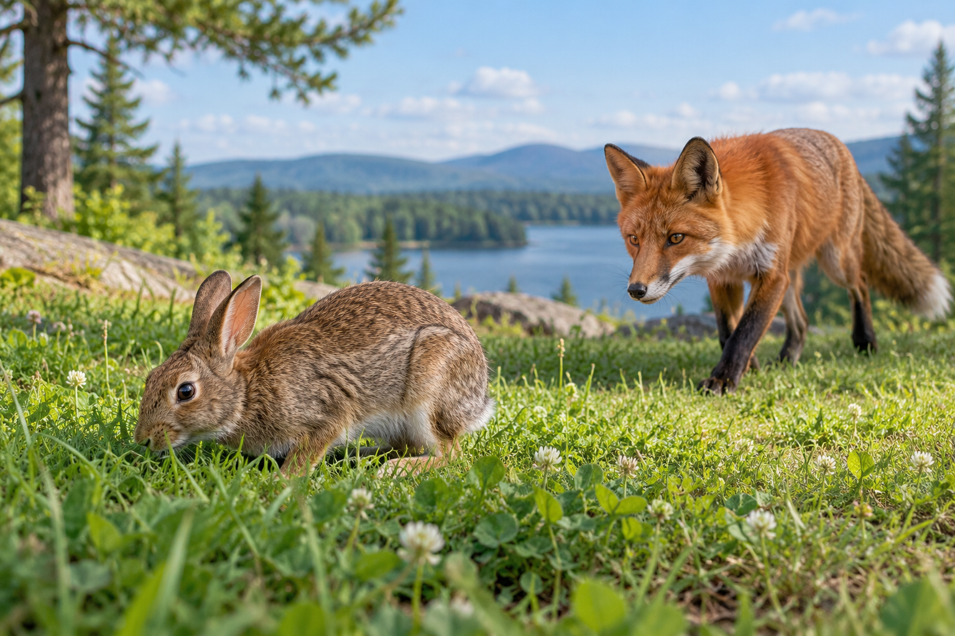
A rabbit among plants with a fox nearby. Producers make food while consumers obtain it from other organisms. Generated contextual illustration; not a scale model.

Trace the connection
A fox eating a rabbit receives some energy that began in the food the rabbit ate. Each organism uses energy for its own life processes; not all energy reaches the next consumer.
Plants also need water and mineral nutrients from their surroundings. Minerals are important materials but are not the plant’s food or energy source.
Removing producers can affect many consumers. A food relationship is a connection through which both matter and energy move.

What to remember
- Producers make food while consumers obtain it from other organisms.
- Food relationships connect matter and energy across several organisms.

Check your understanding
Explain aloud, sketch, or write. Use evidence from the chapter.
1 Why is soil not called a green plant’s food?
My thinking
2 How can a fox depend on plants even if it eats rabbits?
My thinking

Practise the words
Cover the meanings and explain the words. Then cover the words and name the meanings. Give an example.
producer an organism that makes its own food
consumer an organism that obtains food from other organisms
photosynthesis a process using light energy to make sugars

Lesson connection
Lesson 3 · Producers and consumers
Original adaptation informed by Core Knowledge Foundation science materials including Organisms and their Habitats, Habitats and Change, Energy and Matter in Ecosystems. Shared under CC BY NC SA 4.0. Generated contextual illustration.

