Read a Food Chain
  - Grade 4 Unit 3 • Chapter 4
Learning goal I can build a three or four link food chain and explain its arrows.
A food chain is more than a row of organism pictures.

Arrows show a relationship
One possible chain is grass, grasshopper, frog and heron. Arrows go from food to the organism that eats it. They represent a transfer of matter and energy, not the direction an animal chases another.
The first link is a producer. Later links are consumers. Check that the organisms can live in compatible surroundings and that the feeding links are plausible.
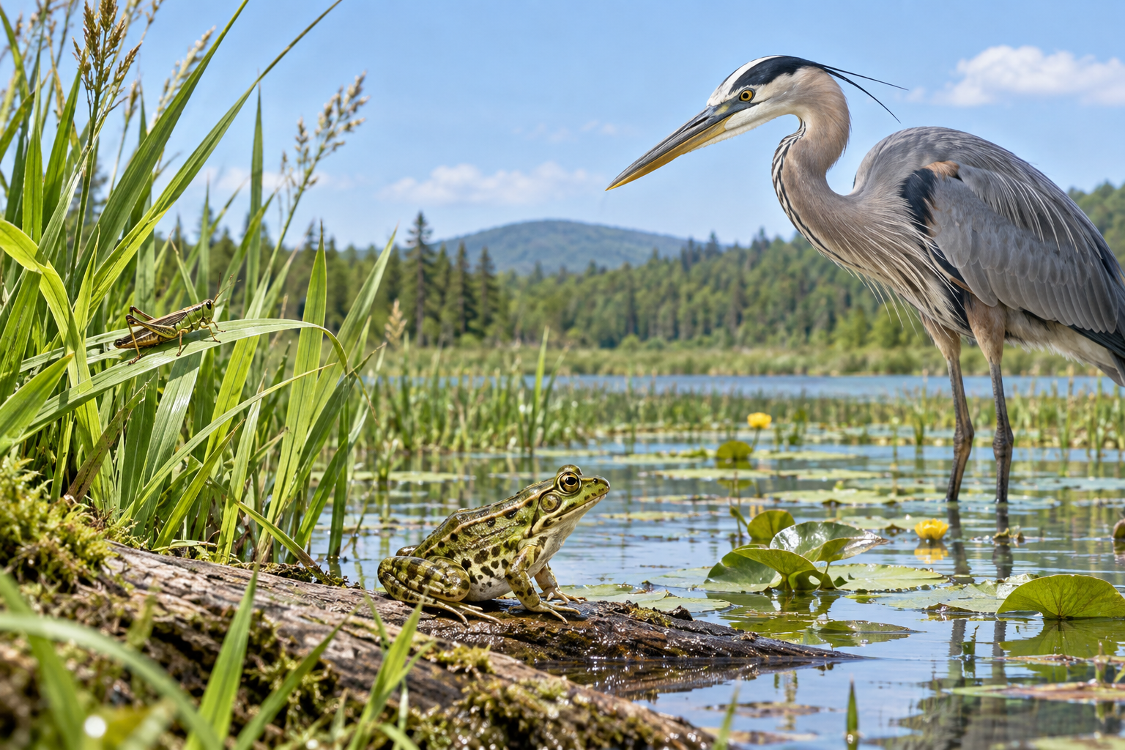
A frog beside reeds and a heron at a pond. Food-chain arrows point from food to the organism receiving it. Generated contextual illustration; not a scale model.

Models have limits
A real habitat contains many feeding connections, forming a food web. A heron may eat fish as well as frogs. One chain shows one path rather than the animal’s full menu.
Changing one population may affect others, but the effects depend on alternative foods and other conditions.
Use a Québec habitat as your setting and explain each arrow in words. A chain is useful only when its links are supported, not when it simply has the required number of pictures.

What to remember
- Food-chain arrows point from food to the organism receiving it.
- A chain represents one feeding path within a more complex web.

Check your understanding
Explain aloud, sketch, or write. Use evidence from the chapter.
1 Which way should an arrow point between a frog and a heron that eats it?
My thinking
2 Why can one chain not predict every effect of losing a food source?
My thinking

Practise the words
Cover the meanings and explain the words. Then cover the words and name the meanings. Give an example.
food chain a model showing a feeding path
energy transfer energy passing from one organism or place to another
prey an animal eaten by another animal

Lesson connection
Lesson 4 · Food chains
Original adaptation informed by Core Knowledge Foundation science materials including Organisms and their Habitats, Habitats and Change, Energy and Matter in Ecosystems. Shared under CC BY NC SA 4.0. Generated contextual illustration.

