Habitats Meet Needs
  - Grade 4 Unit 3 • Chapter 5
Learning goal I can explain how habitat features support a population.
A pond can offer a frog food, water, shelter and places to reproduce.

A habitat is not just an address
A habitat provides conditions and resources an organism needs. Different animals use the same place differently. A tree can provide a bird’s nest site and insects for food while giving a squirrel shelter.
A population includes members of one species in an area. Several populations can live in the same habitat. Counting all animals together does not give the size of one population.
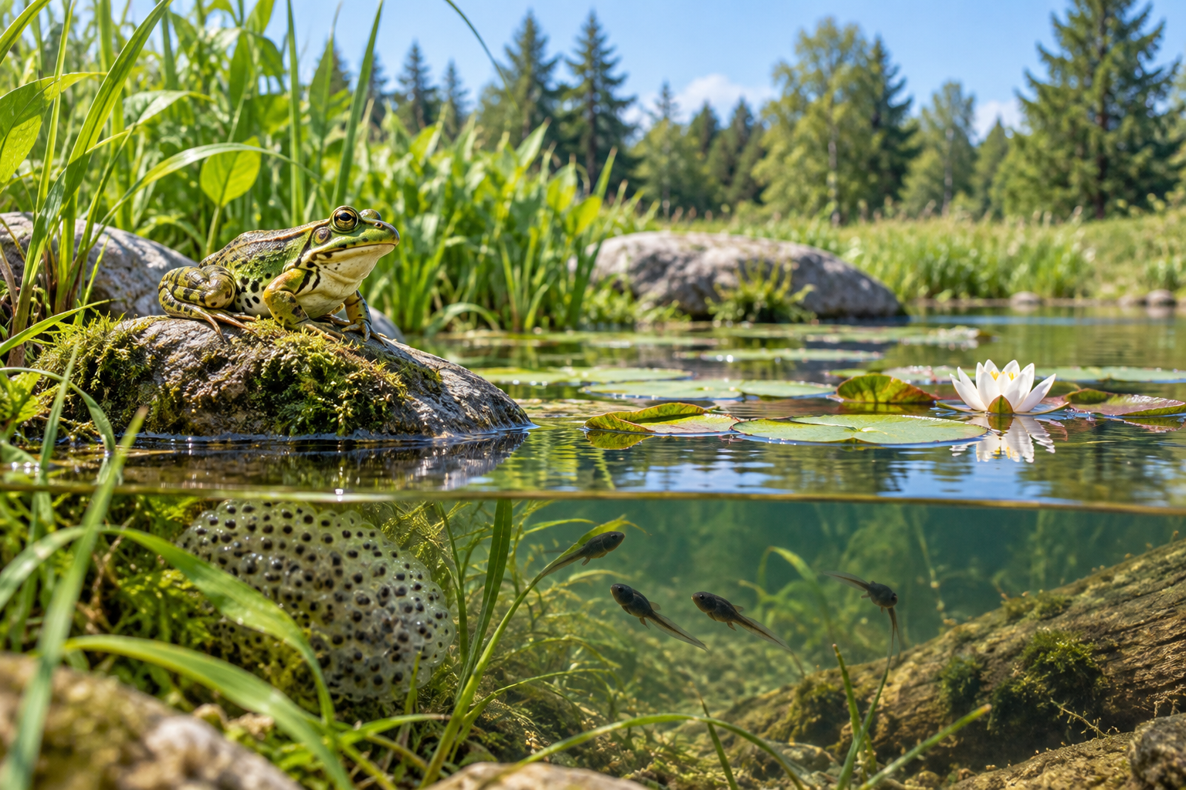
A frog, eggs and tadpoles in and beside a pond. Habitats supply conditions and resources that meet organisms’ needs. Generated contextual illustration; not a scale model.

Study without disturbing
Observe a schoolyard or nearby green space. Record vegetation, water, shelter and signs of organisms. Note date, time and weather.
Not seeing an animal does not prove it is absent. Some are active at night or stay hidden. Signs such as tracks provide a different kind of evidence.
Explain which feature meets which need. Do not collect nests, handle wildlife or change a habitat just to make observations easier.

What to remember
- Habitats supply conditions and resources that meet organisms’ needs.
- A population consists of one species within an area.

Check your understanding
Explain aloud, sketch, or write. Use evidence from the chapter.
1 Why might planting one tree not meet all a bird’s habitat needs?
My thinking
2 Why is counting every animal in a pond not a count of one population?
My thinking

Practise the words
Cover the meanings and explain the words. Then cover the words and name the meanings. Give an example.
habitat the place where an organism meets its needs
population members of one species living in an area
resource something an organism uses to meet a need

Lesson connection
Lesson 5 · Habitats and populations / Lesson 8 · Local habitat study
Original adaptation informed by Core Knowledge Foundation science materials including Organisms and their Habitats, Habitats and Change, Energy and Matter in Ecosystems. Shared under CC BY NC SA 4.0. Generated contextual illustration.

