Predators Parasites and Their Hosts
  - Grade 4 Unit 3 • Chapter 6
Learning goal I can distinguish predation from parasitism and explain an effect.
A heron catching a fish and a tick feeding on a mammal are different relationships.

Relationships differ
Predation involves a predator killing and eating prey. It provides food to the predator and can affect the prey population. Prey have structures and behaviours that can reduce the chance of being caught.
A parasite benefits by living on or inside a host. It obtains resources and harms the host, but usually does not kill the host immediately as a predator does.
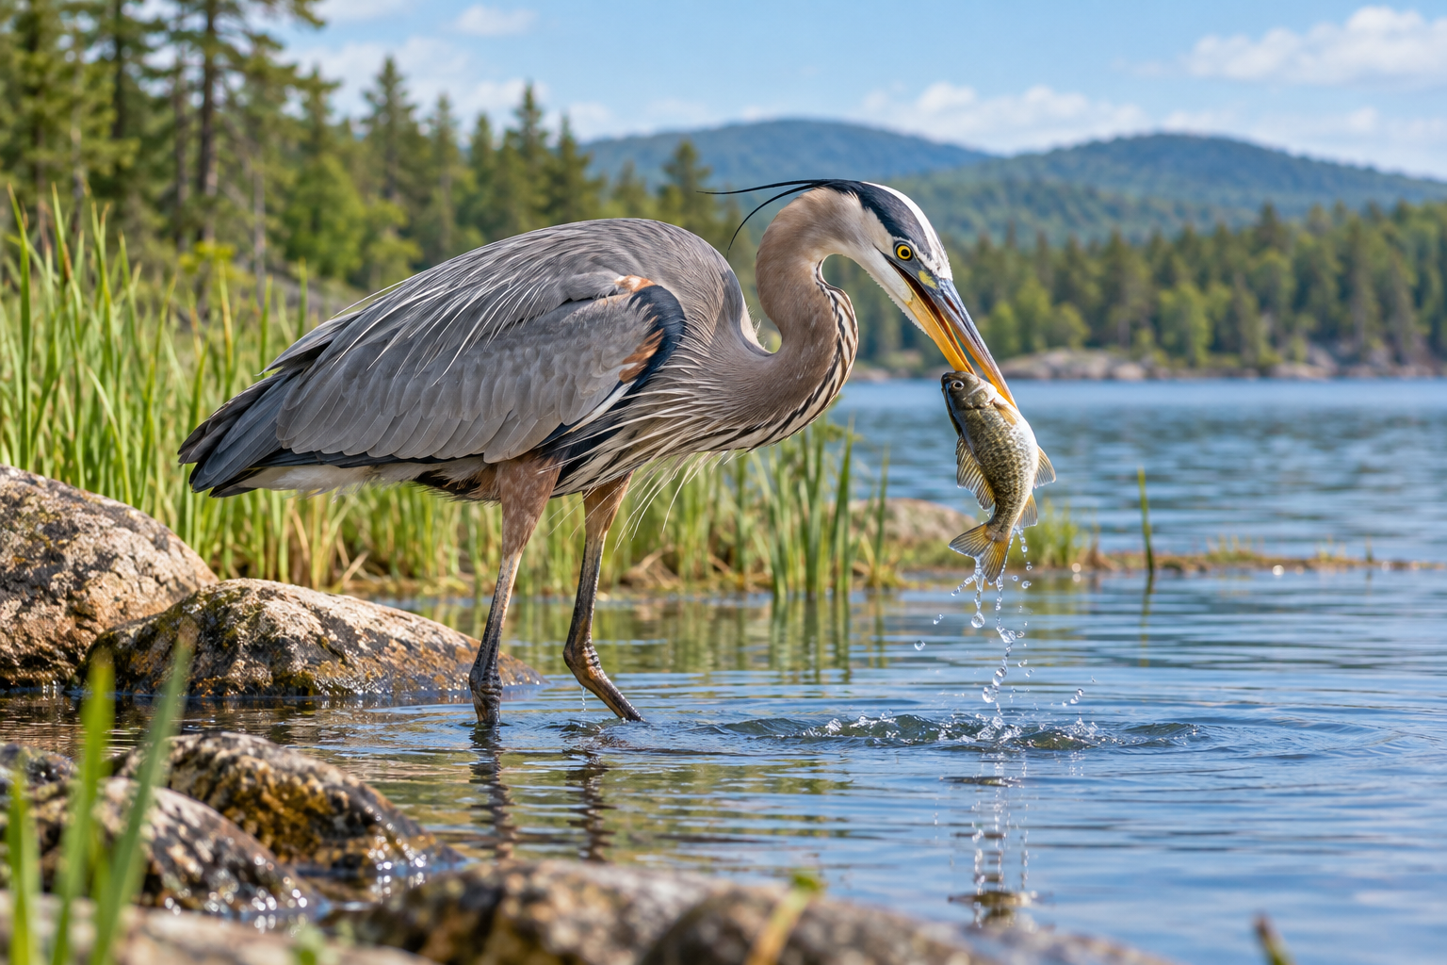
A heron holding a fish it has caught. Predation and parasitism are different ecological relationships. Generated contextual illustration; not a scale model.

Explain without judging
These relationships are part of ecosystems, not examples of organisms being good or bad. An organism can be a predator in one relationship and prey in another.
A frog can eat insects and be eaten by a heron. Several roles connect the same animal to different organisms.
Use pictures or references for parasite study. Do not handle ticks or approach animals. Tell an adult about a safety concern rather than trying to investigate it yourself.

What to remember
- Predation and parasitism are different ecological relationships.
- An organism’s role depends on which relationship is being described.

Check your understanding
Explain aloud, sketch, or write. Use evidence from the chapter.
1 How can a frog be both predator and prey?
My thinking
2 Why does a tick-host relationship differ from a heron-fish relationship?
My thinking

Practise the words
Cover the meanings and explain the words. Then cover the words and name the meanings. Give an example.
predation one organism killing and eating another
parasite an organism that lives on or in a host and benefits at its expense
host an organism supporting a parasite

Lesson connection
Lesson 6 · Ecological relationships
Original adaptation informed by Core Knowledge Foundation science materials including Organisms and their Habitats, Habitats and Change, Energy and Matter in Ecosystems. Shared under CC BY NC SA 4.0. Generated contextual illustration.

