Adaptations and Growing Food
  - Grade 4 Unit 3 • Chapter 7
Learning goal I can explain camouflage and mimicry and connect food technologies to needs.
A snowshoe hare’s pale winter coat can make it harder to notice against snow.

Features have effects
Camouflage reduces detection in particular surroundings. A feature useful in one setting may be less useful elsewhere. Mimicry involves resemblance, such as an insect resembling a twig or a harmless species resembling a defended species.
An individual does not choose a new inherited adaptation when it needs one. Features vary and can influence survival and reproduction across generations.
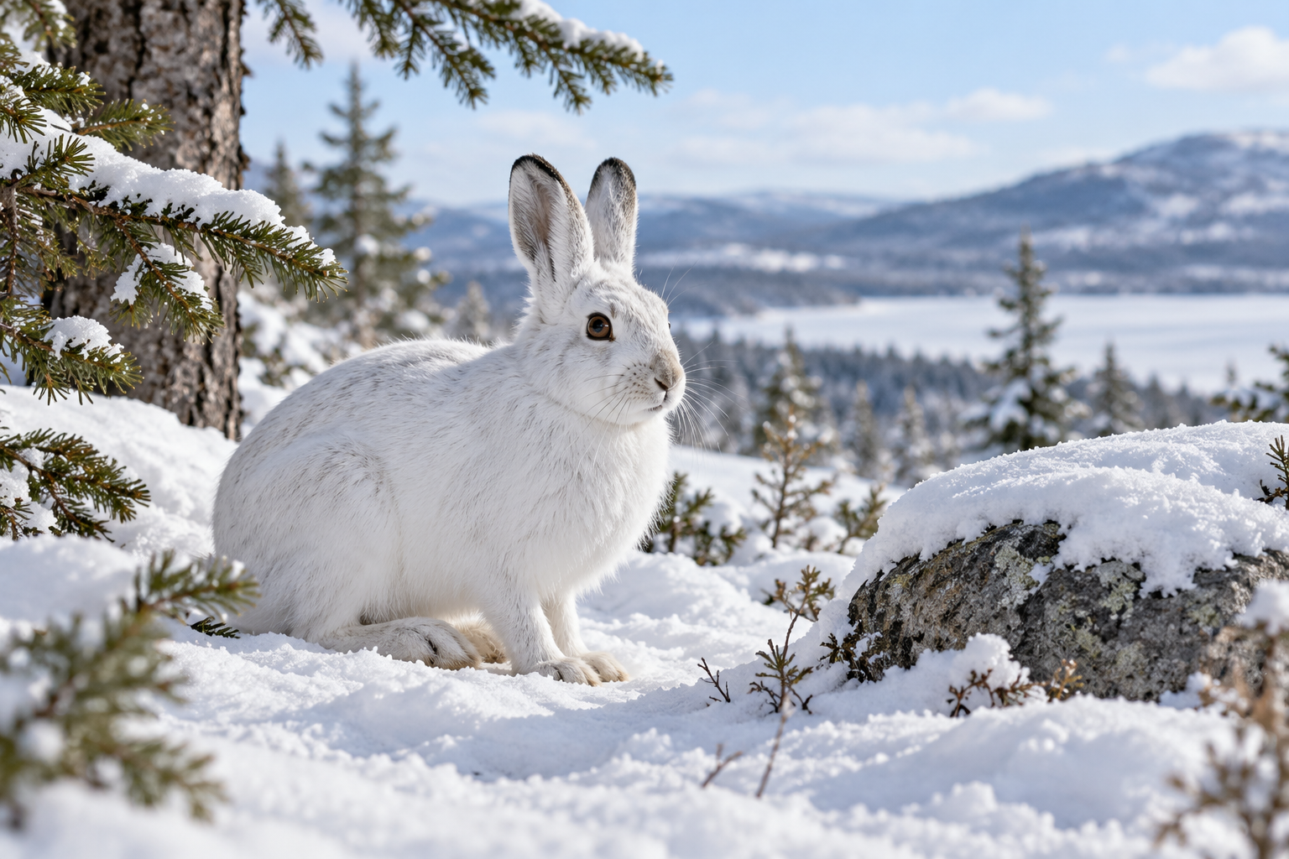
A pale snowshoe hare against a snowy forest background. Camouflage and mimicry can improve survival in particular surroundings. Generated contextual illustration; not a scale model.

People design food technologies
Agriculture uses knowledge about organisms and their needs. Irrigation supplies water; greenhouses alter growing conditions; refrigeration slows many processes that spoil harvested food.
These technologies can improve food supply but use water, energy and materials. Compare a benefit with a tradeoff rather than assuming technology has only good or bad effects.
A classroom proposal should explain what need it meets and how evidence supports it. Natural adaptations and designed technologies both have effects, but they arise in different ways.

What to remember
- Camouflage and mimicry can improve survival in particular surroundings.
- Food technologies meet needs but also use resources and create tradeoffs.

Check your understanding
Explain aloud, sketch, or write. Use evidence from the chapter.
1 Why might white camouflage be less useful when snow is absent?
My thinking
2 How could a greenhouse help plants while creating a tradeoff?
My thinking

Practise the words
Cover the meanings and explain the words. Then cover the words and name the meanings. Give an example.
adaptation an inherited feature that can improve survival or reproduction
camouflage features that make an organism hard to distinguish from surroundings
mimicry resemblance to another organism or object

Lesson connection
Lesson 7 · Adaptation
Original adaptation informed by Core Knowledge Foundation science materials including Organisms and their Habitats, Habitats and Change, Energy and Matter in Ecosystems. Shared under CC BY NC SA 4.0. Generated contextual illustration.

