Environmental Systems Are Connected
  - Grade 4 Unit 4 • Chapter 1
Learning goal I can explain how a human change can affect water, soil, air and living things.
Rain washes across a paved schoolyard differently than across a planted garden.

One change can spread
Water, soil, air and organisms interact. Paving can reduce infiltration and increase runoff. Runoff can carry particles and pollutants to streams. Removing plant cover can also reduce habitat.
Urbanization, agriculture and resource use change these systems in different ways. People need homes and food, so the question is how to meet needs while reducing harmful effects.
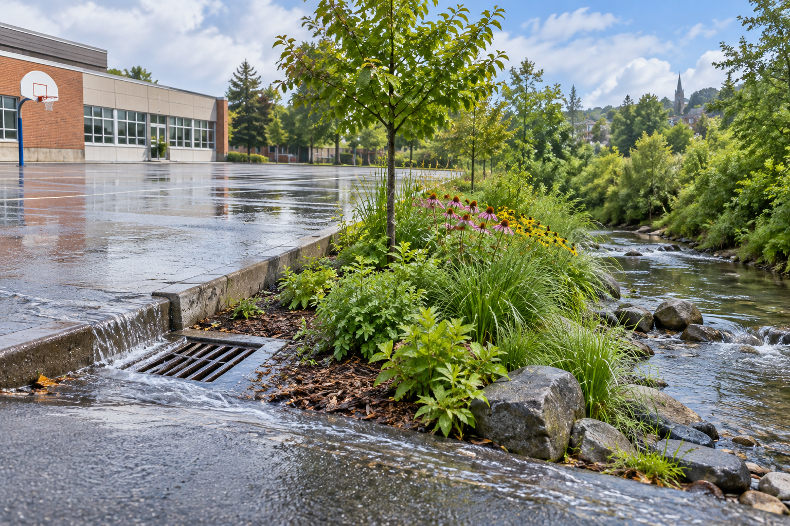
Runoff near a paved schoolyard, a drain and a planted strip. Environmental systems connect water, soil, air and living things. Generated contextual illustration; not a scale model.

Trace a cause and an effect
A useful explanation names a specific change and follows its path. More pavement can mean more runoff, which can change stream conditions.
Not every change has the same effect everywhere. Soil, slope, weather and the design itself matter. Observation helps test whether a proposed explanation fits the place.
Compare both benefits and costs. A planted strip may support organisms and absorb some rainwater, but it also needs a suitable location and care.

What to remember
- Environmental systems connect water, soil, air and living things.
- A local human change can have effects beyond its immediate site.

Check your understanding
Explain aloud, sketch, or write. Use evidence from the chapter.
1 Why can a schoolyard change affect a stream outside the school?
My thinking
2 Why is it useful to consider both a paved path and planted space?
My thinking

Practise the words
Cover the meanings and explain the words. Then cover the words and name the meanings. Give an example.
system connected parts that affect one another
biodiversity the variety of living things
pollution harmful materials or changes introduced into an environment

Lesson connection
Lesson 1 · Environmental systems / Lesson 2 · Human pressures
Original adaptation informed by Core Knowledge Foundation science materials including Using Natural Resources, Protecting Earths Resources. Shared under CC BY NC SA 4.0. Generated contextual illustration.

