A Product Has a Life Cycle
  - Grade 4 Unit 4 • Chapter 2
Learning goal I can trace the environmental effects of making, using and disposing of a product.
A lunch container has environmental effects before it becomes waste.

Look beyond the bin
Its materials must be obtained, transported and manufactured. Each step can use energy and water or create pollution. The container is then used, cleaned, repaired or replaced.
After use, it may be reused, recycled or disposed of. Calling a product recyclable tells us about one possible stage, not its whole life cycle.
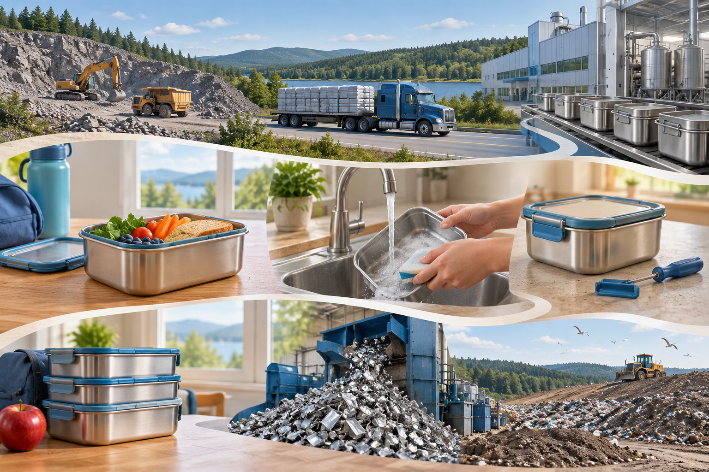
A composite product life-cycle illustration showing materials, manufacturing, washing, reuse and disposal. A product’s environmental effects extend from raw materials through use and disposal. Generated contextual illustration; not a scale model.

Compare the whole job
A durable container used many times can avoid some disposable packaging. Its production and cleaning still have effects. The useful comparison considers how often it is used and what it replaces.
Resource extraction, waste management and land use can affect habitats and communities. A design decision should connect an effect to a stage.
Draw the path of a familiar product and identify where reducing material, repairing or reusing could help. Avoid a claim that one material is always best in every situation.

What to remember
- A product’s environmental effects extend from raw materials through use and disposal.
- Durability, reuse and repair can change the whole-life comparison.

Check your understanding
Explain aloud, sketch, or write. Use evidence from the chapter.
1 Why does recyclable not mean a product has no environmental effects?
My thinking
2 Why does number of uses matter when comparing containers?
My thinking

Practise the words
Cover the meanings and explain the words. Then cover the words and name the meanings. Give an example.
raw material matter used to make a product
life cycle stages from a product’s materials to its final use or disposal
durable able to remain useful for a long time

Lesson connection
Lesson 3 · Product and material life cycles
Original adaptation informed by Core Knowledge Foundation science materials including Using Natural Resources, Protecting Earths Resources. Shared under CC BY NC SA 4.0. Generated contextual illustration.

