Recycling Changes Materials
  - Grade 4 Unit 4 • Chapter 3
Learning goal I can explain how sorting and material properties affect recycling.
Putting paper in a collection bin is not the same as making new paper.

A bin is the beginning
Recycling needs collection, sorting and processing. Materials must be identified by their properties. Paper fibres can be made into pulp and formed into new sheets. Metals may be separated and melted.
These steps use energy and can involve physical changes. Different materials need different processes; not every plastic follows the same recycling path.
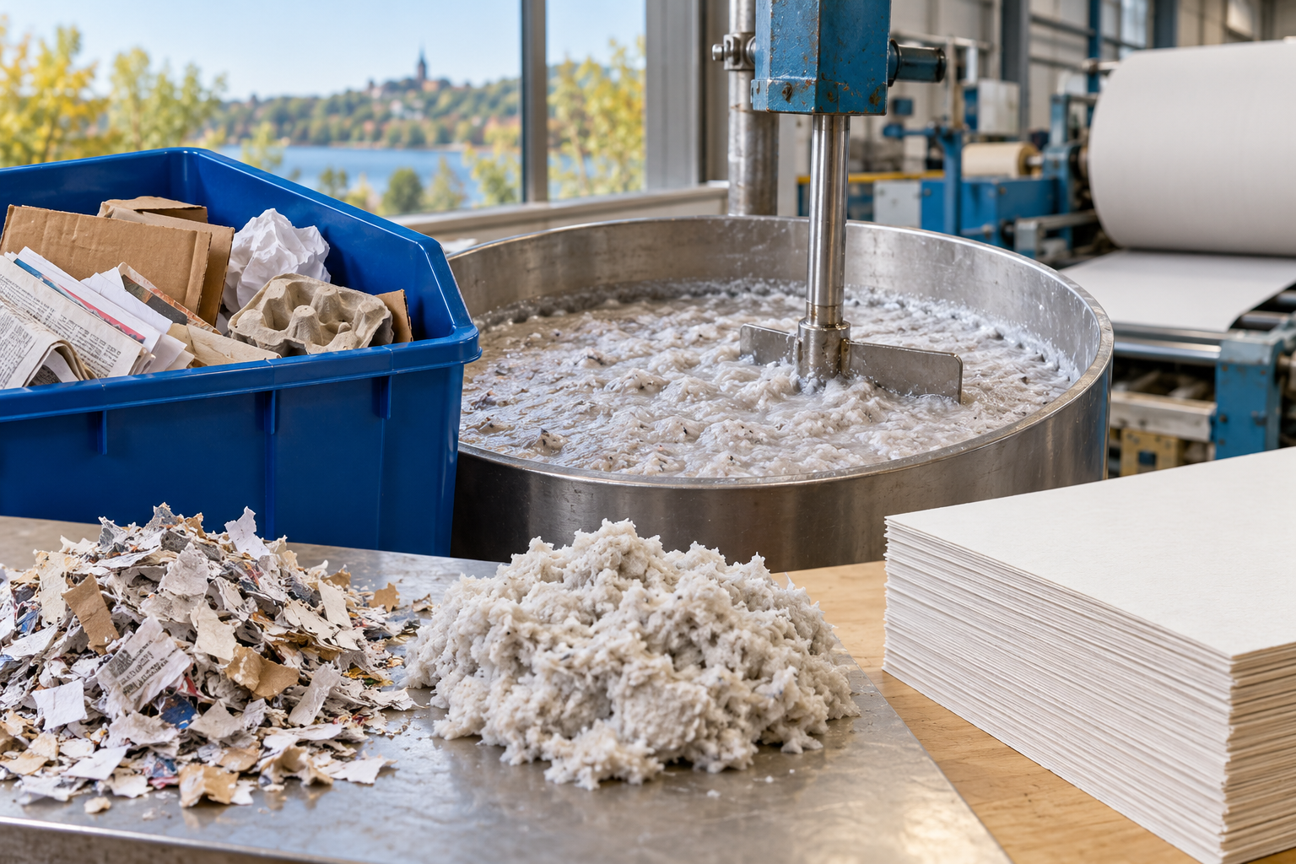
Recovered paper, paper pulp and formed paper sheets beside processing equipment. Recycling needs sorting and processing matched to material properties. Generated contextual illustration; not a scale model.

Reduce confusion and waste
Food residue or unsuitable materials can interfere with sorting and processing. Follow the collection instructions for your school or municipality rather than guessing from appearance.
Recycling can recover useful matter, but avoiding unnecessary products and reusing items can prevent waste before processing is needed.
Compare a sorting design using safe, clean samples. Explain which property helps the separation and how you know it works. Do not assume all items placed in a bin are automatically recovered.

What to remember
- Recycling needs sorting and processing matched to material properties.
- Reduction and reuse can prevent some waste before processing is needed.

Check your understanding
Explain aloud, sketch, or write. Use evidence from the chapter.
1 Why should different materials be separated before processing?
My thinking
2 Why can reuse be useful even when an item is recyclable?
My thinking

Practise the words
Cover the meanings and explain the words. Then cover the words and name the meanings. Give an example.
recycling processing used material so it can be used again
sorting separating materials by useful categories
property a feature of a material

Lesson connection
Lesson 4 · Recycling
Original adaptation informed by Core Knowledge Foundation science materials including Using Natural Resources, Protecting Earths Resources. Shared under CC BY NC SA 4.0. Generated contextual illustration.

