Composting and a Local Design
  - Grade 4 Unit 4 • Chapter 4
Learning goal I can explain decomposition and justify a school waste-reduction design.
An apple core does not disappear when it is composted. Its matter changes and moves.

Matter returns to systems
Decomposers, including microorganisms and fungi, break down suitable organic material. They use food energy and release some as thermal energy. Air, moisture and suitable conditions affect the process.
Finished compost contains transformed organic material that can improve soil. Not every product labelled natural belongs in a classroom compost system.
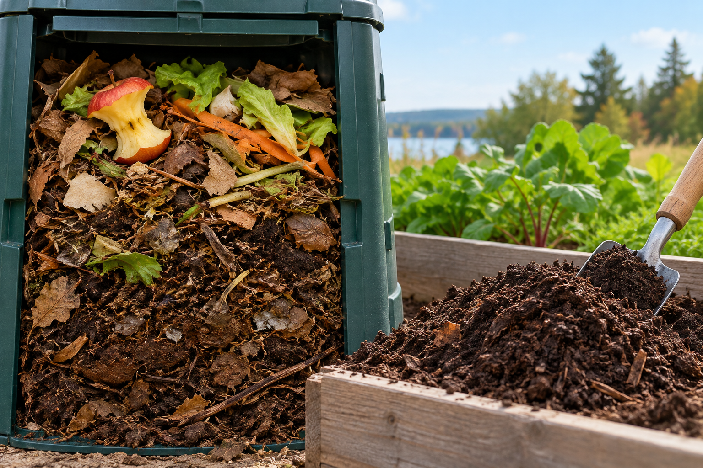
Organic scraps and decomposed material in a compost setting. Decomposers transform organic matter and use its food energy. Generated contextual illustration; not a scale model.

Design around the cause
Find where school waste begins. Could a change prevent waste, encourage reuse or improve sorting? Measure a baseline before judging a solution.
Use the school’s accepted-material instructions. A classroom model does not guarantee that materials will behave the same in every municipal system.
State what your design improves and what still needs checking. For example, clearer sorting signs may reduce mistakes, but only observations can show whether people use them successfully.

What to remember
- Decomposers transform organic matter and use its food energy.
- A local design should address a specific cause and be checked with evidence.

Check your understanding
Explain aloud, sketch, or write. Use evidence from the chapter.
1 Why is composting more than shrinking a pile of scraps?
My thinking
2 How would you know whether new sorting signs helped?
My thinking

Practise the words
Cover the meanings and explain the words. Then cover the words and name the meanings. Give an example.
decomposition breaking down remains and wastes of organisms
compost partly decomposed organic material used to improve soil
decomposer an organism that breaks down organic material

Lesson connection
Lesson 5 · Composting / Lesson 6 · Local design response
Original adaptation informed by Core Knowledge Foundation science materials including Using Natural Resources, Protecting Earths Resources. Shared under CC BY NC SA 4.0. Generated contextual illustration.

