Objects Are Made of Materials
  - Grade 5 Unit 1 • Chapter 1
Learning goal I can identify materials in an object and connect them to a purpose.
A winter boot is not made from one substance with one job.

One object several materials
Rubber or another flexible material can form a waterproof sole. Fabric and insulation can slow thermal energy transfer. Fasteners connect parts. Each material contributes particular properties.
An object’s appearance does not always reveal its material. A metallic coating can cover plastic, and a wooden surface can cover a different core. Use more than colour when identifying materials.
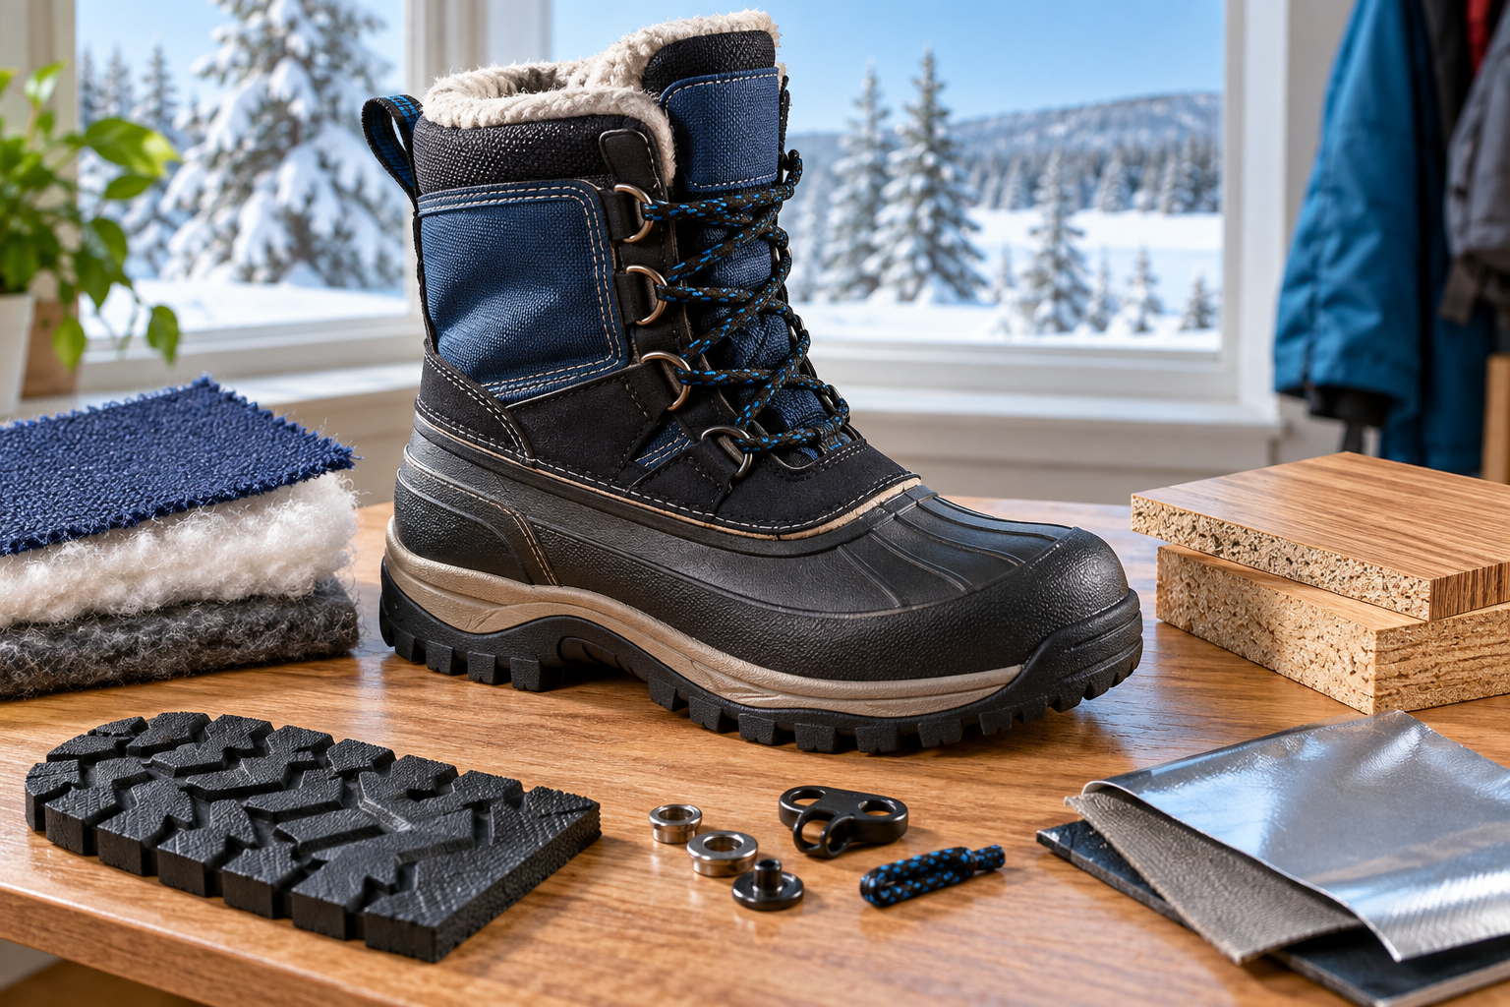
A winter boot surrounded by rubber, insulating fabric, fasteners and other material samples. An object can combine materials with different useful properties. Generated contextual illustration; not a scale model.

Identify then justify
Ask what each part must do. A transparent window needs different properties from a supportive frame. A composite combines materials to provide useful features that one alone may not provide.
Use labels, references and safe tests to support identification. Do not burn, taste or scratch unknown products. A classroom investigation should not damage protective equipment.
Choosing a material also involves availability, durability and environmental effects. Name a property and show why it fits the part’s actual function.

What to remember
- An object can combine materials with different useful properties.
- Material identification needs more evidence than surface appearance.

Check your understanding
Explain aloud, sketch, or write. Use evidence from the chapter.
1 Why might a boot need several materials rather than one?
My thinking
2 Why does a shiny surface not prove that an object is solid metal?
My thinking

Practise the words
Cover the meanings and explain the words. Then cover the words and name the meanings. Give an example.
material matter used to make an object
property a feature used to describe or compare matter
composite a material made by combining different materials

Lesson connection
Lesson 1 · Objects and materials
Original adaptation informed by Core Knowledge Foundation science materials including Investigating Matter, Properties of Matter. Shared under CC BY NC SA 4.0. Generated contextual illustration.

