Evidence of Chemical Reactions
  - Grade 5 Unit 1 • Chapter 5
Learning goal I can explain chemical changes in cooking, combustion, oxidation and acid-base reactions.
A rusty bicycle chain has changed chemically, not just become dirty.

Familiar changes have causes
Rust forms when iron reacts with oxygen in the presence of water. The resulting material has different properties from iron. Cooking can also produce chemical changes, such as changes to proteins when an egg cooks.
Combustion involves fuel reacting with oxygen and releasing energy. Smoke and ash may form, depending on the fuel and conditions.
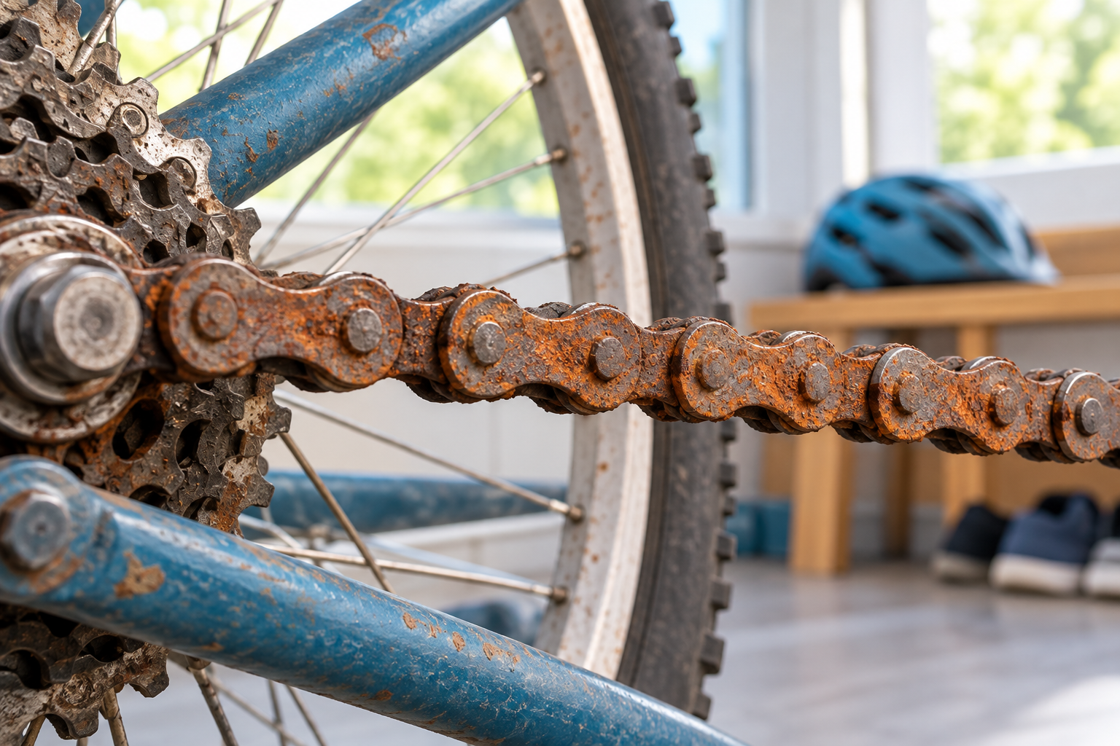
Rust on a bicycle chain and nearby metal parts. Cooking, combustion, oxidation and acid-base reactions can produce new substances. Generated contextual illustration; not a scale model.

Interpret several clues
An acid and a base can react to make new substances. Some particular combinations, such as vinegar and baking soda, release a gas. Not every acid-base reaction makes visible bubbles.
Use only teacher-approved, small classroom demonstrations. Never mix cleaning products, handle strong bases or conduct combustion yourself.
A strong explanation links observations to a model of new substances forming. Explain why evidence fits a reaction and identify what further information would strengthen the conclusion.

What to remember
- Cooking, combustion, oxidation and acid-base reactions can produce new substances.
- A reaction explanation connects several observations to the substances formed.

Check your understanding
Explain aloud, sketch, or write. Use evidence from the chapter.
1 Why does rusting count as a chemical change?
My thinking
2 If an acid-base mixture makes no bubbles, can a reaction still happen?
My thinking

Practise the words
Cover the meanings and explain the words. Then cover the words and name the meanings. Give an example.
reaction a process in which substances become different substances
oxidation a reaction often involving oxygen
combustion a reaction with oxygen that releases energy
acid a substance with particular chemical properties including reactions with bases

Lesson connection
Lesson 5 · Evidence of reaction
Original adaptation informed by Core Knowledge Foundation science materials including Investigating Matter, Properties of Matter. Shared under CC BY NC SA 4.0. Generated contextual illustration.

