Manufacturing Uses Planned Changes
  - Grade 5 Unit 1 • Chapter 6
Learning goal I can explain paper and soap manufacture and justify a material choice.
The paper on a desk and soap at a sink come from controlled manufacturing processes.

Paper and soap follow different paths
Paper manufacture separates plant fibres into pulp, forms a wet sheet, presses out water and dries it. Some processes use recovered paper. Cutting and forming change shape; some fibre-processing steps may also involve chemical treatments.
Soap manufacture includes a chemical reaction between fats or oils and a strong base. New substances include soap and glycerol. It requires trained adults and protective equipment, not a student experiment.
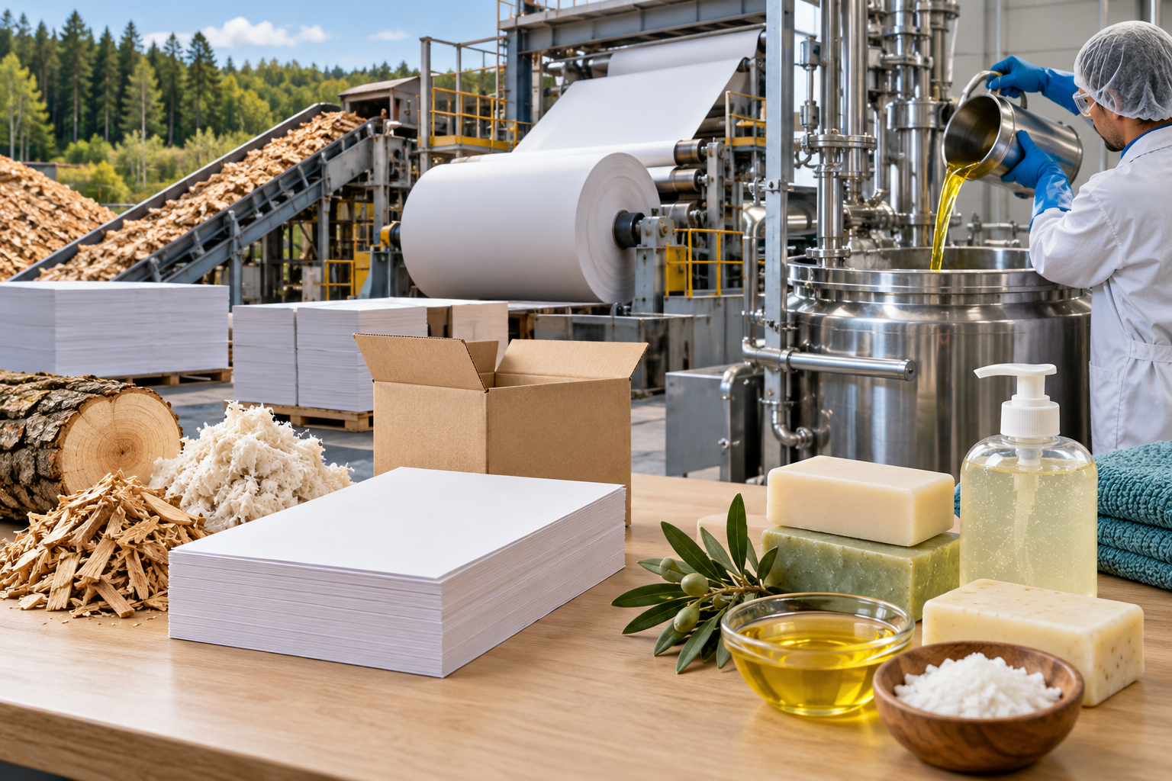
A composite illustration of paper manufacture and controlled soap manufacture. Manufacturing combines planned physical and chemical processes. Generated contextual illustration; not a scale model.

Choose and check materials
A manufacturer needs consistent properties as well as a working process. Paper for a box must withstand its load; soap must meet safety and performance requirements.
Quality control checks materials, conditions and products. Properties such as hardness, solubility or elasticity can help answer different questions.
A responsible design also considers resource use, repair, reuse and disposal. Explain both why a material works and how its manufacture or use affects the environment.

What to remember
- Manufacturing combines planned physical and chemical processes.
- Material choices and quality checks connect properties to useful, safe products.

Check your understanding
Explain aloud, sketch, or write. Use evidence from the chapter.
1 Why do pressing paper and making soap involve different kinds of changes?
My thinking
2 Why must a manufacturer test a product even if its ingredients are familiar?
My thinking

Practise the words
Cover the meanings and explain the words. Then cover the words and name the meanings. Give an example.
manufacture make products through planned controlled steps
pulp a wet mixture of separated fibres
quality control checks that a product meets requirements

Lesson connection
Lesson 6 · Manufacturing / Lesson 7 · Materials design and application
Original adaptation informed by Core Knowledge Foundation science materials including Investigating Matter, Properties of Matter. Shared under CC BY NC SA 4.0. Generated contextual illustration.

